



**SM6P07NI Digital Media Project**

**50% Individual Artifact**

**2022-23 Autumn**

**Student Name: Samaya Shrestha**

**London Met ID: 20049329**

**College ID: NP01MM4S210034**

**External Supervisor: Rupesh Dangol**

**Internal Supervisor Dibesh Maskey**

**Assignment Due Date: April 26, 2023**

**Assignment Submission Date: April 26, 2023**

**Word Count: 3790**

*I confirm that I understand my coursework needs to be submitted online via Google Classroom under the relevant module page before the deadline in order for my assignment to be accepted and marked. I am fully aware that late submissions will be treated as non-submission and a marks of zero will be awarded.*

**Table of Contents**

1 Introduction 3

2 Planning 4

2.1 Concept 4

2.2 Target audience 4

2.3 Uses of the project 4

3 Production Phases 5

3.1 Pre-production 5

3.1.1 Writing concept 5

3.1.2 Research on Architecture 6

3.1.3 Research on Software for production 10

3.2 Production 11

3.2.1 Modeling 11

3.2.2 UV Editing 46

3.2.3 Texturing 67

3.2.4 Compilation & Rendering 73

3.3 Post-production 79

3.3.1 Compiling 79

4 Testing 83

5 Links 88

5.1 YouTube link: 88

5.2 Drive 88

5.3 GitHub 88

6 References 89

7 Appendix 90

7.1 Logbook 90

# Table of Figures

*Figure 1: Reference of Gaddi Baithak* 9

*Figure 2: Reference of Kumari Ghar* 10

*Figure 3: Reference of Basanatapur Durbar* 11

*Figure 4: Reference 1 of house* 11

*Figure 5: Reference 2 of house* 12

*Figure 6: Creating Base of Gaddi Baithak* 14

*Figure 7: Creating body.* 15

*Figure 8: Adding roof.* 15

*Figure 9: Creating and placing poles* 16

*Figure 10: Creating roof artifacts.* 16

*Figure 11: Creating roof patterns.* 17

*Figure 12: Creating window 1* 18

*Figure 13: Creating window 2* 18

*Figure 14: Creating window 3 and door.* 19

*Figure 15: Creating body of side building.* 19

*Figure 16: Adding details to the side building.* 20

*Figure 17: Complete model* 20

Figure 18: Creating the base. 21

Figure 19: Creating the middle portion of the building. 22

Figure 20: Adding the side portins of the building 22

Figure 21: Adding roof. 23

Figure 22: Creating the top portion of the architecture. 23

Figure 23: Adding roof supports. 24

Figure 24: Adding windows and door (Complete model) 25

Figure 25: Creating Base 26

Figure 26: Creating the body. 27

Figure 27: Adding poles according to the reference. 27

Figure 28: Placing door and windows. 28

Figure 29: Creating and adding overhang. 28

Figure 30: Placing roof and supports. 29

Figure 31: Creating and adding stairs and temple. 29

Figure 32: Completed Structure 30

Figure 33: Creating base. 30

Figure 34:Creating the body. 31

Figure 35: Adding poles. 31

Figure 36: Creating and placing door and windows. 32

Figure 37: Creating roof. 32

Figure 38: Creating and placing roof supports. 33

Figure 39: Creating balcony and adding poles. 33

Figure 40: Creating and placing top 34

Figure 41: Completed structure 34

Figure 42: Creating and placing the base. 35

Figure 43: Creating and placing the body. 35

Figure 44: Placing the windows and doors. 36

Figure 45: Creating and placing over hangs. 36

Figure 46: Creating and placing balcony. 37

Figure 47: Creating and placing roof and supports. 37

Figure 48: Creating and placing stairs. 38

Figure 49: Creating and placing poles. 38

Figure 50: Completed structure. 39

Figure 51: Creating base. 39

Figure 52: Creating and placing body. 40

Figure 53: Adding roofs. 40

Figure 54: Creating and adding overhang 1. 41

Figure 55: Creating and adding overhang 2. 41

Figure 56: Adding roof supports. 42

Figure 57: Adding windows. 42

Figure 58: Creating the top. 43

Figure 59: Creating the stairs. 43

Figure 60:Completed structure. 44

Figure 61: Creating the body of the house 45

Figure 62: Creating and placing roof. 46

Figure 63: Creating and placing windows and door 46

Figure 64:Completed house. 47

Figure 65:Completed house 1. 47

Figure 66:Completed house 2. 48

Figure 67:Completed house 3. 48

Figure 68: Uv Map Pillar 49

Figure 69: Uv Map Pole 50

Figure 70: Uv Map Arch 50

Figure 71: Uv Map Window 51

Figure 72: Uv Map Side Building 51

Figure 73: Uv Map Roof Artifacts 52

Figure 74: Uv Map Base 52

Figure 75: UV map Wall 53

Figure 76: UV map Roof 53

Figure 77: UV map Window 1 54

Figure 78: UV map Window 2 54

Figure 79: UV map Window 3 55

Figure 80: UV map Door 55

Figure 81: UV map Top 56

Figure 82:Uv map temple(right) 57

Figure 83:Uv map doors and poles(right) 57

Figure 84:Uv map roof(right) 58

Figure 85:Uv map overhang(right) 58

Figure 86:Uv map stairs(right) 59

Figure 87: Uv map roof(back) 59

Figure 88: Uv map walls(back) 60

Figure 89: Uv map base(back) 60

Figure 90: Uv map window(back) 61

Figure 91: Uv map pole(back) 61

Figure 92: Uv map roof(left) 62

Figure 93: Uv map overhang (left) 62

Figure 94: Uv map window(left) 63

Figure 95: Uv map stairs(left) 63

Figure 96: Uv map roof support(back) 64

Figure 97: Uv map top(front) 64

Figure 98: Uv map overhang 1(front) 65

Figure 99: Uv map overhang 2(front) 65

Figure 100: Uv map wall(front) 66

Figure 101:Uv map window 1(house3) 67

Figure 102: Uv map window 2(house3) 67

Figure 103: Uv map walls 1(house3) 68

Figure 104: Uv map roof(house1) 68

Figure 105: Uv map window(house1) 69

Figure 106: Uv map door(house1) 69

Figure 107: Creating new project. 70

Figure 108: Importing UV map. 71

Figure 109: Texture bake settings 72

Figure 110: Applying texture. 73

Figure 111: Export settings 74

Figure 112: Creating project in Twinmotion 76

Figure 113: Selecting Import option. 77

Figure 114: Importing assets 78

Figure 115: Assigning texture to assets 78

Figure 116: Creating Environment 79

Figure 117: Opening video settings 80

Figure 118: Creating a walk through video. 80

Figure 119: Managing Export Settings 81

Figure 120: Creating new project. 82

Figure 121:Importing video. 83

Figure 122: Importing audio file. 83

Figure 123: Compiling Video 84

Figure 124:Exporting Final Video 85

# Introduction

This coursework is the part of the Final Year Project (FYP) of the module Digital Media Project. In this module we, students are required to select a field of interest and create a project in the field. The project that we are required to create is a student driven project that differs from student to student.

For this module of Digital Media Project, a project on architectural visualization is decided and it will be based on Nepali architecture. The project will involve the process of 3D modelling, texturing, rendering and the final output will be an environment output video with the 3D assets.

# Planning

## Concept

For this project, the architecture of Basantapur was taken as reference and the architectural assets will be made in 3D based software. Along with the architecture of Basantapur, the environment of the Basantapur will also be made for the audience as a reference or visualization. These assets can be used in various 3D fields such as game environment, 3d animations, etc.

## Target audience

The target audience for this project are the people who are interested in the Nepali architecture and the people who can use the assets created in 3D. The Target audience mostly consists of people from 3D backgrounds such as animation, game environment and asset developers, etc. as they are constantly in need of assets that they can use for the project that they are working on. The target audience will also consist of people who are interested in the architecture of Nepal and are also people who are interested in the history of Nepal as many of the Nepalese architecture come from the history of Nepal.

## Uses of the project

The project consists of different architectural structures of Nepal. These architectural structures can be used together or separate as per the requirements of the uses. These assets can be used for creating an environment based in Nepal for games, animation. These assets can also be used in movies. The assets will be packaged into a library and will be placed on SketchFab, Deviantart and ArtStation.

# Production Phases

For this project, the tasks that were done are categorized into 3 phases of production. They are as follows:

## Pre-production

Pre-production is the first phase of the production. This phase mainly consists of planning, prototyping, referencing, etc. To ensure the project was completed smoothly, everything was planned ahead the production process.

### Writing concept

For any product to undergo production, concept needs to be created as concept acts as a reference for tasks ahead. Concept writing is a difficult process, as it is needed to please a group of people with different mindset.

Nepali architecture of Basanatapur was taken as the theme of the project. The architecture that are to be created are presented in the Basantapur Durbar Square and has historical signification. These architectures will be created digitally in a 3D software.

**Final concept:**

The map of the Basanatapur Durbar Square will be recreated with some of the main build i.e. Kumari Ghar, Gaddi Baithak, Basantapur Durbar Square and some small house in the area.

### Research on Architecture

The main purpose of this project is to create an asset library which can be used in various field for various purposes.

#### Gaddi Baithak

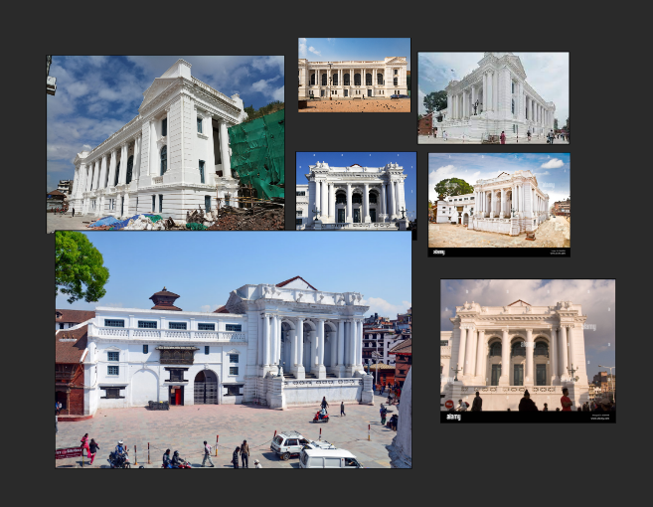

*Figure 1: Reference of Gaddi Baithak*

#### Kumari Ghar

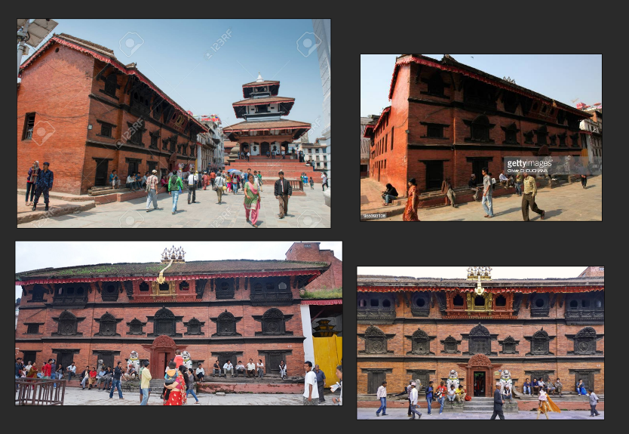

*Figure 2: Reference of Kumari Ghar*

#### Basanatapur Durbar Square

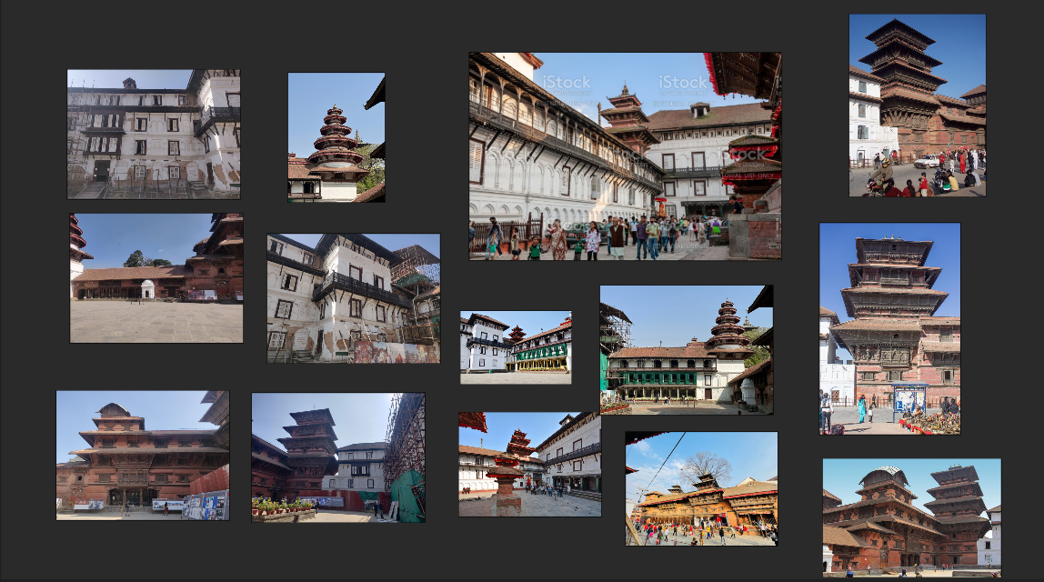

*Figure 3: Reference of Basanatapur Durbar*

#### Houses

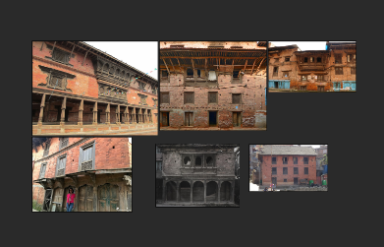

*Figure 4: Reference 1 of house*

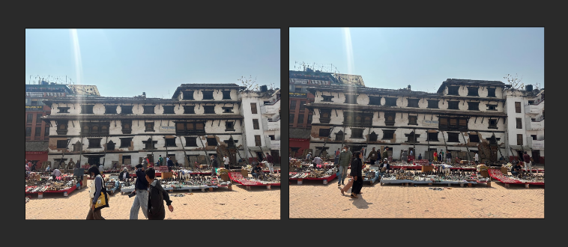

*Figure 5: Reference 2 of house*

### Research on Software for production

For the Digital Media Project, various software was used to create the project.

* **Maya:**

Maya is a 3D computer graphics software that is widely used in film, television, and game development industries. It is a comprehensive tool for creating 3D models, animations, and visual effects. Maya is known for its ability to handle complex 3D scenes, and its powerful animation and rendering capabilities.

In this project, it was used for the creation of props.

* **Substance Painter:**

Substance Painter is a 3D painting software that is used for texturing and material authoring. It is designed to create high-quality textures for 3D models quickly and easily. Substance Painter uses a PBR (physically based rendering) workflow, which allows users to create realistic materials that respond to light in a physically accurate way.

In this project, it was used for creating textures for the models.

* **Twin motion:**

Twin motion is a real-time 3D rendering and visualization software that is used for architectural visualization, urban planning, and interior design. It is designed to provide architects, designers, and engineers with a fast and easy way to create high-quality visualizations of their projects.

In this project, twin motion was used for creation of an environment with models and rendering the scenes.

* **Adobe Premiere Pro:**

Adobe Premiere Pro is a professional-level video editing software developed by Adobe Inc. It is part of the Adobe Creative Cloud suite of applications and is widely used by video editors, content creators, and filmmakers. Premiere Pro offers a range of features and tools for video editing, including timeline-based editing, color correction and grading, audio editing and mixing, motion graphics and visual effects, and multi-camera editing.

In this project, Adobe Premiere pro was used for compiling the final video export.

## Production

Production is the second phase of the production. This phase mainly consists of carrying out of the task that was planned in the first phase of the production process. Due to complete planning and scheduling the task in the production went smoothly.

### Modeling

For modeling the architectures, the research was done in the pre-production. Then everything was created using maya. The whole modeling process was done in maya software.

#### Gaddi Baithak

First a cube was imported in the scene and given the shape of the front base of the architecture. Then another cube was imported and was given a rectangular shape which was also similar in the back, so it was duplicated and placed in the back. Before duplicating and placing the shape in the back another cube was imported and shaped and placed according to the references.

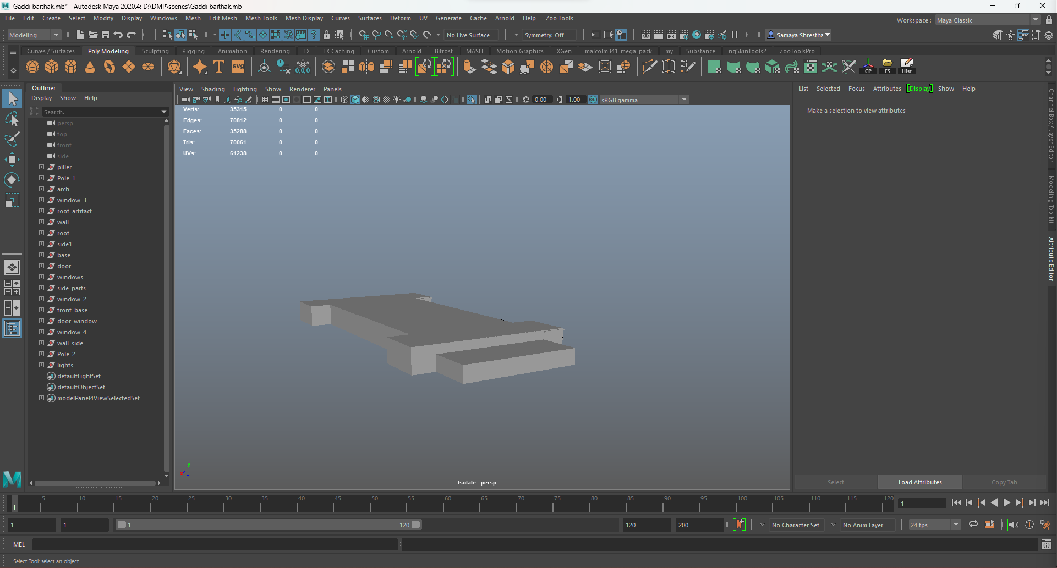

*Figure 6: Creating Base of Gaddi Baithak*

As the base was completed then the body of the architecture was created. Then the base was duplicated and moved to the top as the base and top were similar.

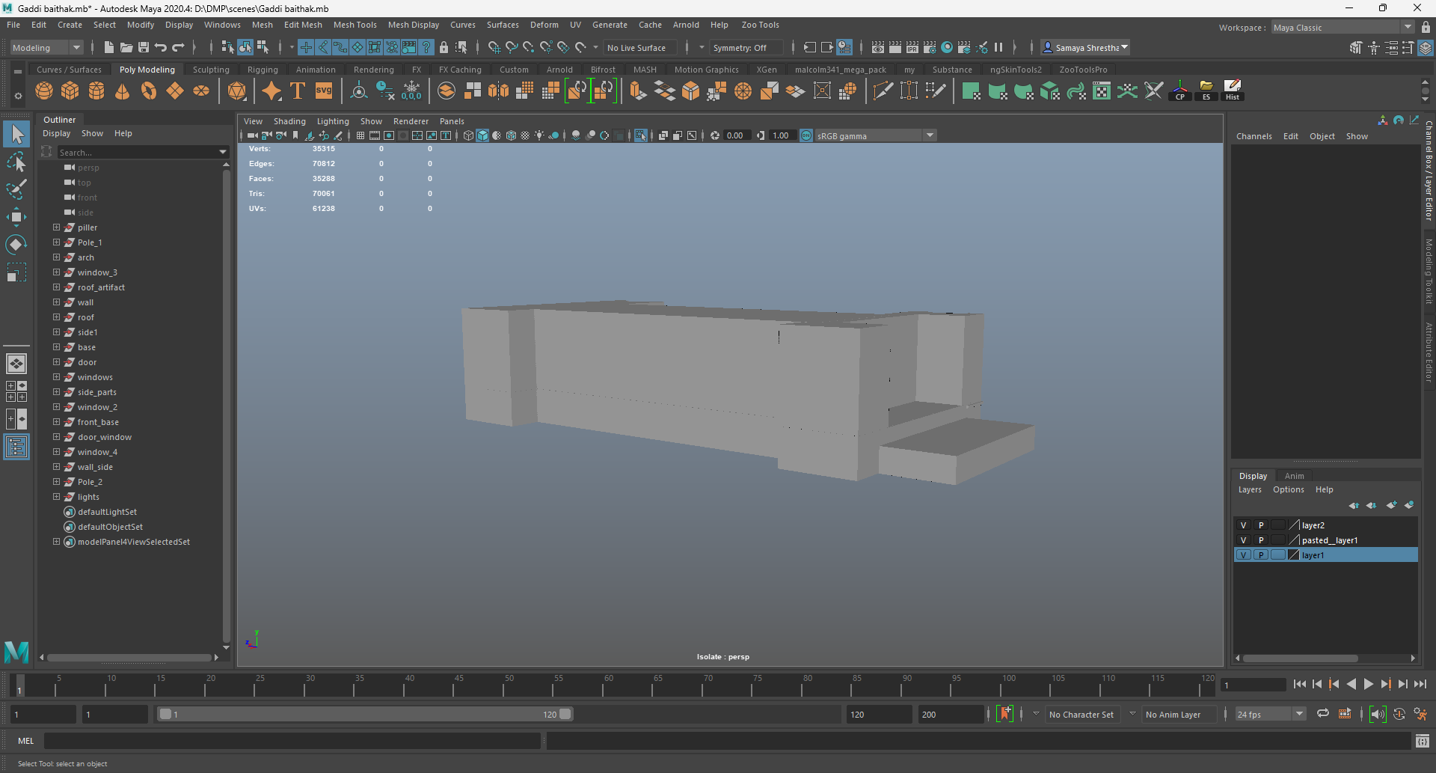

*Figure 7: Creating body.*

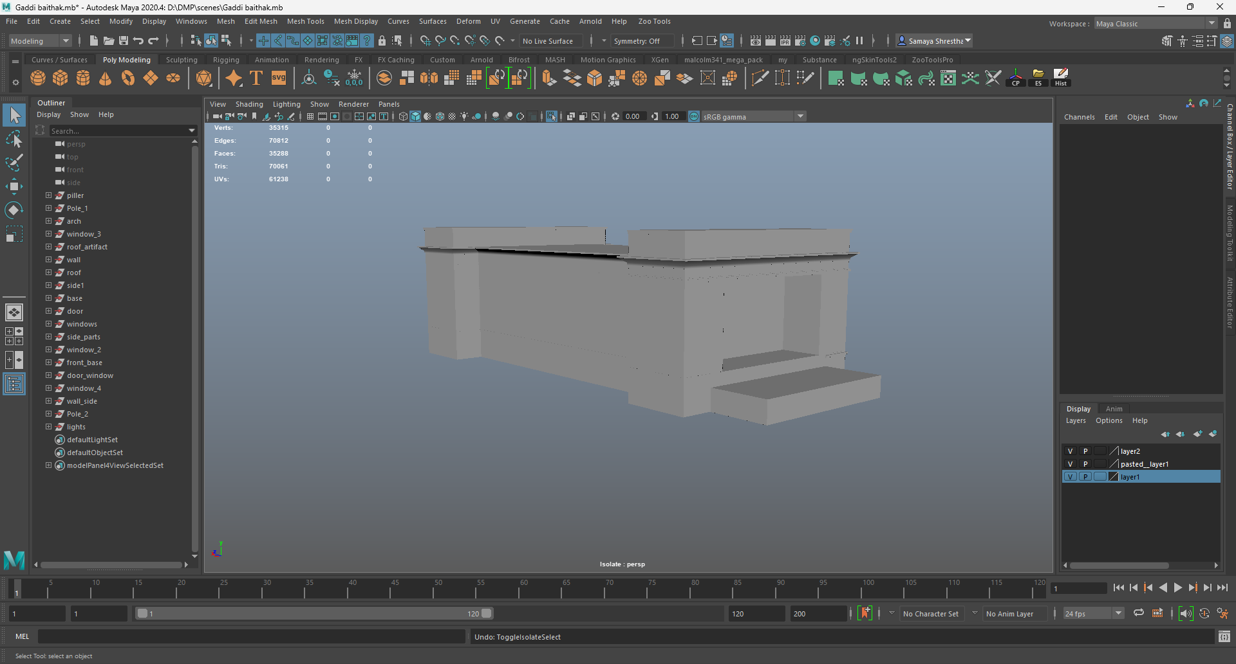

*Figure 8: Adding roof.*

Then the pillars were made using the cube which was extruded, and the extruded face was circularized and cut into half which mirrored and placed in its respective places.

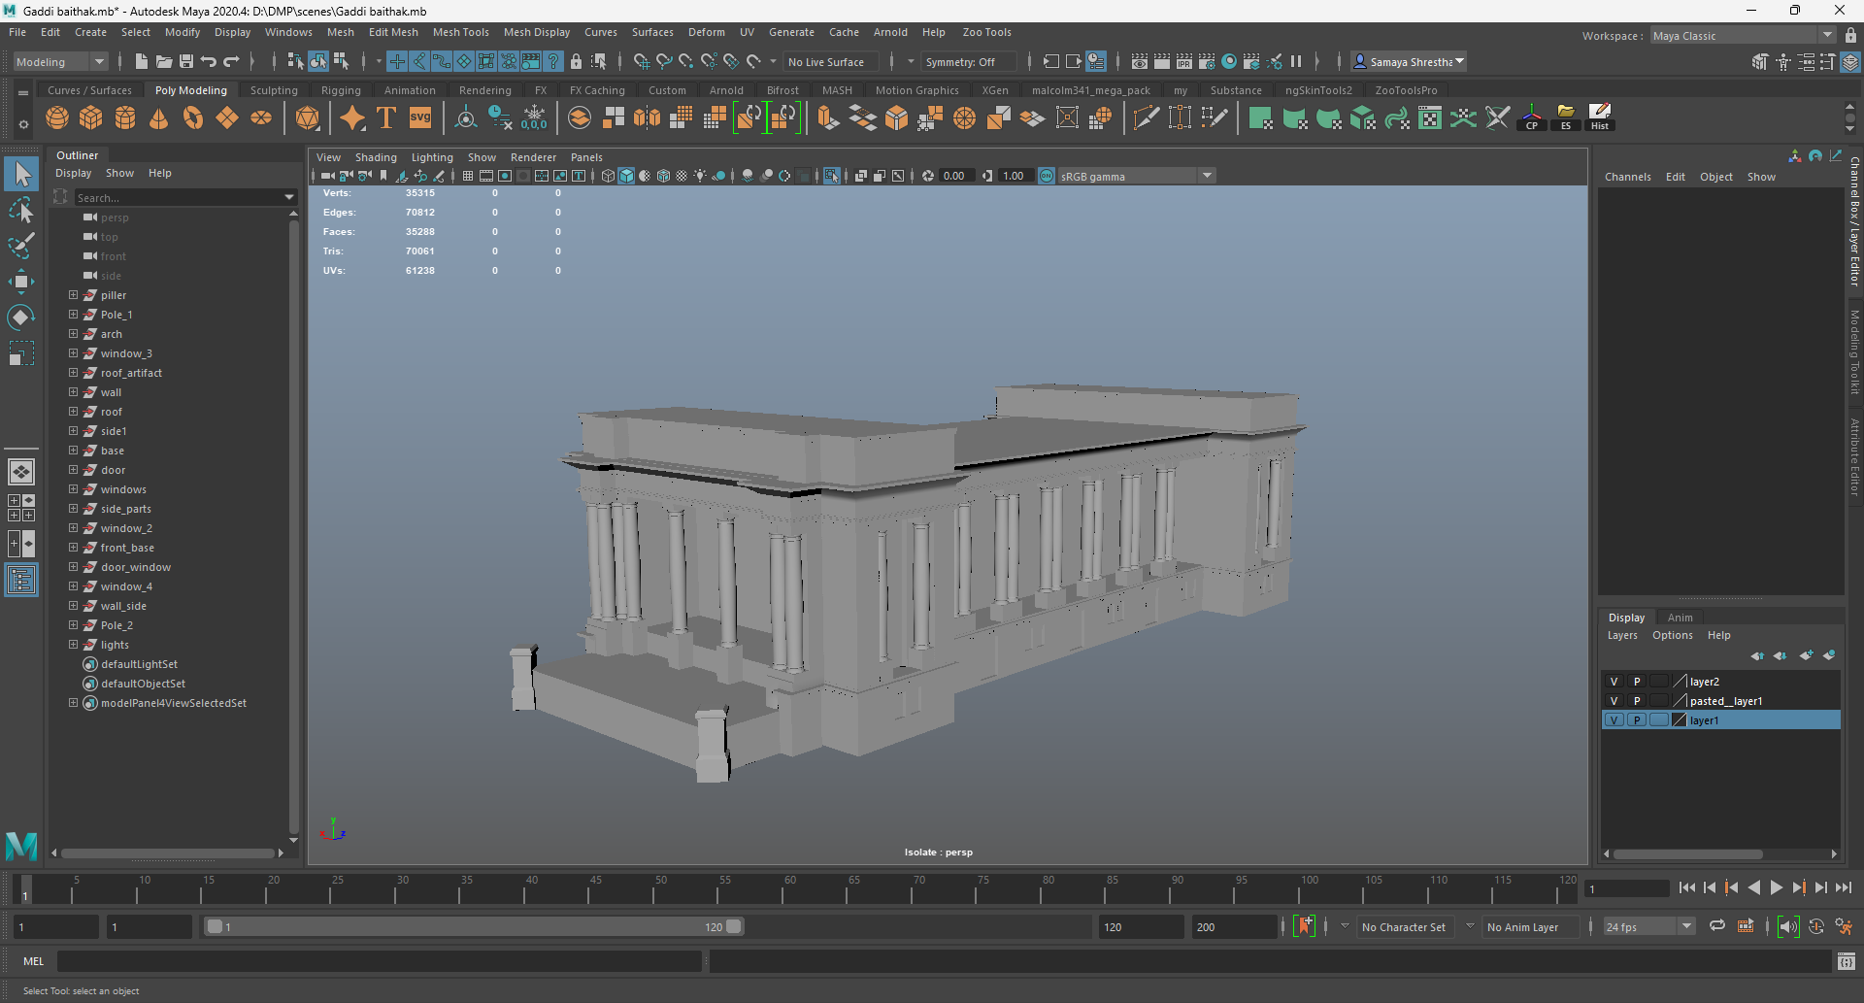

*Figure 9: Creating and placing poles*

The roof of the architecture has some artifacts which were created using the cylinders, the cylinder was subdivided and resided as per the requirements of the artifact. After that it was duplicated and placed.

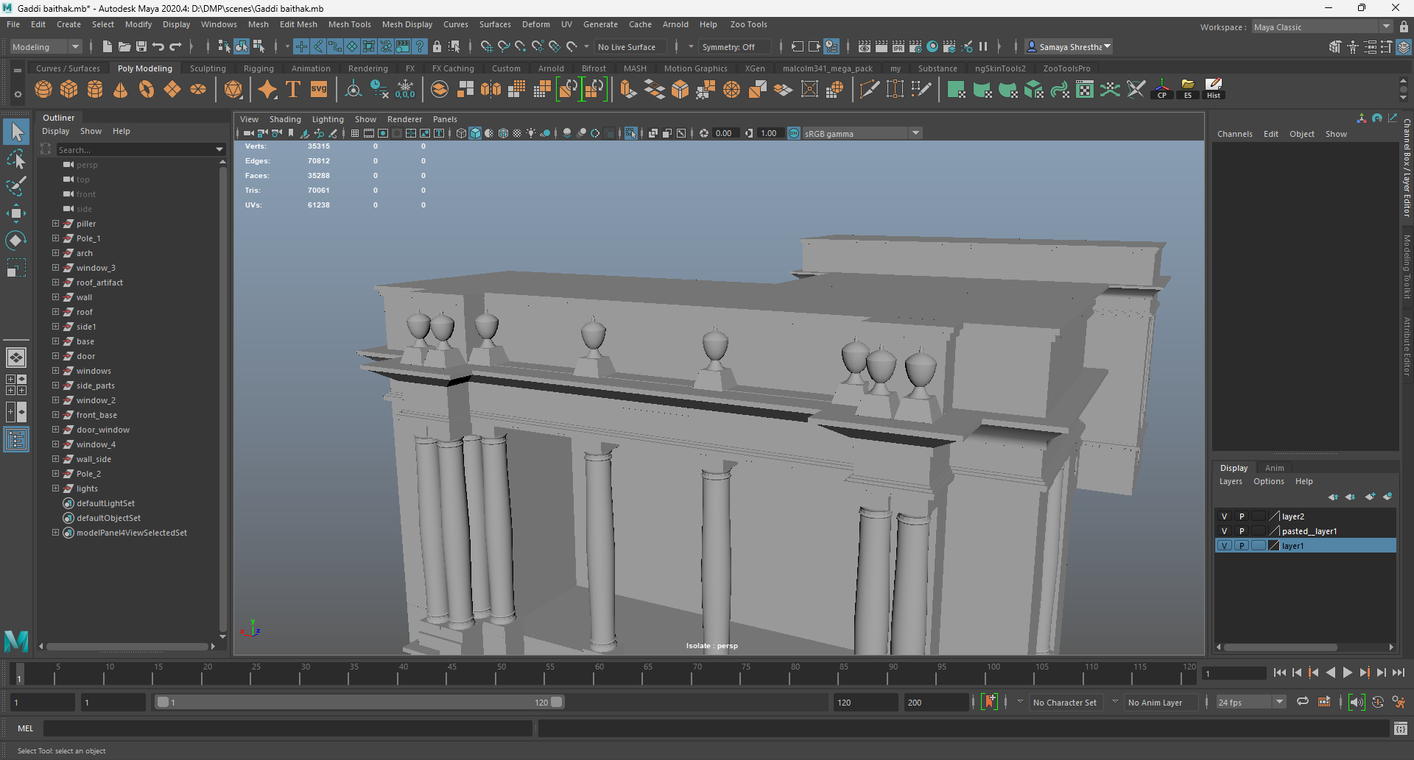

*Figure 10: Creating roof artifacts.*

The roof also has a triangle shape piece which was created in a cube. The edges of the cube were merged to create a triangle which was extruded and shaped to give the design that was required as per the reference.

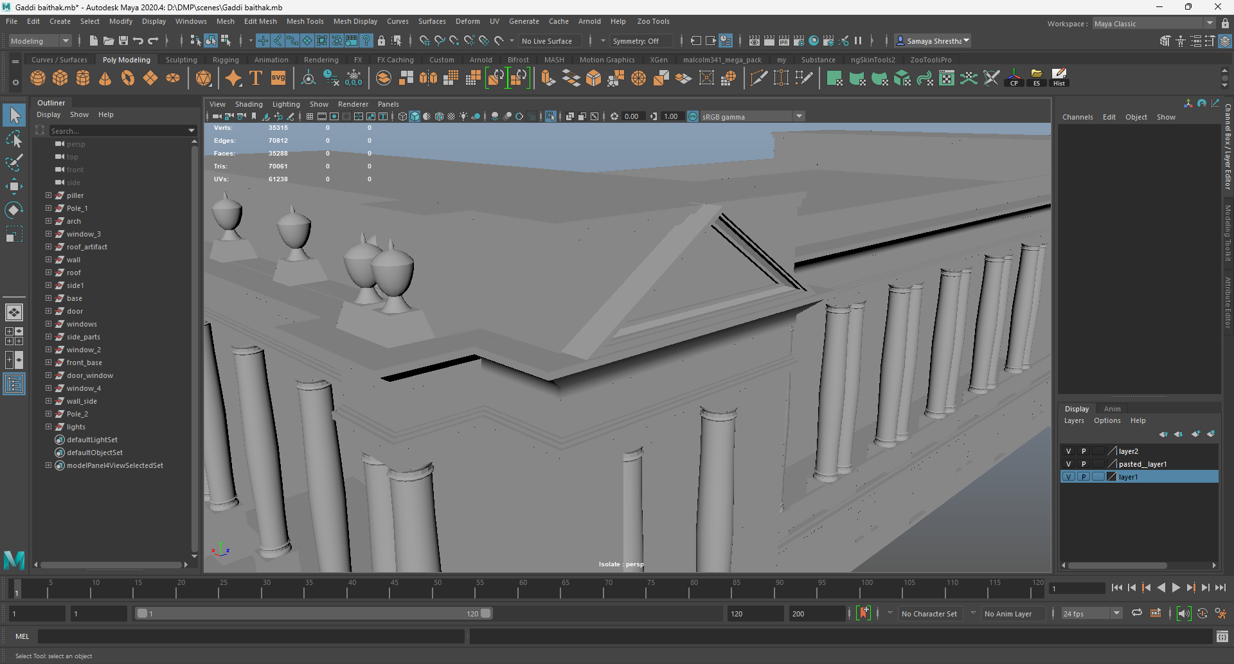

*Figure 11: Creating roof patterns.*

The windows were made using a cube which was subdivided, and vertices were moved to create a semicircle on the top of the window. Along with this there are two more types of windows one of which is similar to this one but longer in length and another was a normal one. The normal window was also created using a cube. Similar to the windows the door was also created.

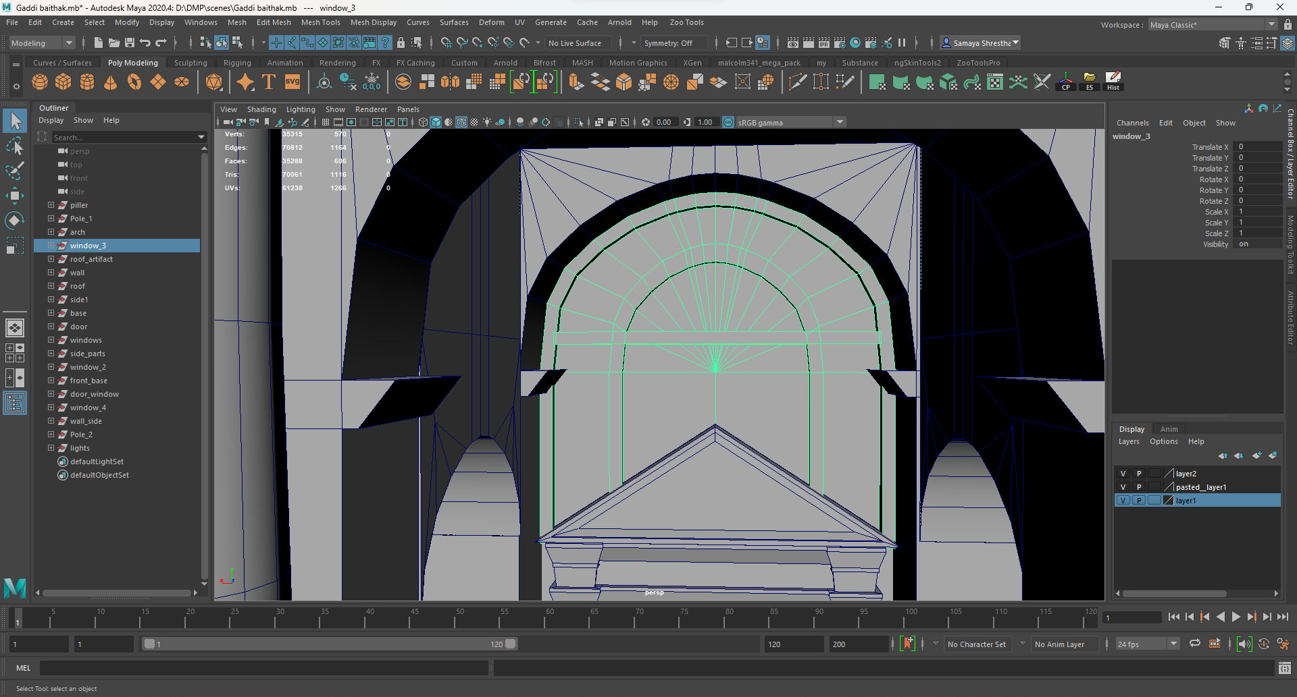

*Figure 12: Creating window 1*

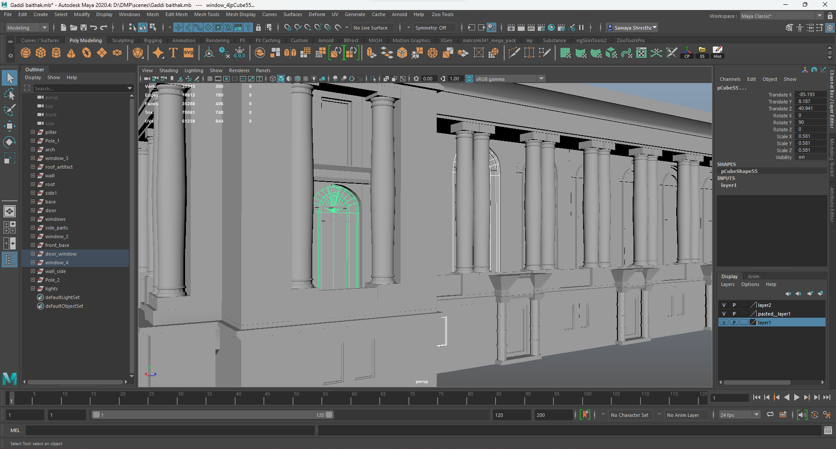

*Figure 13: Creating window 2*

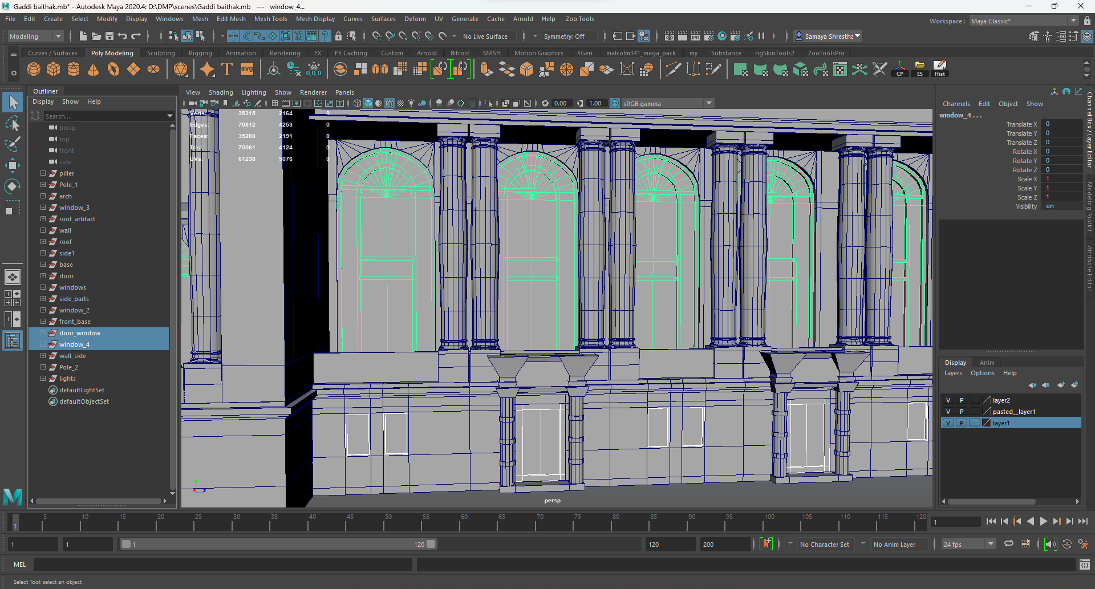

*Figure 14: Creating window 3 and door.*

For the side building, a cube was taken, and the structure of the architecture was created. After that structure that were similar to the main building duplicated resized and placed creating the side building.

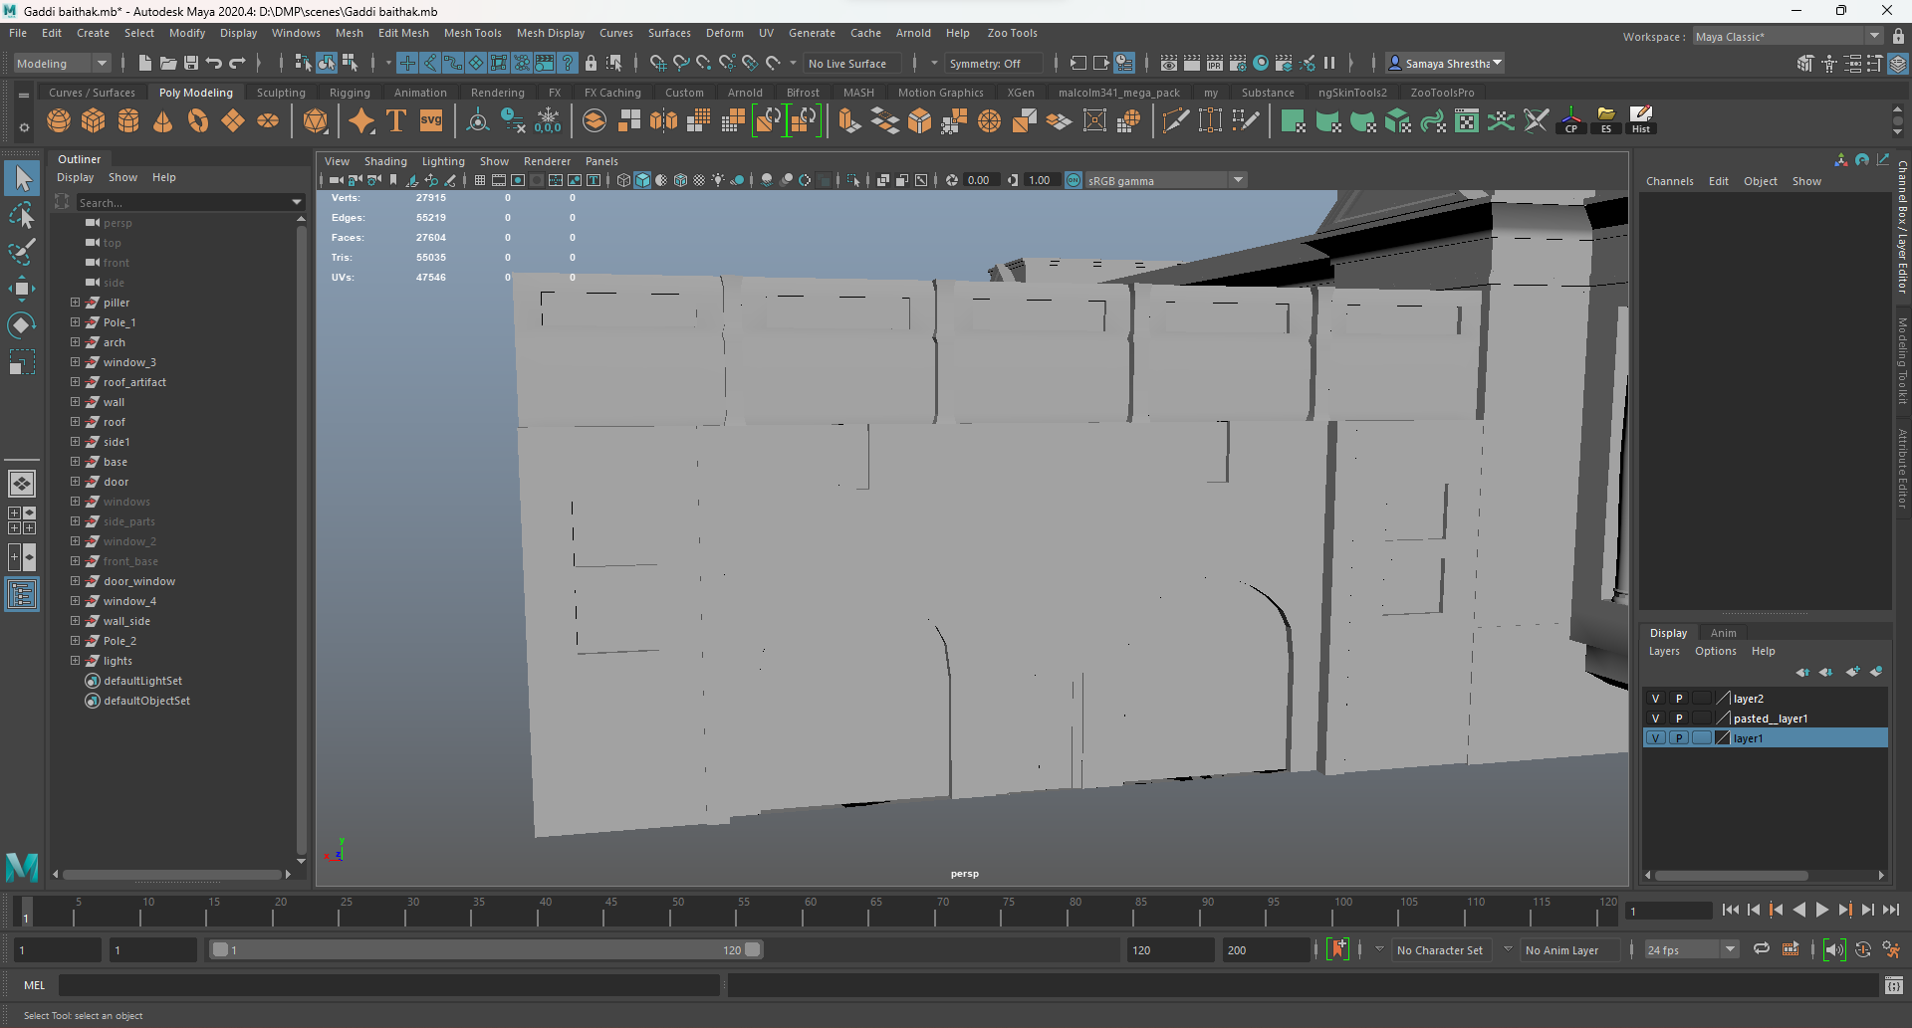

*Figure 15: Creating body of side building.*

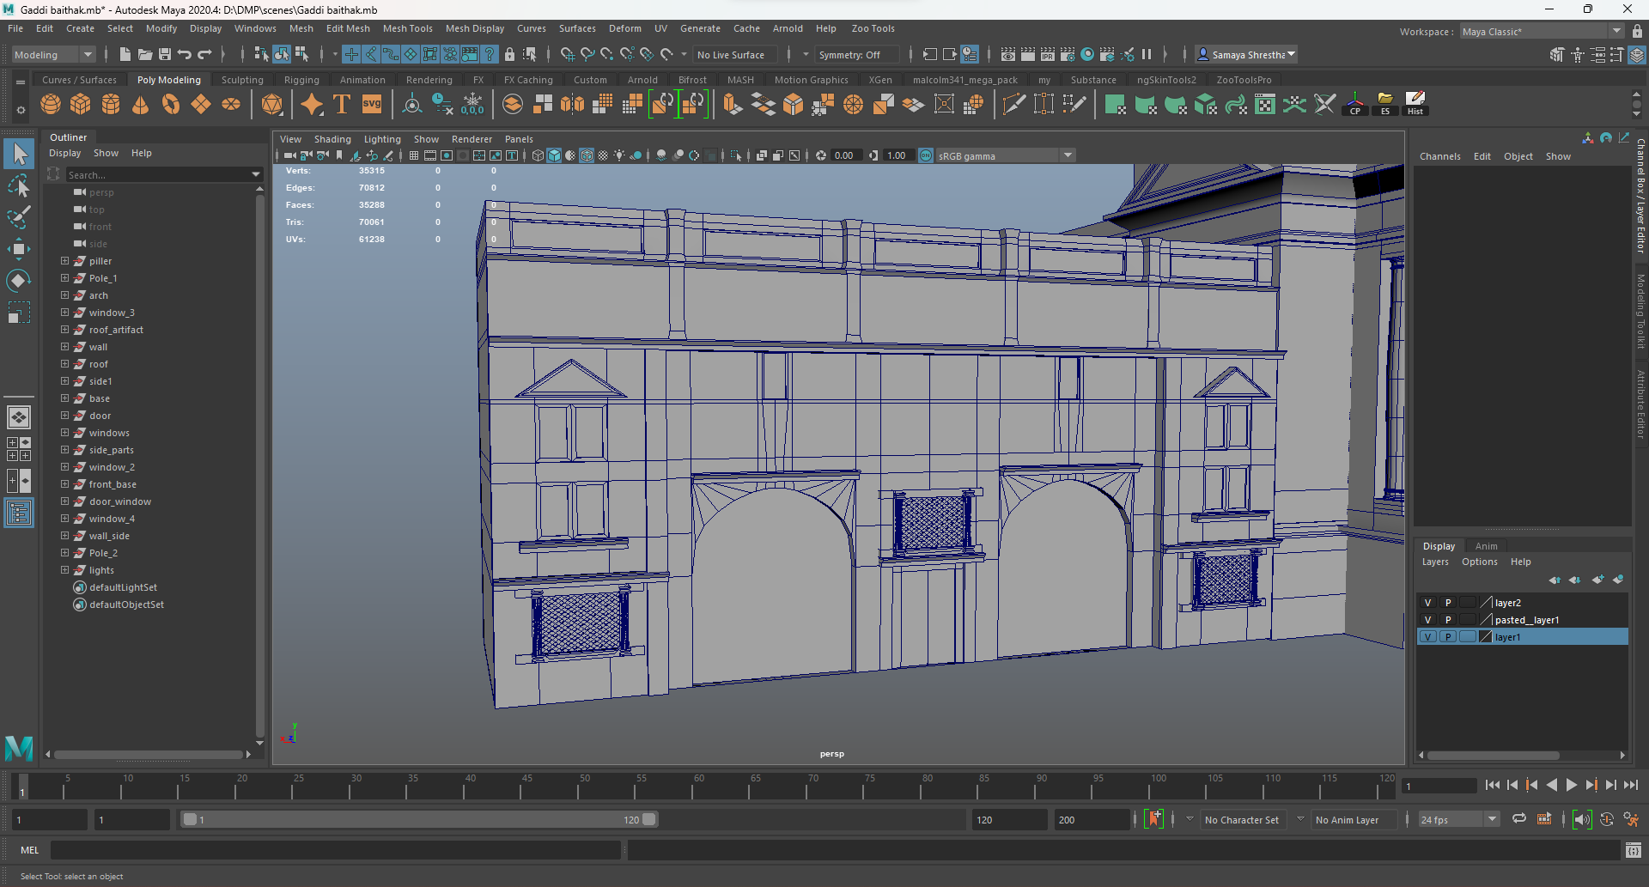

*Figure 16: Adding details to the side building.*

After adding some more details to the architecture the model was completed.

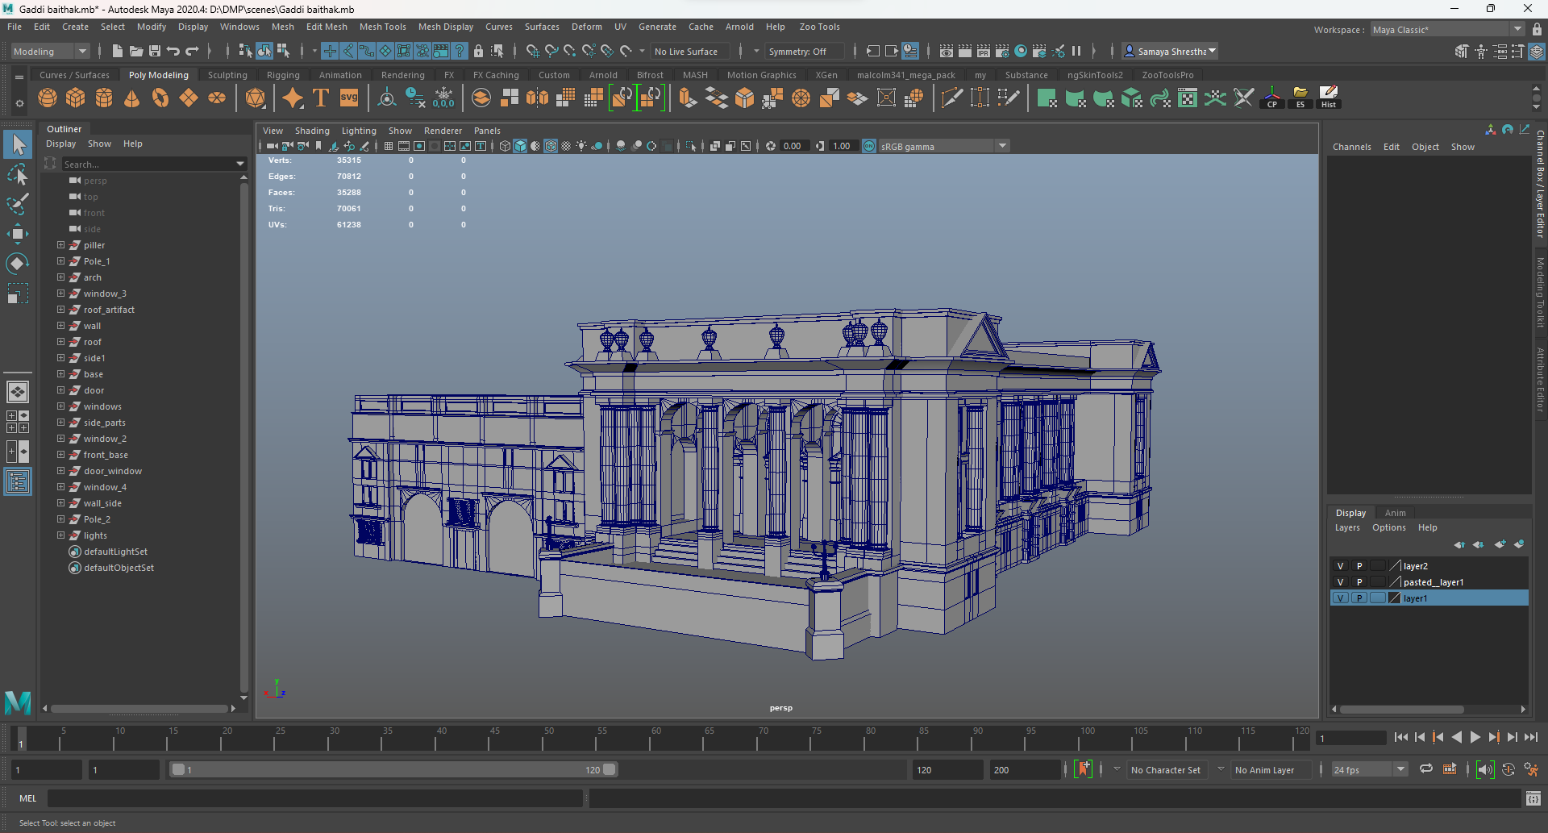

*Figure 17: Complete model*

#### Kumari Ghar

First the base of the model was created using a cube. The shape was achieved using various tools in maya such as multi cut, extrude, etc. which had ladder in the middle.

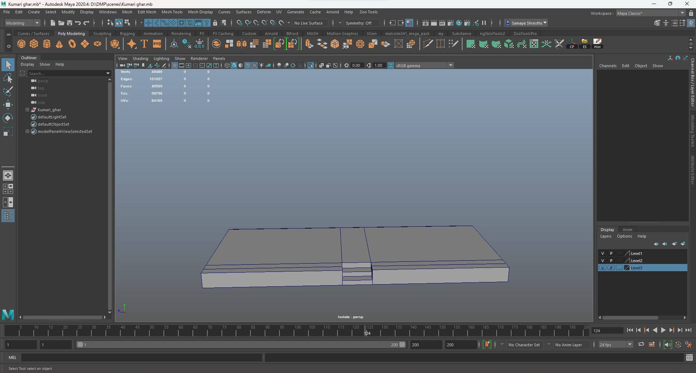

Figure : Creating the base.

Then another cube was imported in the scene, then the middle part of the building was created. Then it was duplicated as other floors are also similar.

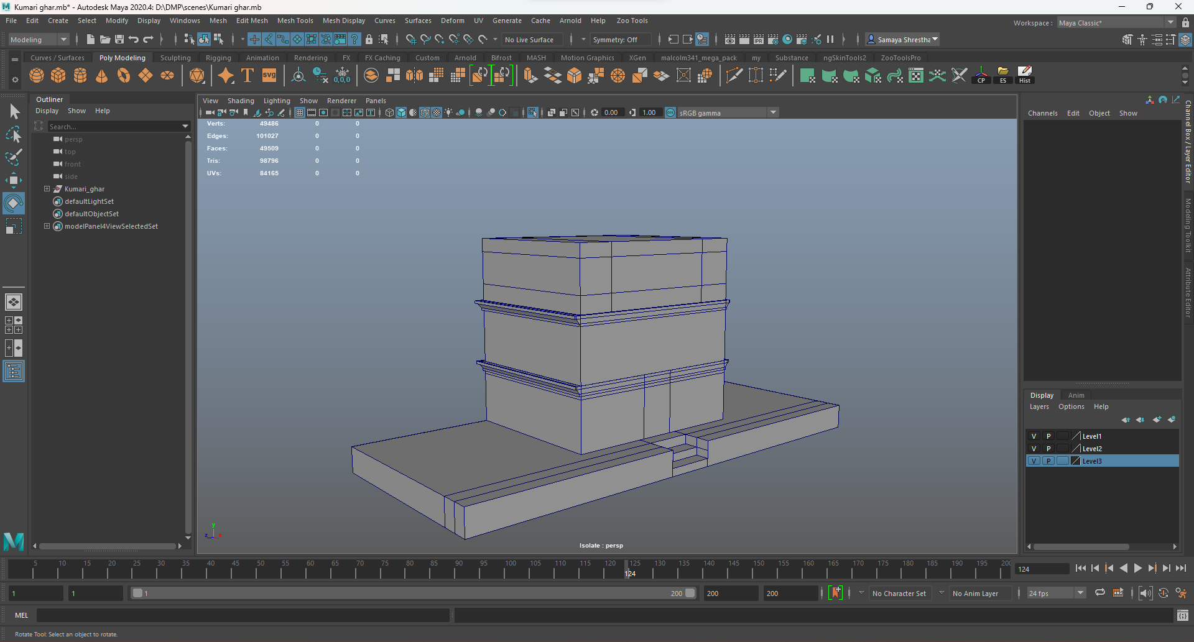

Figure : Creating the middle portion of the building.

Then the sides of the building were made using another cube. Then the cube was duplicated and placed as other floors were also similar.

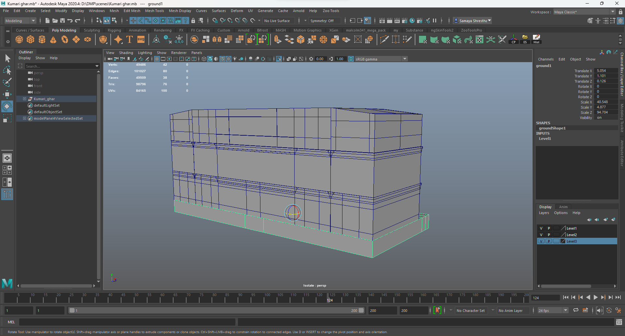

Figure : Adding the side portins of the building

Then the roof was made using another cube. It was given the shape using a multi cut tool.

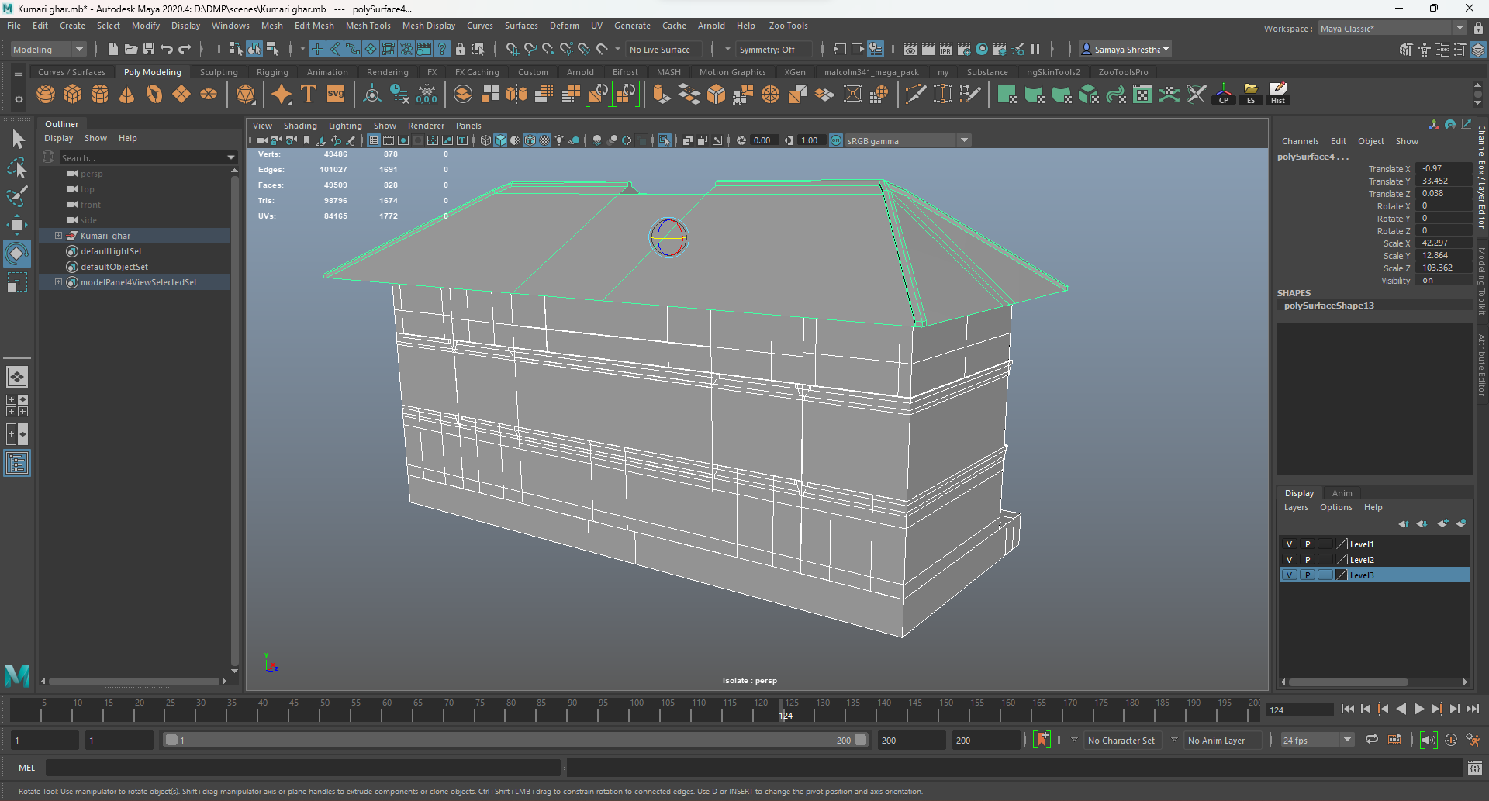

Figure : Adding roof.

Then the curve was used to make the top portion of the architecture. After the basic outline of the shape was created then revolved was used to create the shape and then convert was used to convert it into polygons.

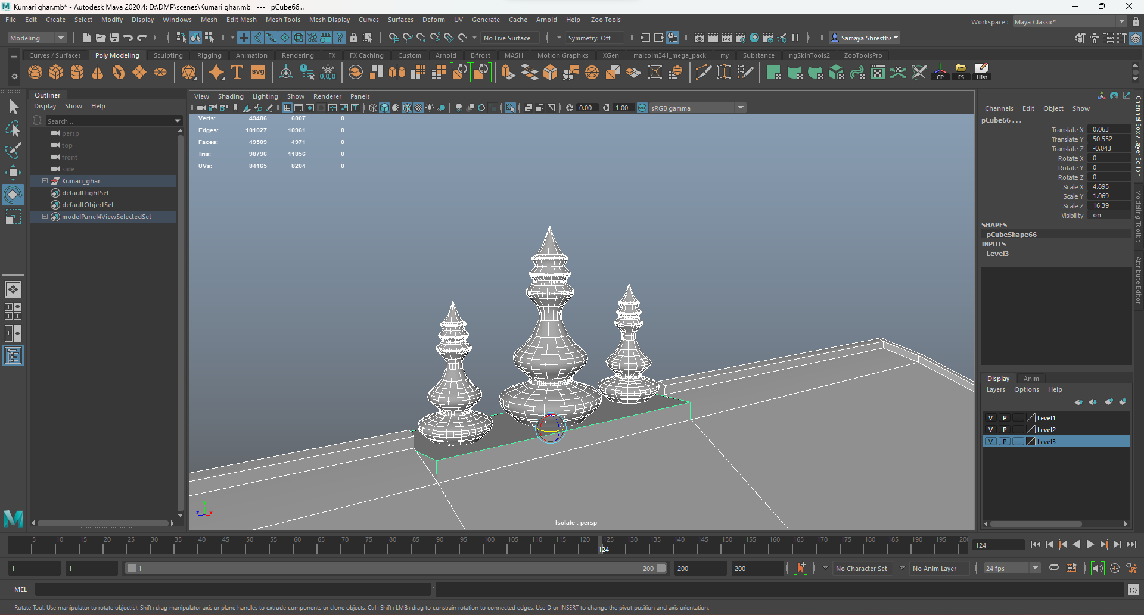

Figure : Creating the top portion of the architecture.

Then a plane was imported and extruded to create the hanging part of the architecture. As the roof had supports a cube was imported and given the shape of the support and placed then duplicated as required 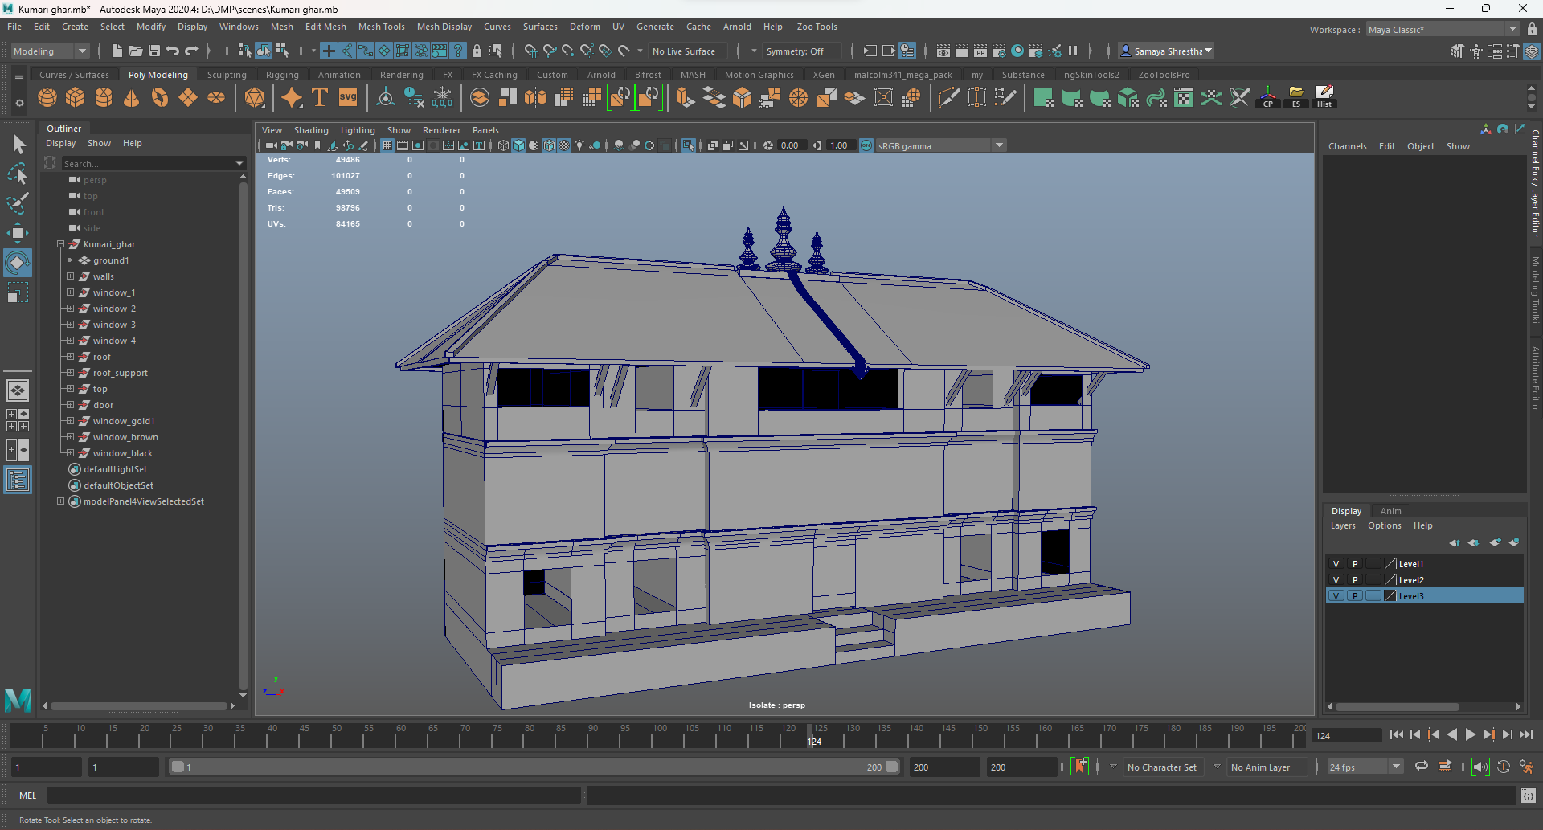

Figure : Adding roof supports.

The windows were also made using the cubes. The cube was given the basic shape of the window then it was extruded, and the middle part of the cube was deleted to make the frame of the window. Then as there were multiple style windows it was duplicated and modified some had net like designs, so another cube was to create it, some had doors, so it was created and placed. The windows also have a pole like design with some detail that was created using a cylinder in which details were added using the multi cut along with resize. Thus, the model was completed.

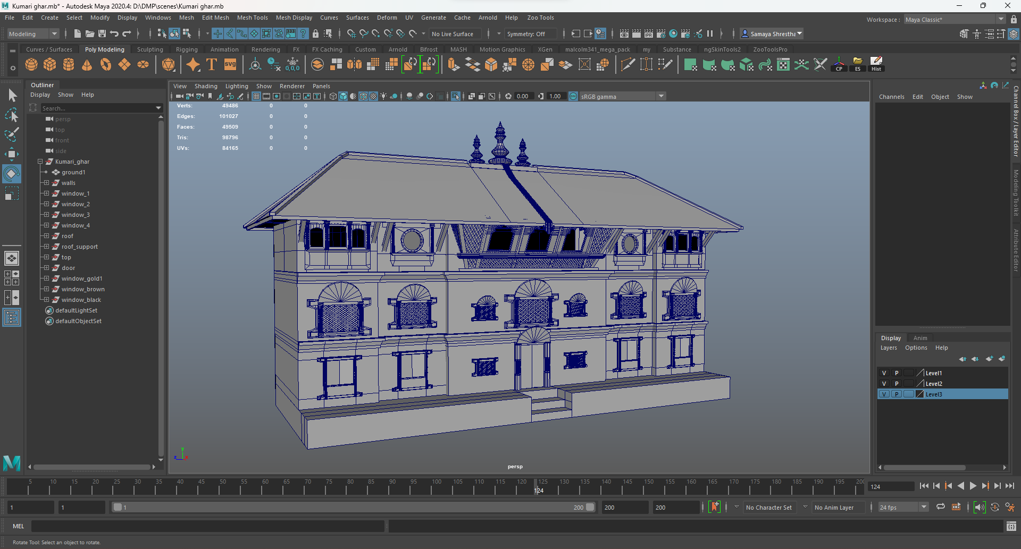

Figure : Adding windows and door (Complete model)

#### Basantapur Durbar

This model was divided into four parts which are front, back, left, and right respectively. It was divided into four parts as it was a big and complex model.

First the right part of the model was made. Similar to the other models the base of the architecture was made.

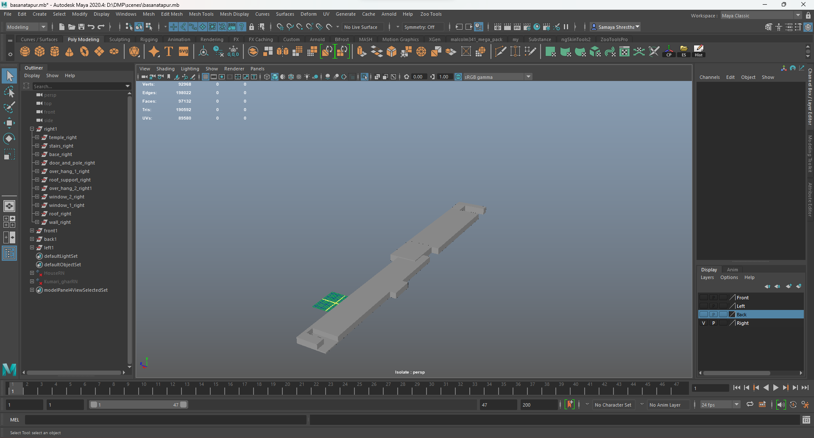

Figure : Creating Base

Then the body of the architecture was made. After the body was made the poles in the architecture were made, duplicated, and placed.

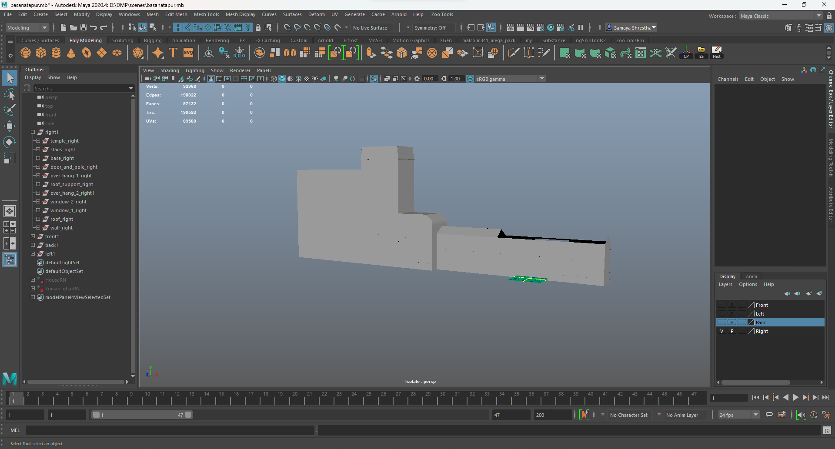

Figure : Creating the body.

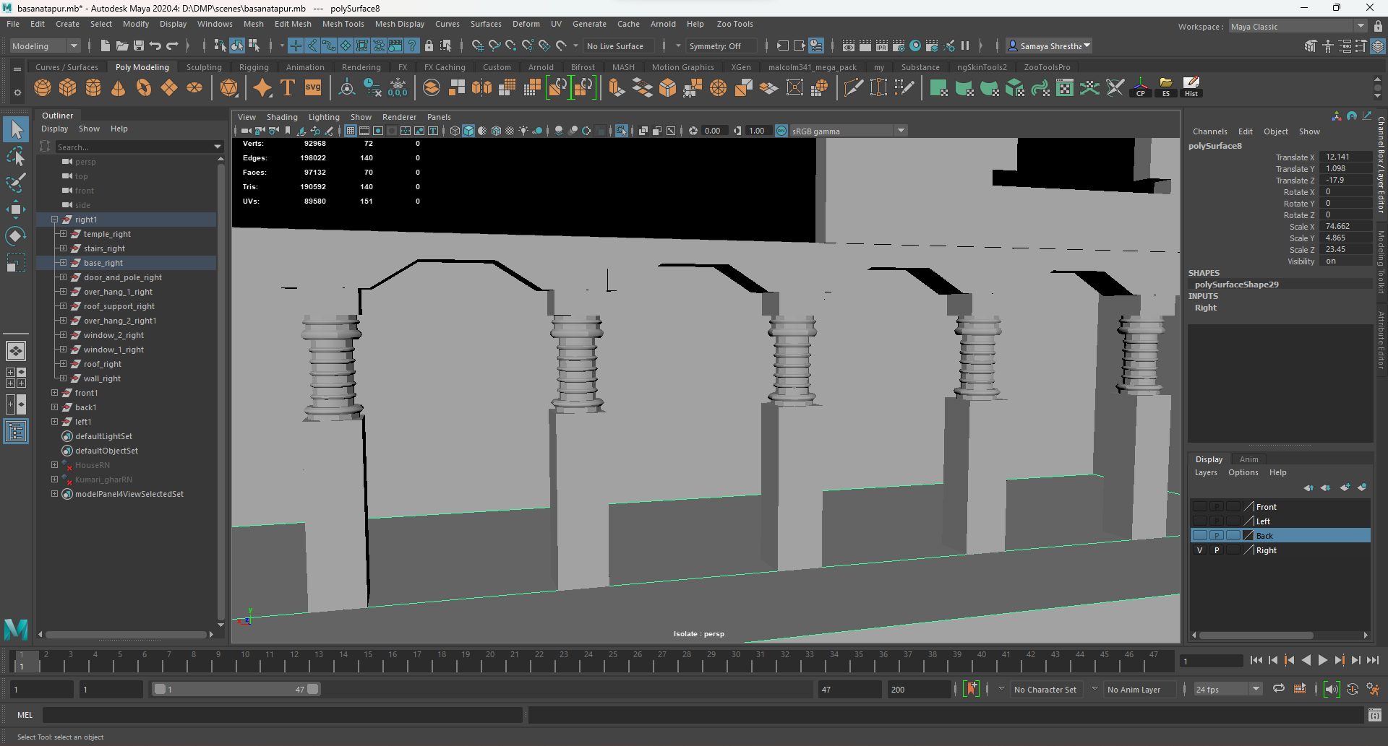

Figure : Adding poles according to the reference.

Along with the pole the doors and windows were also made. Then the overhang was made.

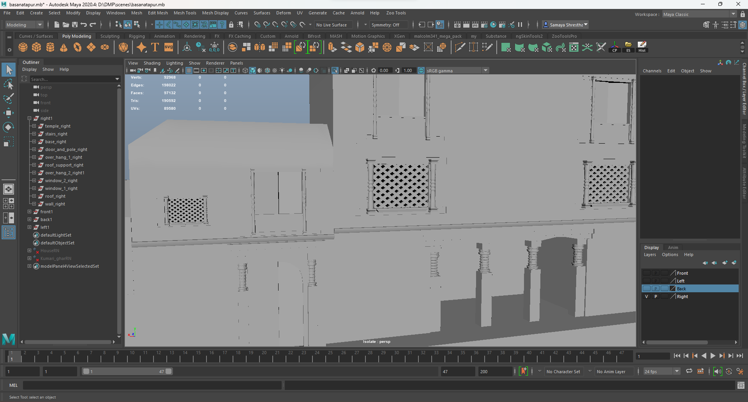

Figure : Placing door and windows.

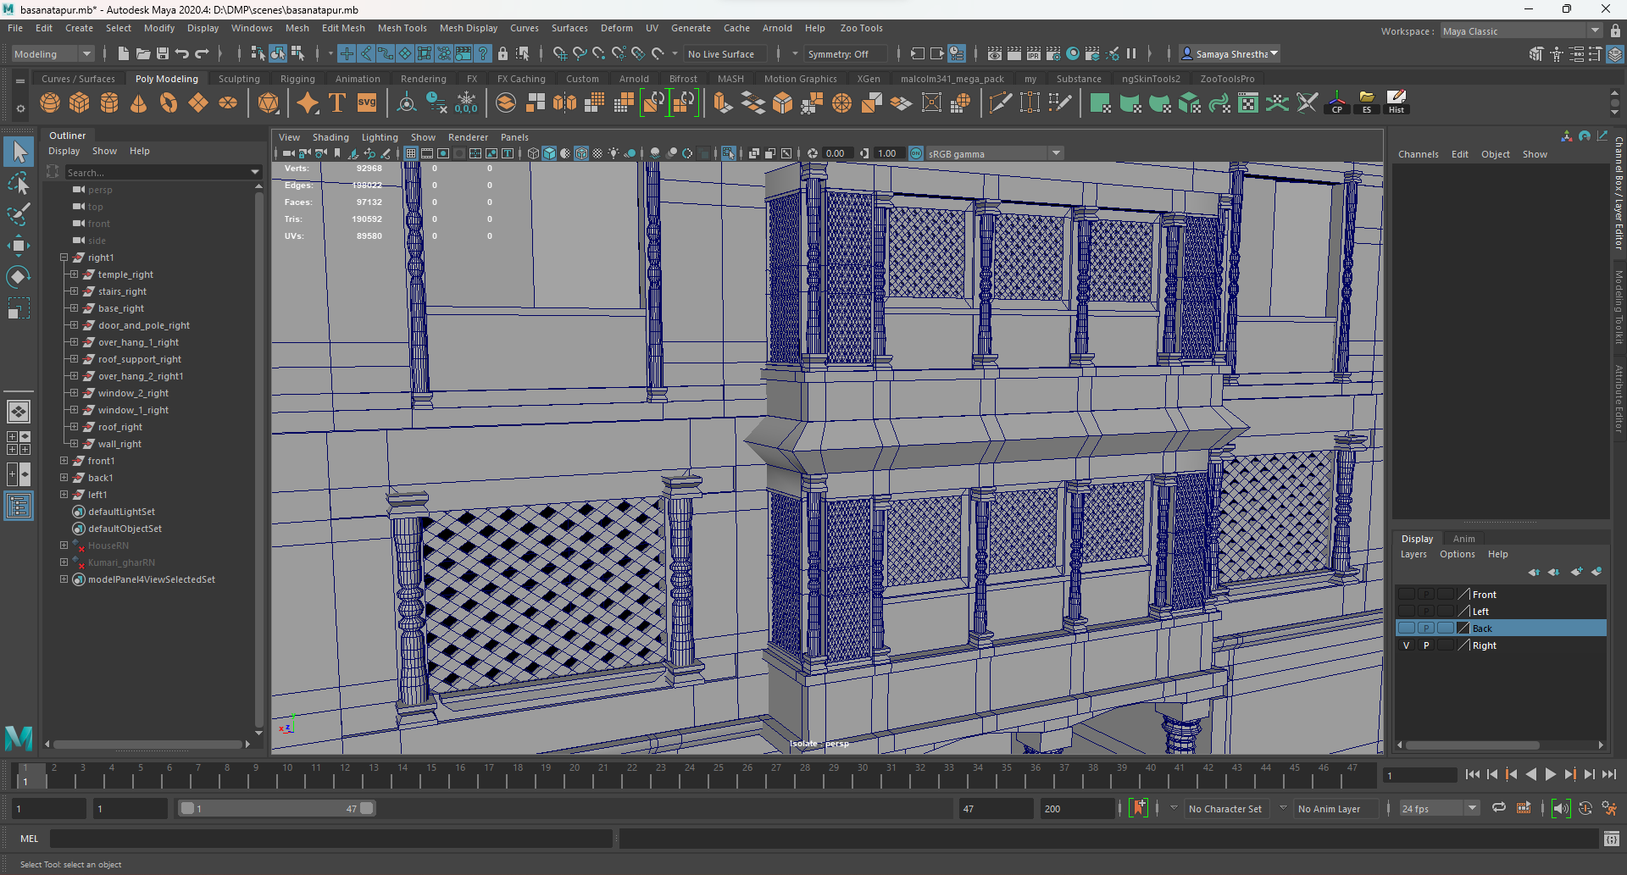

Figure : Creating and adding overhang.

Then the roof of the architecture was made. After the roof was made the supports to the roof were made and placed according to the reference.

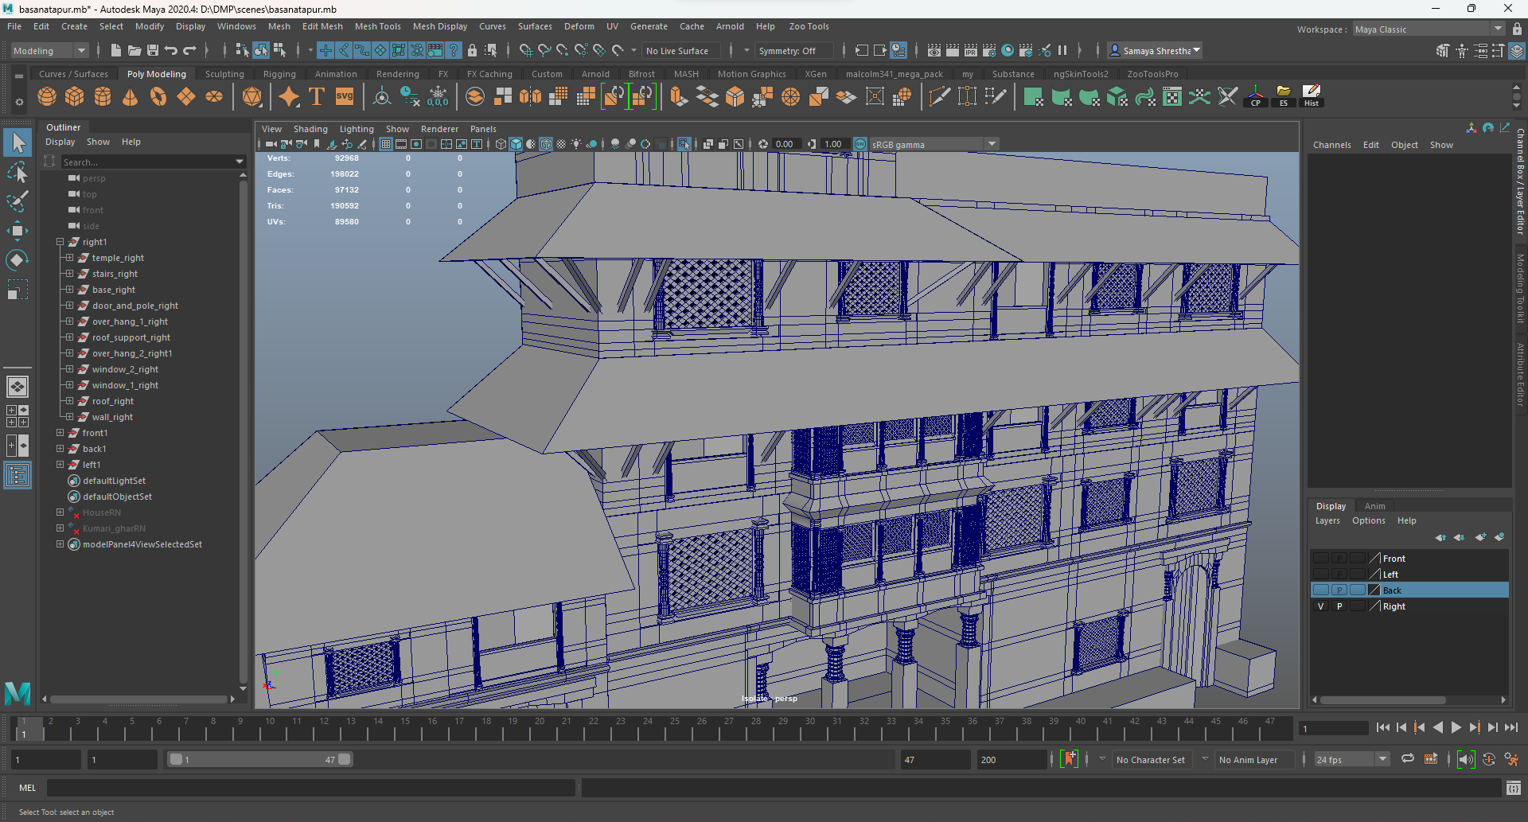

Figure : Placing roof and supports.

At last, the temple was created along with the stairs and placed. Thus, the model was completed.

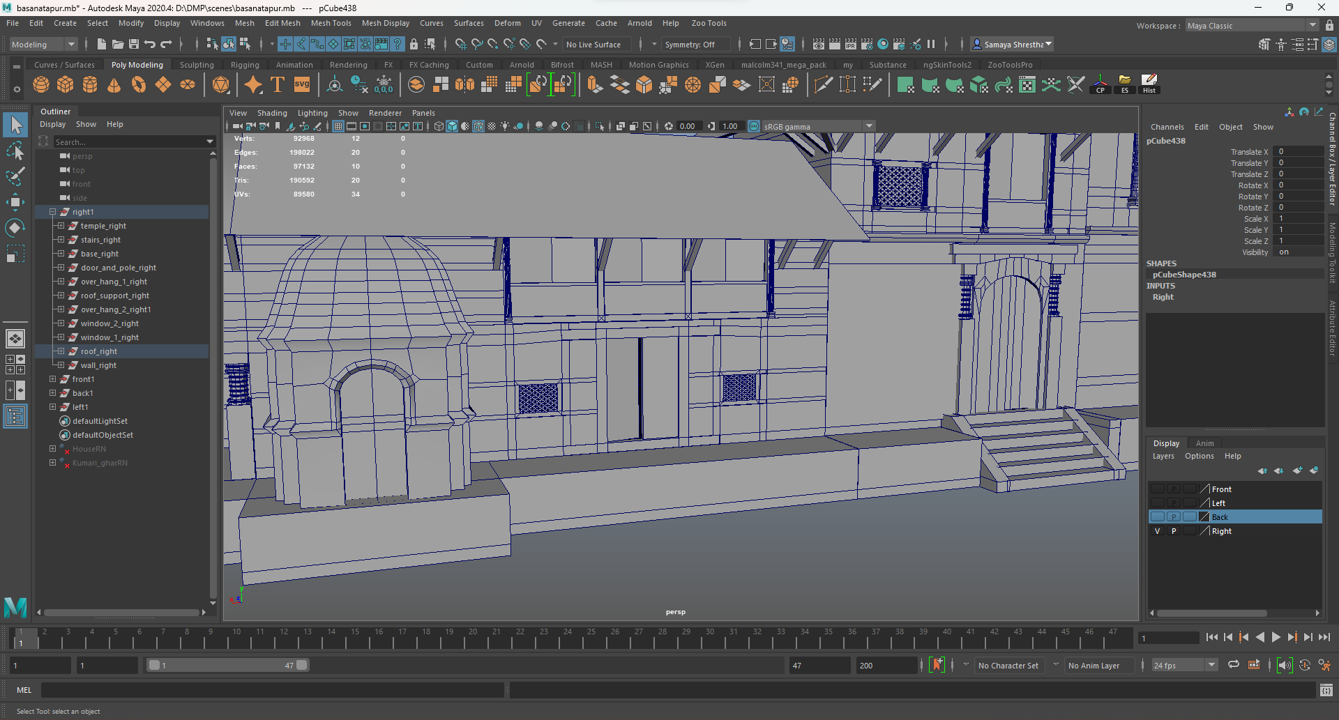

Figure : Creating and adding stairs and temple.

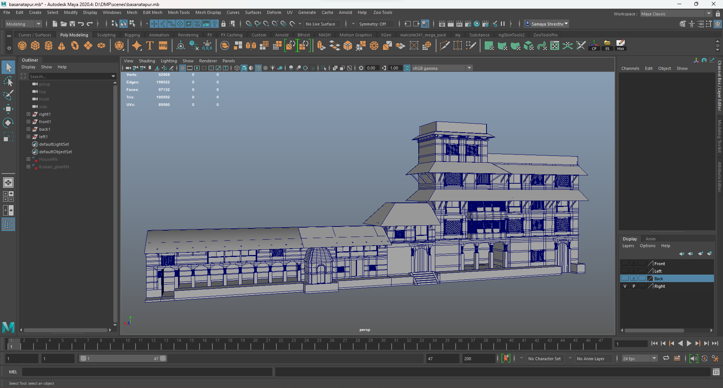

Figure : Completed Structure

Second the back part of the model was made. Similar to the previous models the base of the architecture was made.

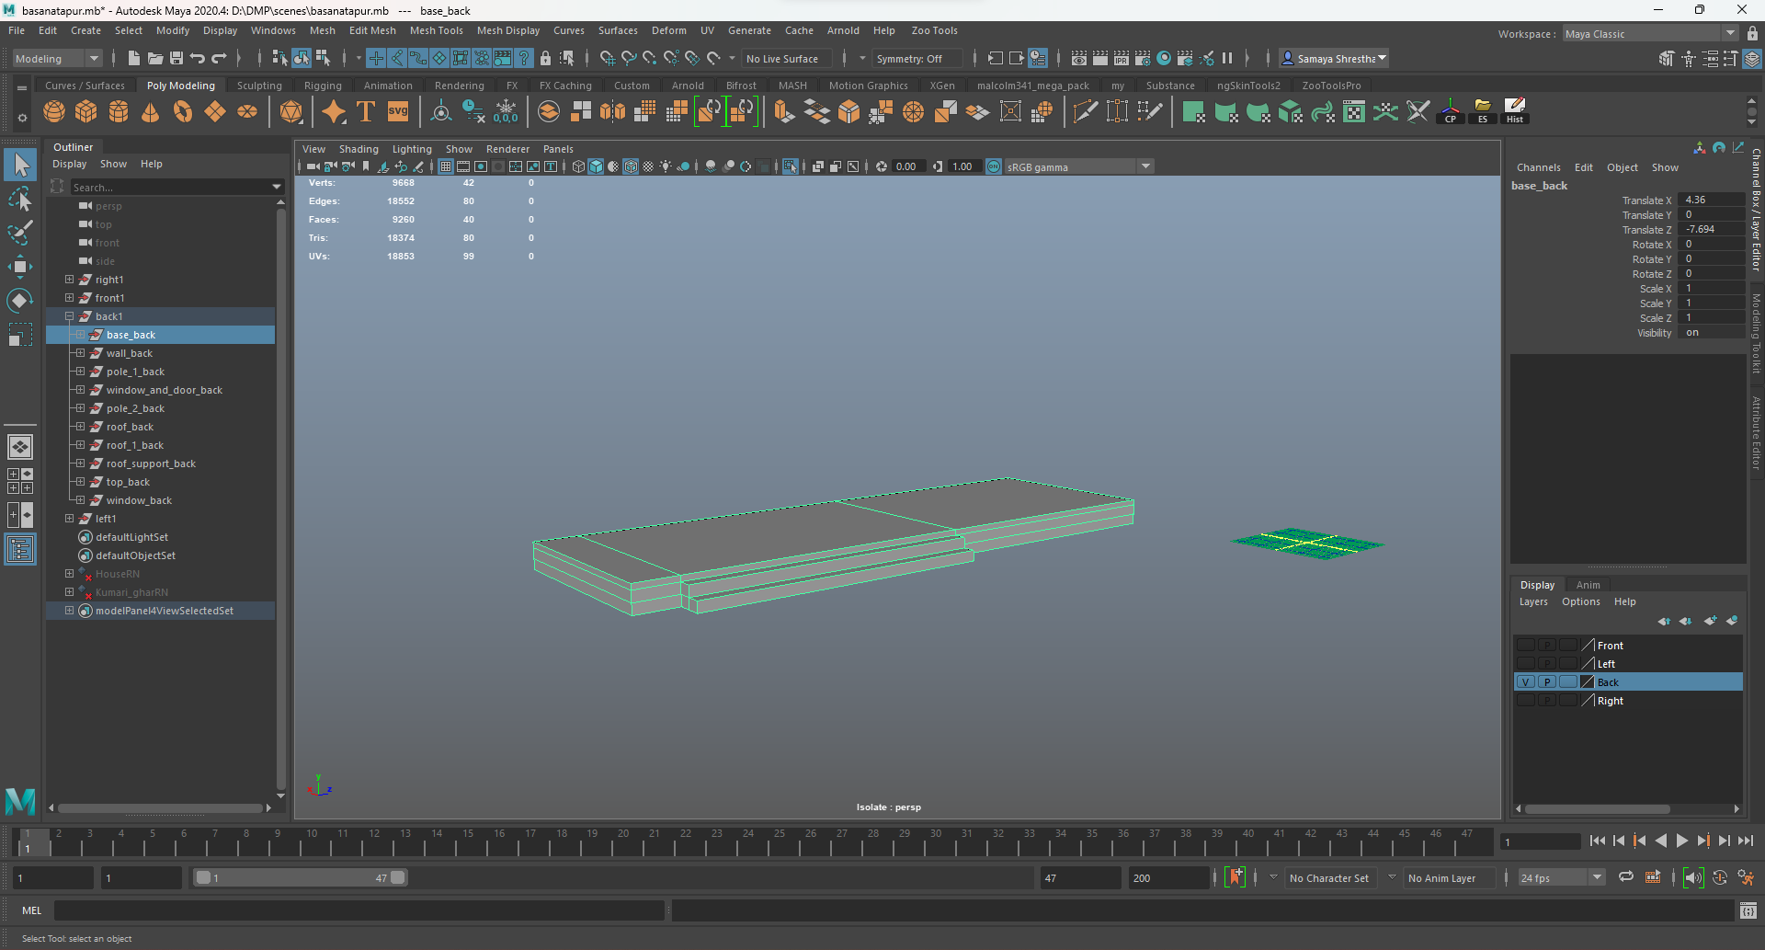

Figure : Creating base.

Then the body of the architecture was made using the cubes. After the body was made the poles in the architecture were made, duplicated, and placed.

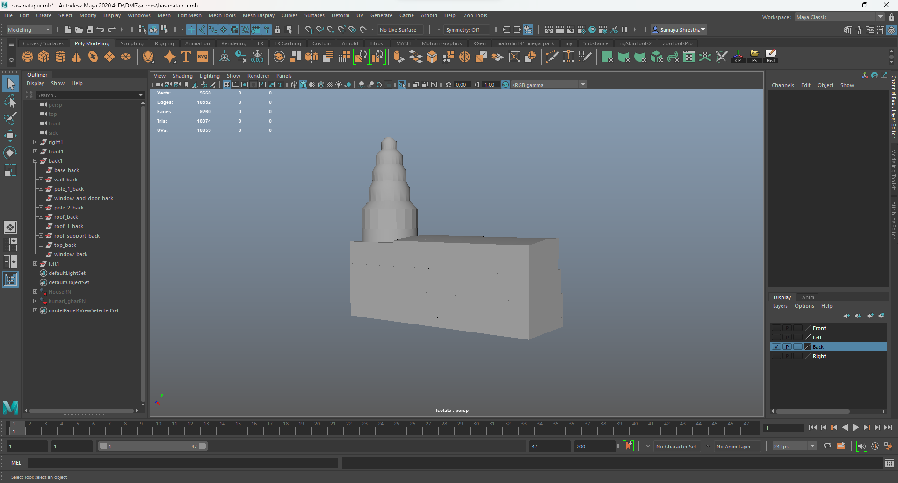

Figure :Creating the body.

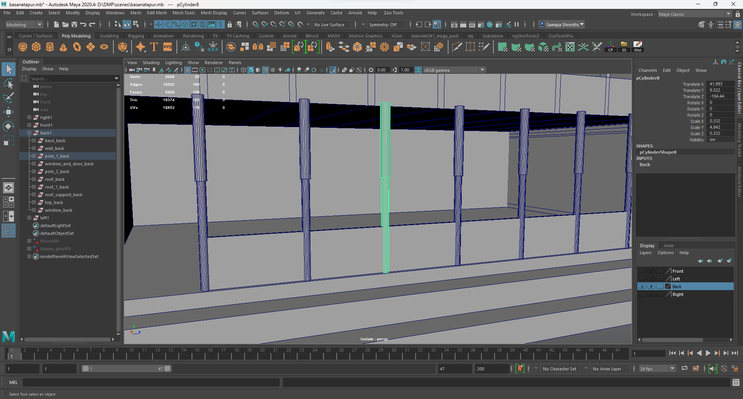

Figure : Adding poles.

Along with the pole the doors and windows were also made. Then the roof of the architecture was made.

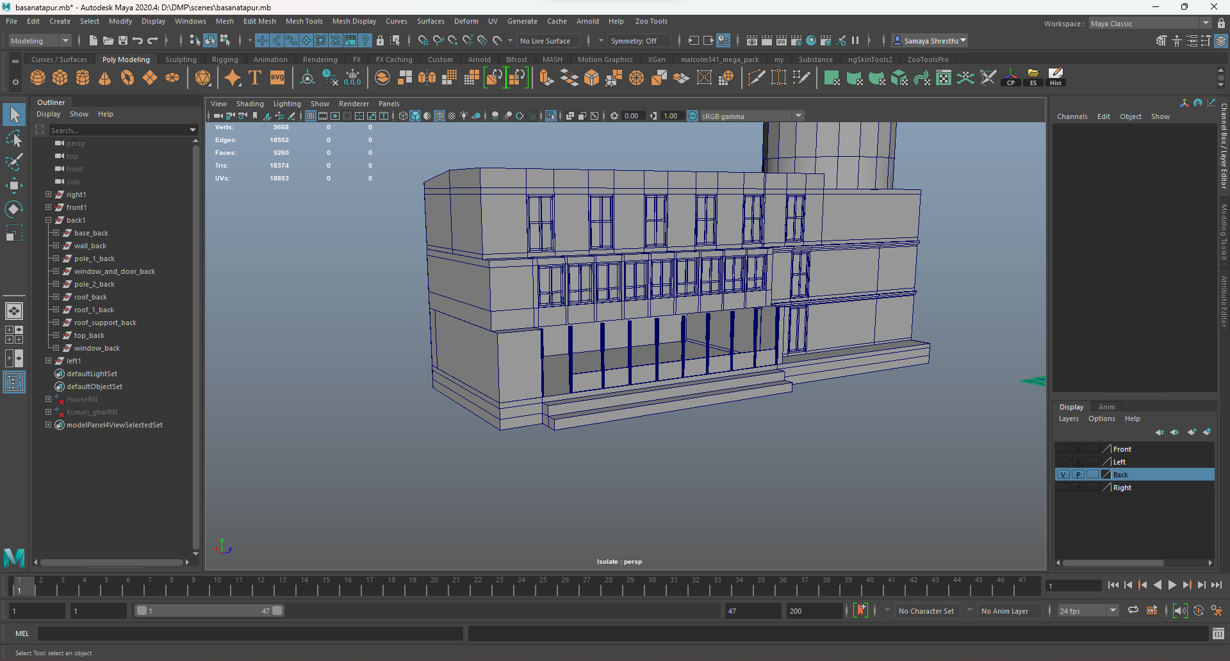

Figure : Creating and placing door and windows.

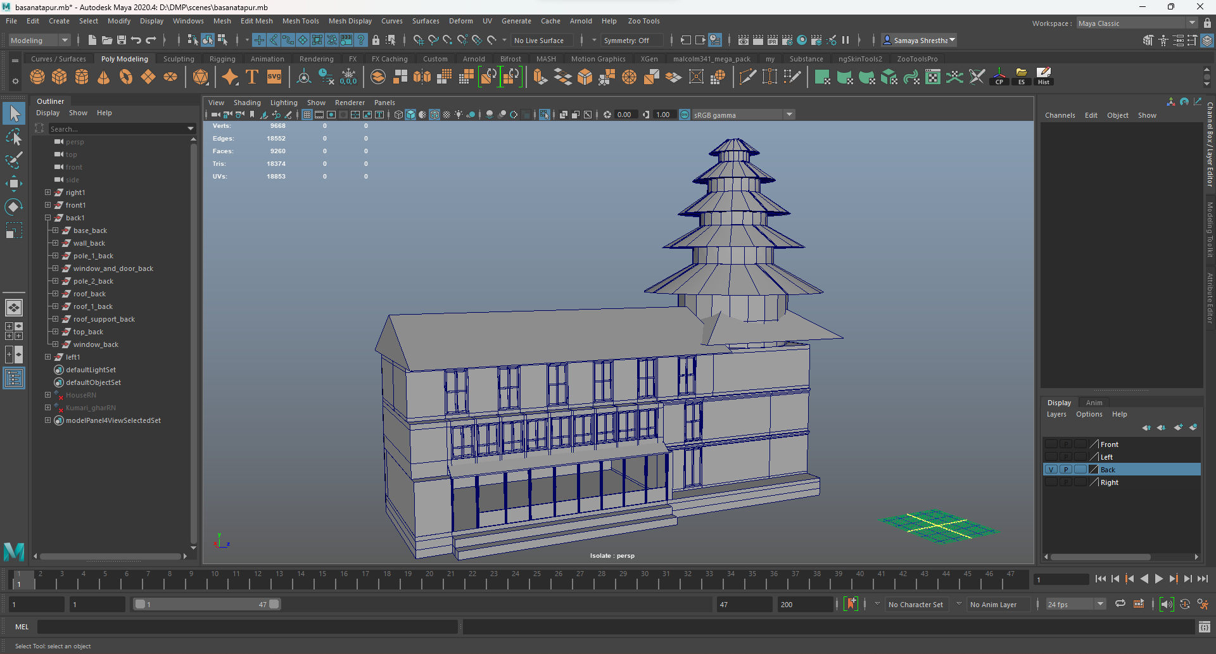

Figure : Creating roof.

After the roof was made the supports to the roof were made and placed according to the reference. The balcony was along made using cubes. The pole which was previously made were duplicated and placed as they were similar.

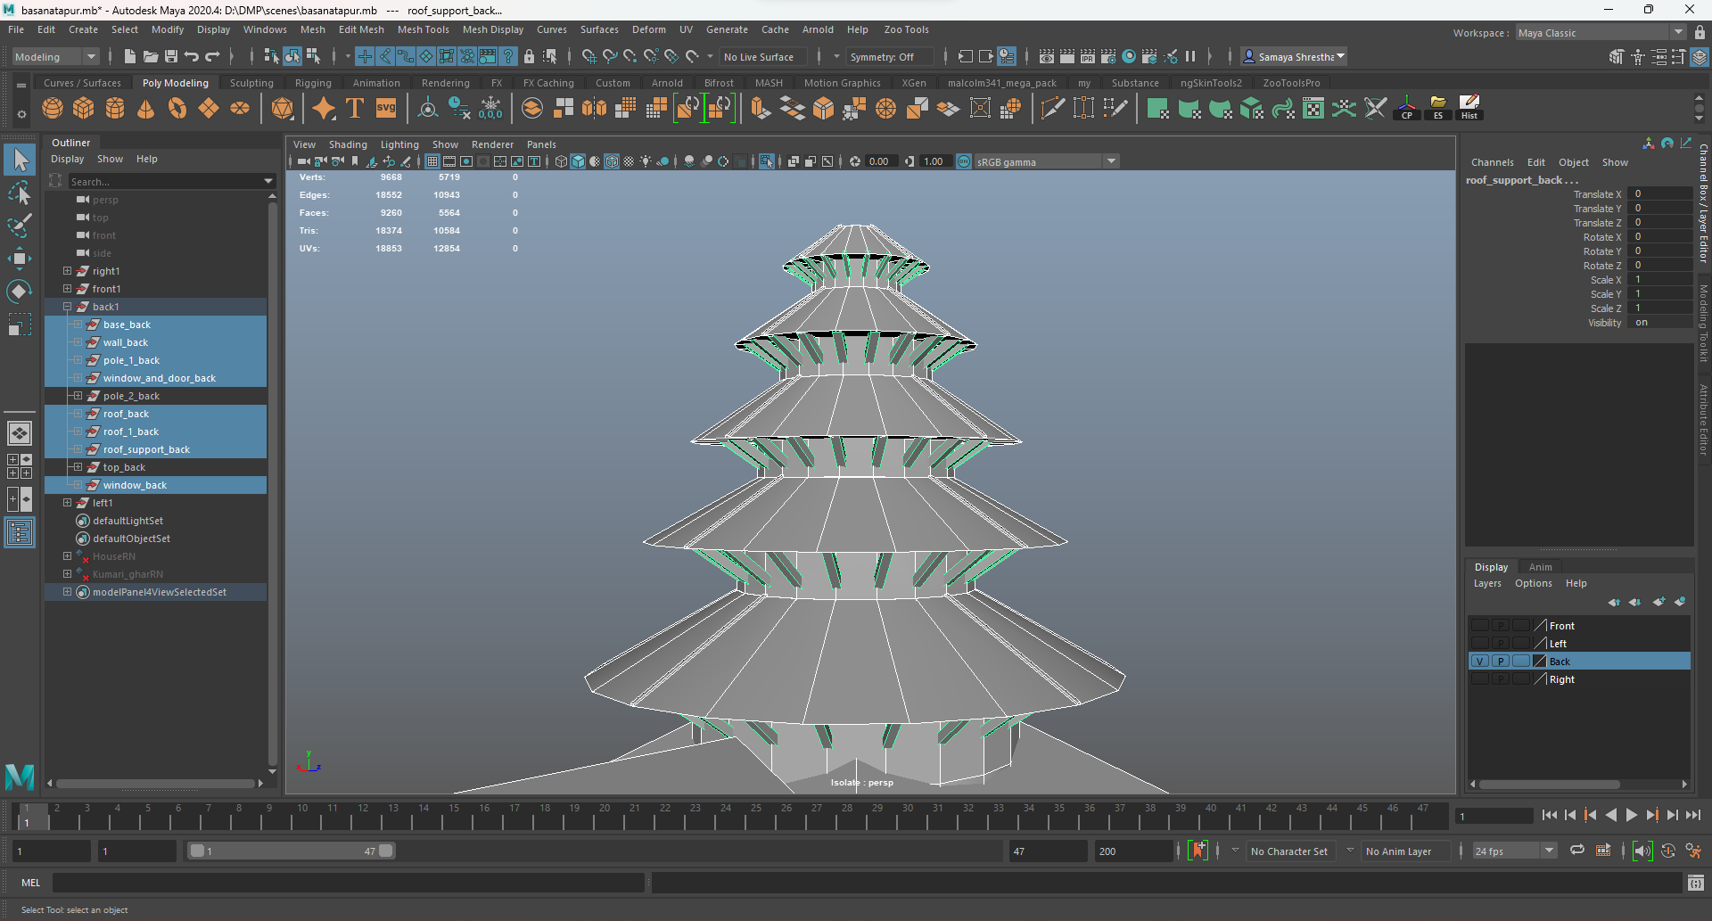

Figure : Creating and placing roof supports.

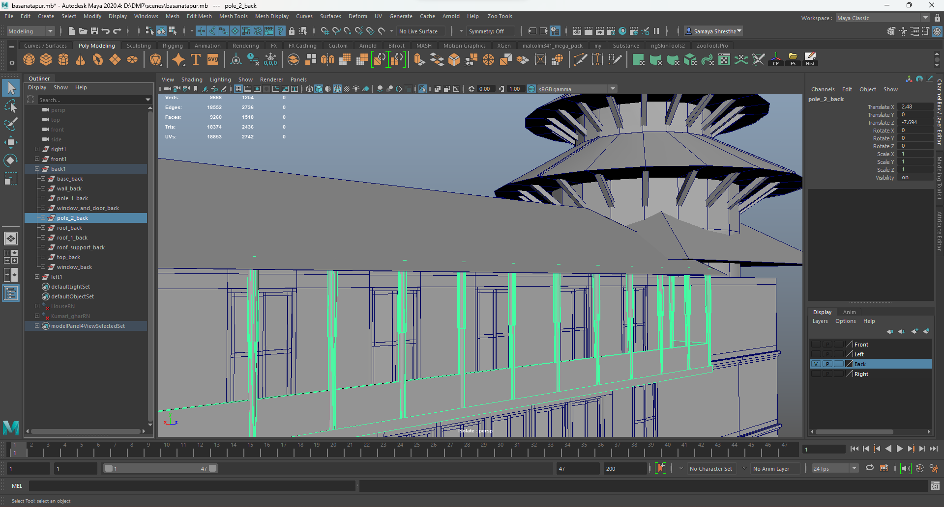

Figure : Creating balcony and adding poles.

At the end, the top of the architecture was made. Thus, the structure was completed.

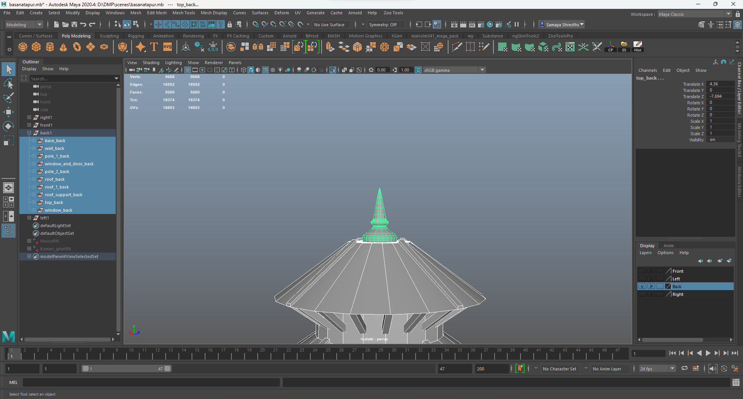

Figure : Creating and placing top

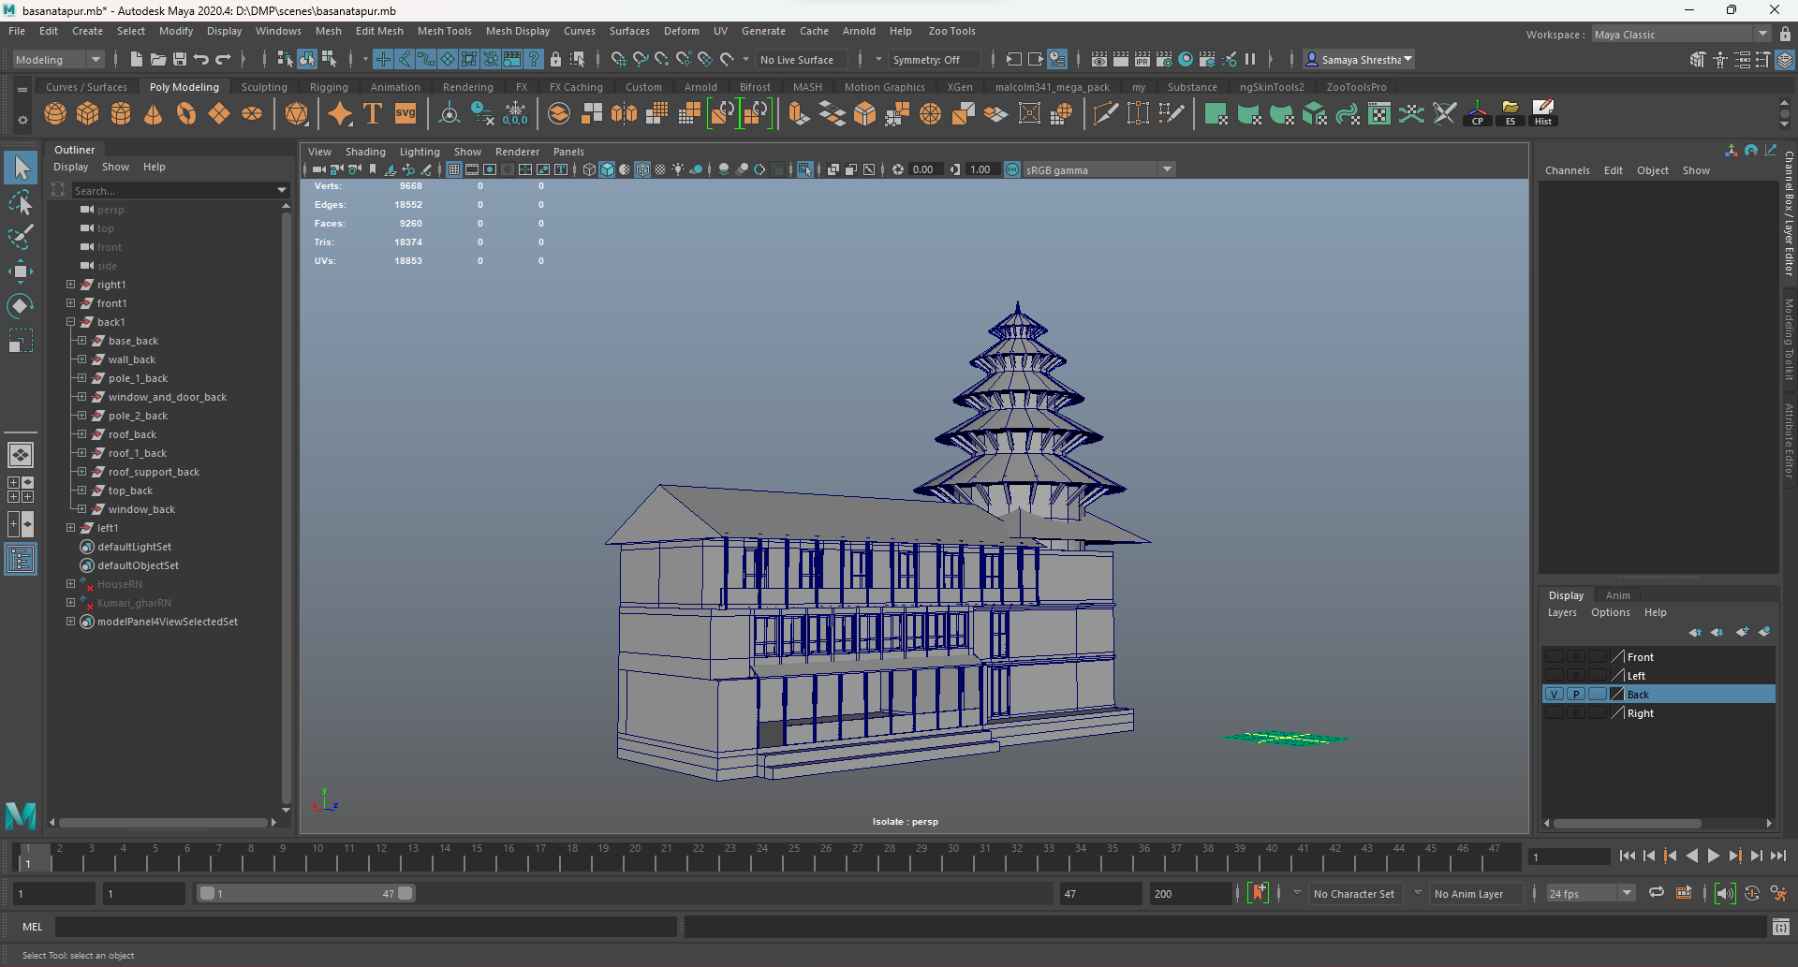

Figure : Completed structure

Third the left part of the model was made. The base of the architecture was made first. Then the body of the architecture was made.

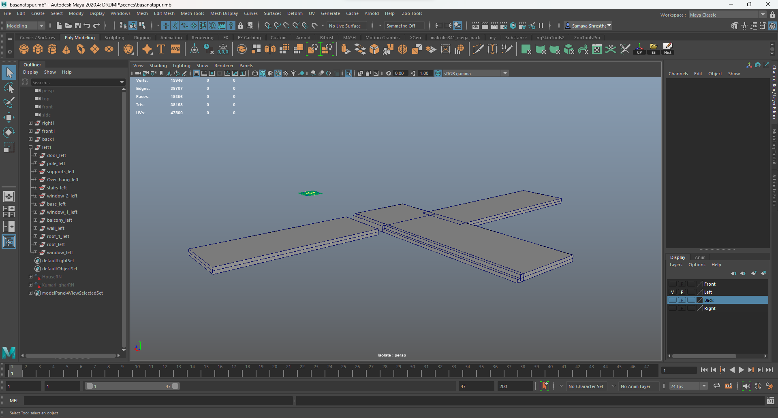

Figure : Creating and placing the base.

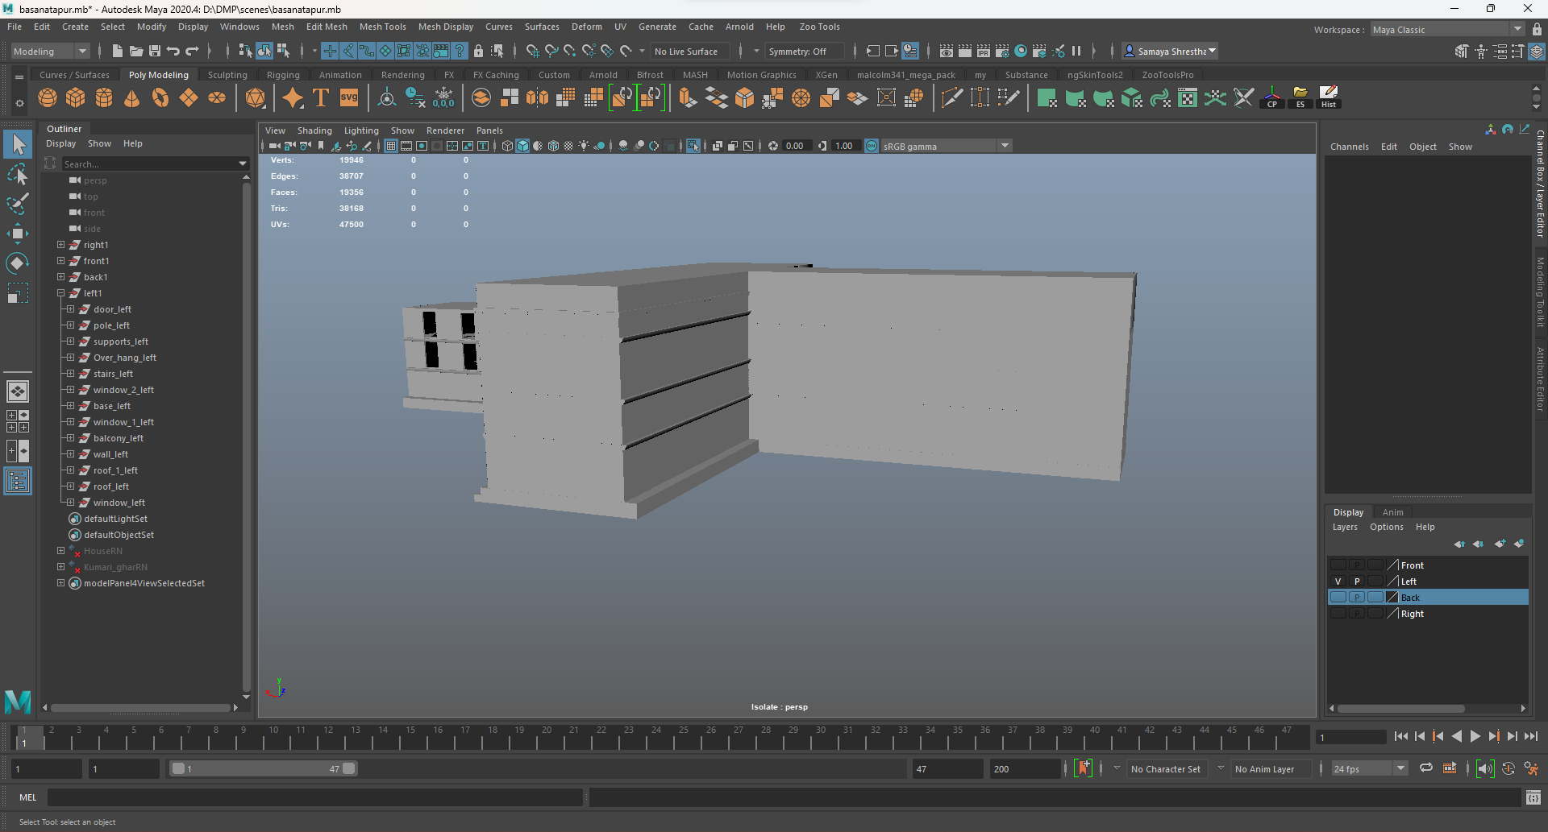

Figure : Creating and placing the body.

After that doors and windows were made.

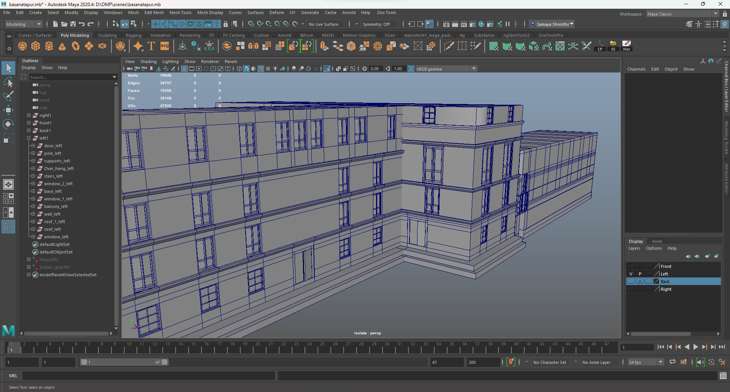

Figure : Placing the windows and doors.

After the body was made the overhang and the balcony was made and placed.

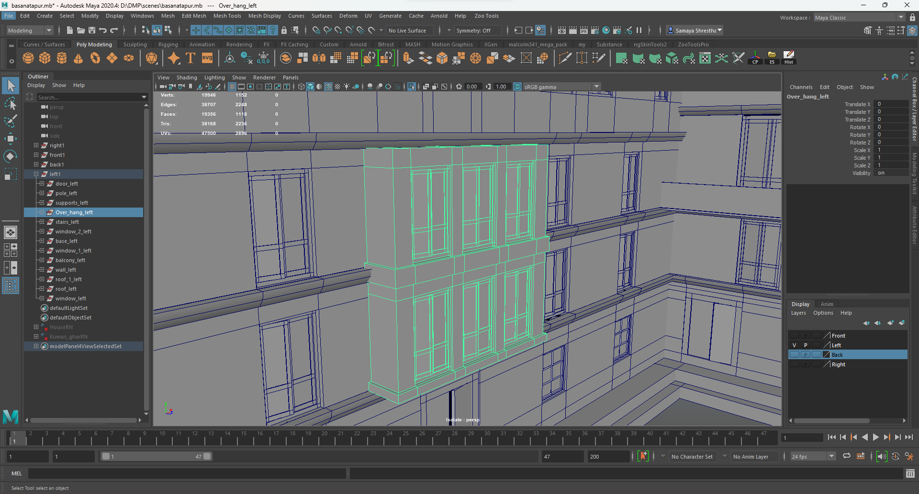

Figure : Creating and placing over hangs.

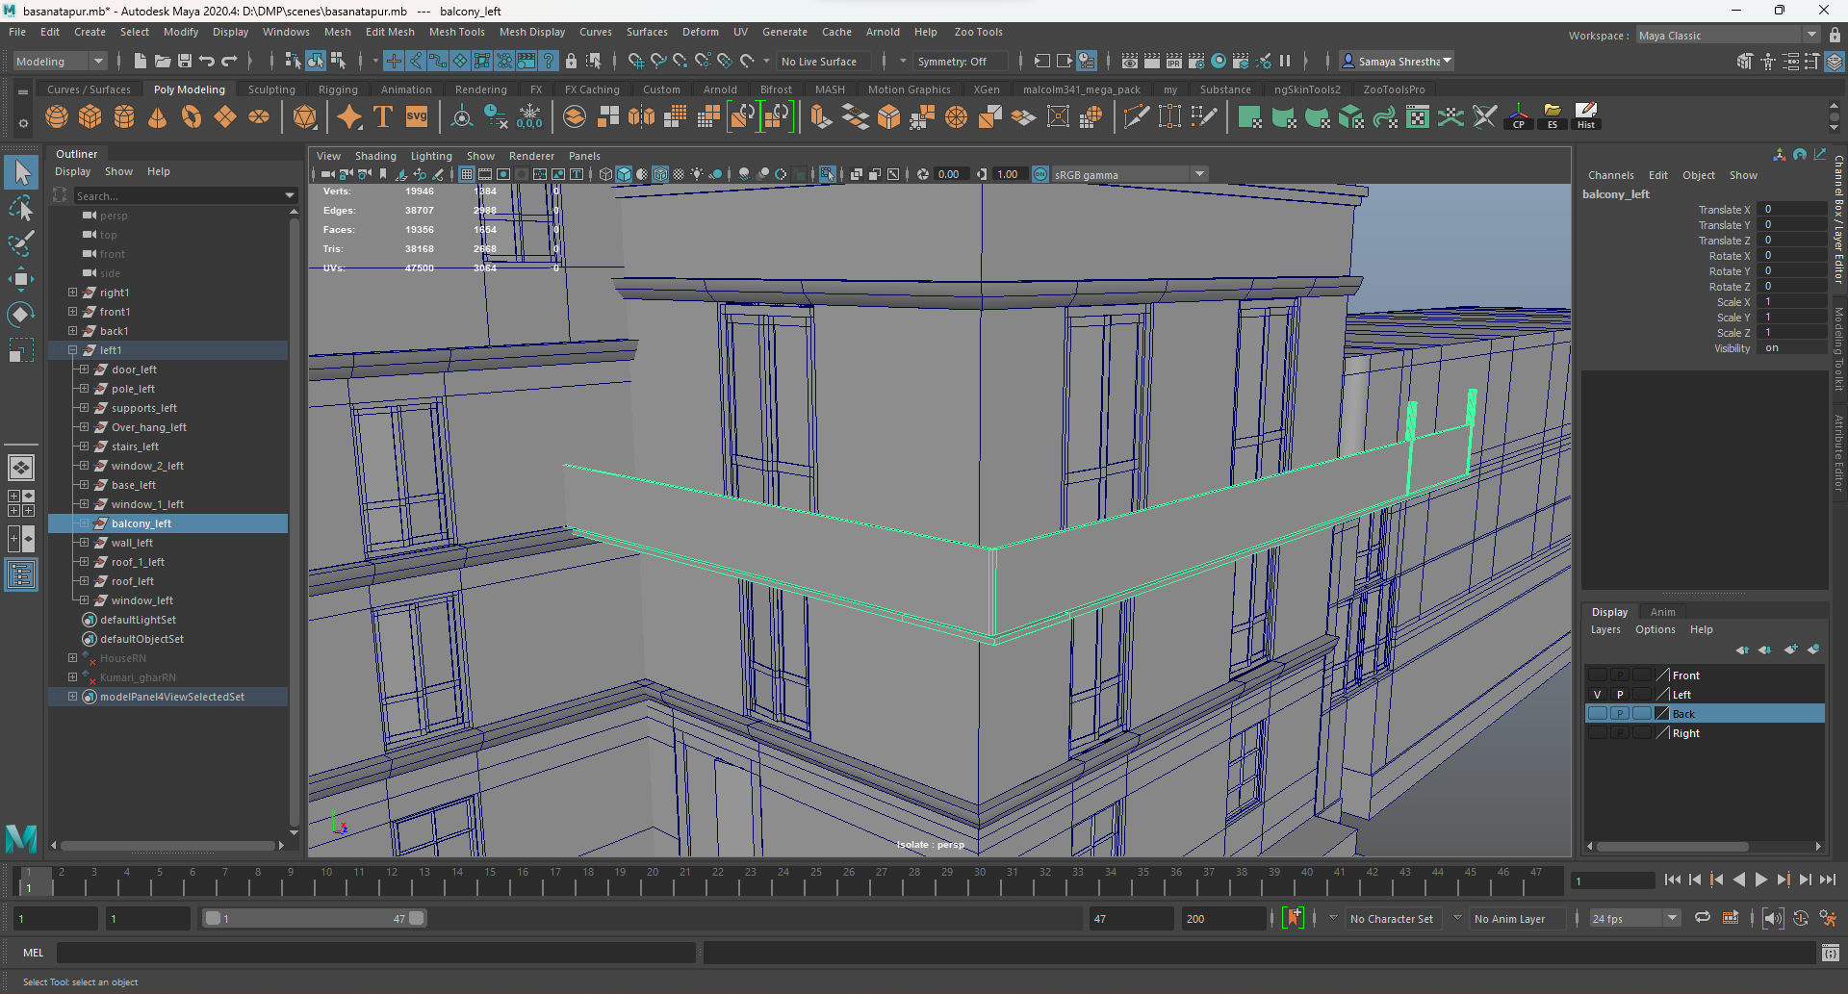

Figure : Creating and placing balcony.

Then the roof of the architecture was made. After the roof was made the supports to the roof according to the reference.

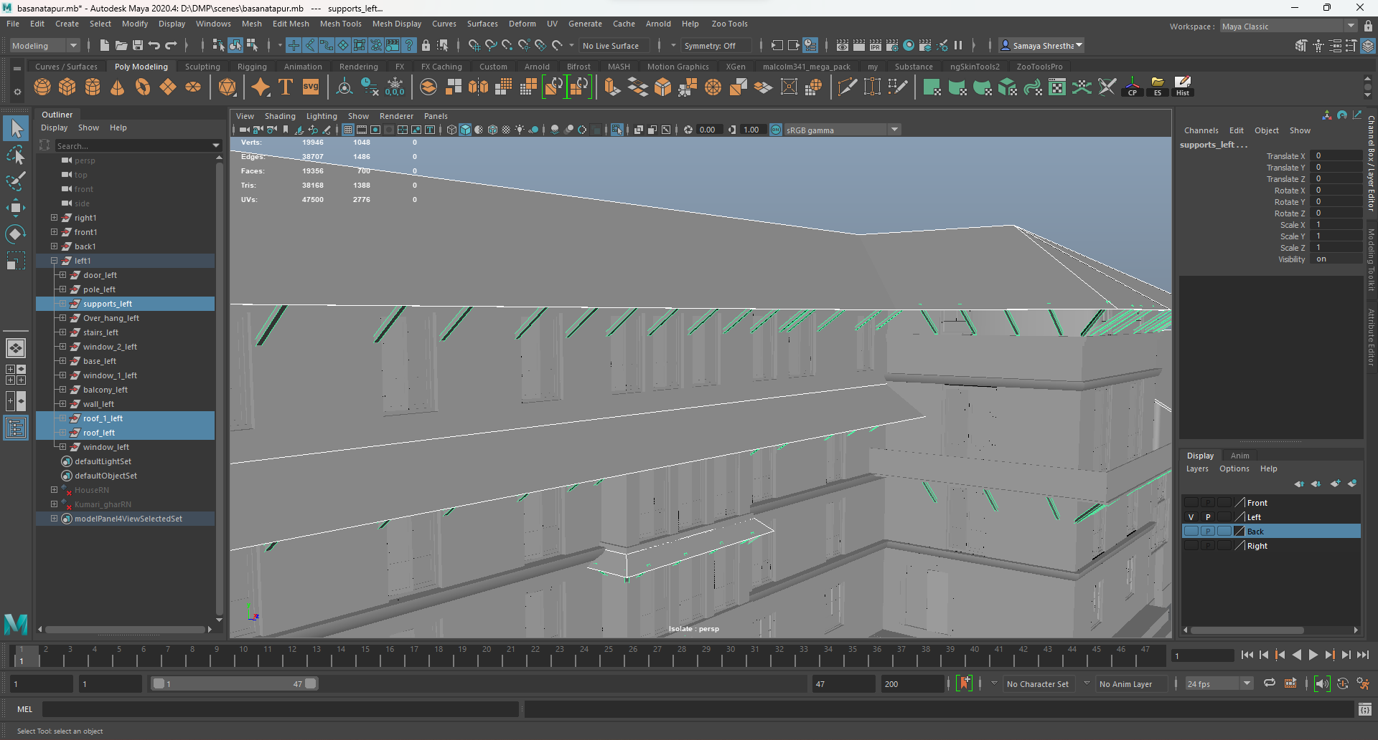

Figure : Creating and placing roof and supports.

After that poles and stairs were made and placed.

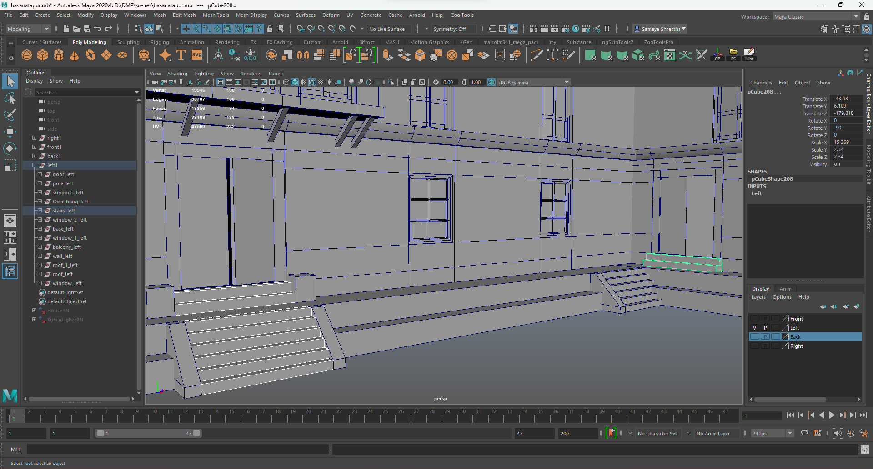

Figure : Creating and placing stairs.

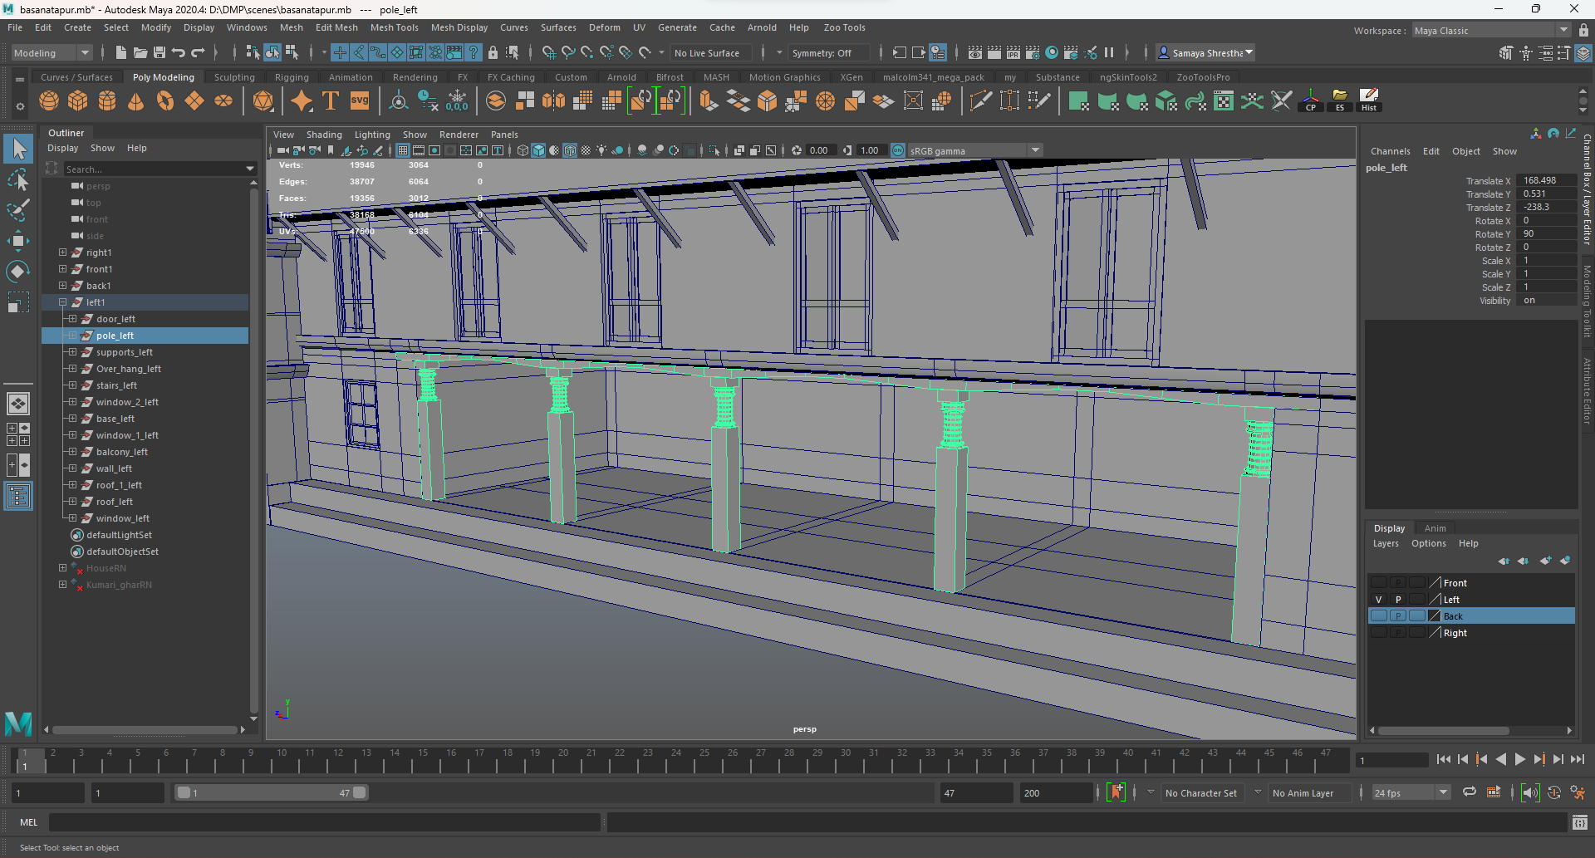

Figure : Creating and placing poles.

Thus, the structure was completed.

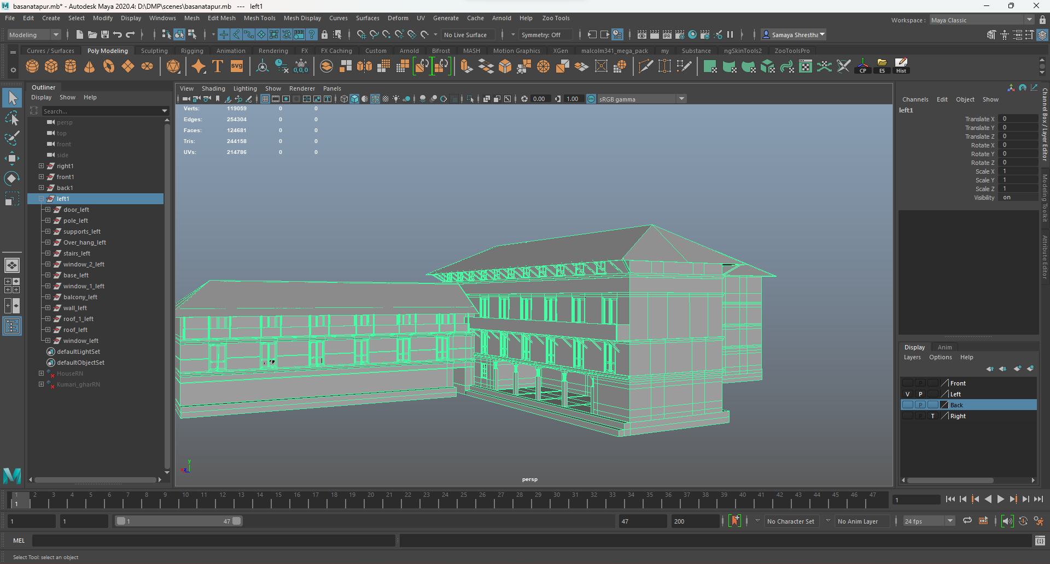

Figure : Completed structure.

Fourth the front part of the model was made. Similar to the other models the base of the architecture was made. Then the body of the architecture was made.

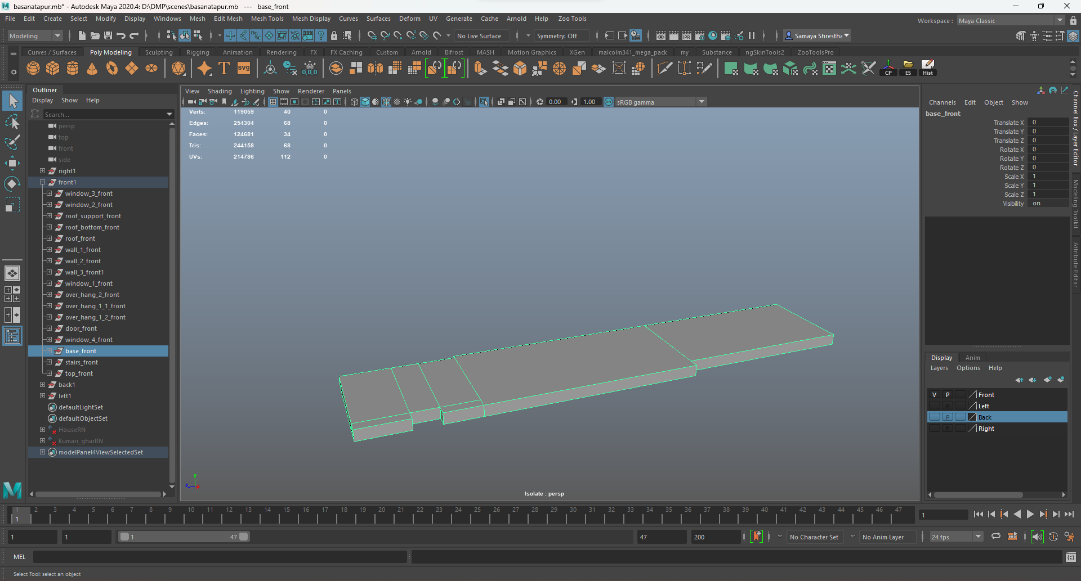

Figure : Creating base.

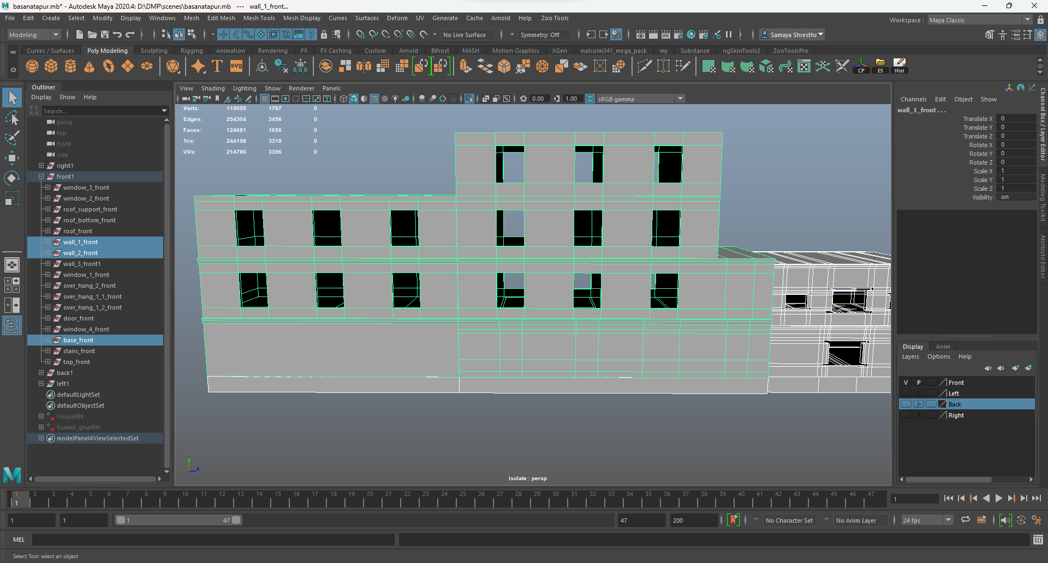

Figure : Creating and placing body.

After the body was made bottom part of the roof was made along the roof.

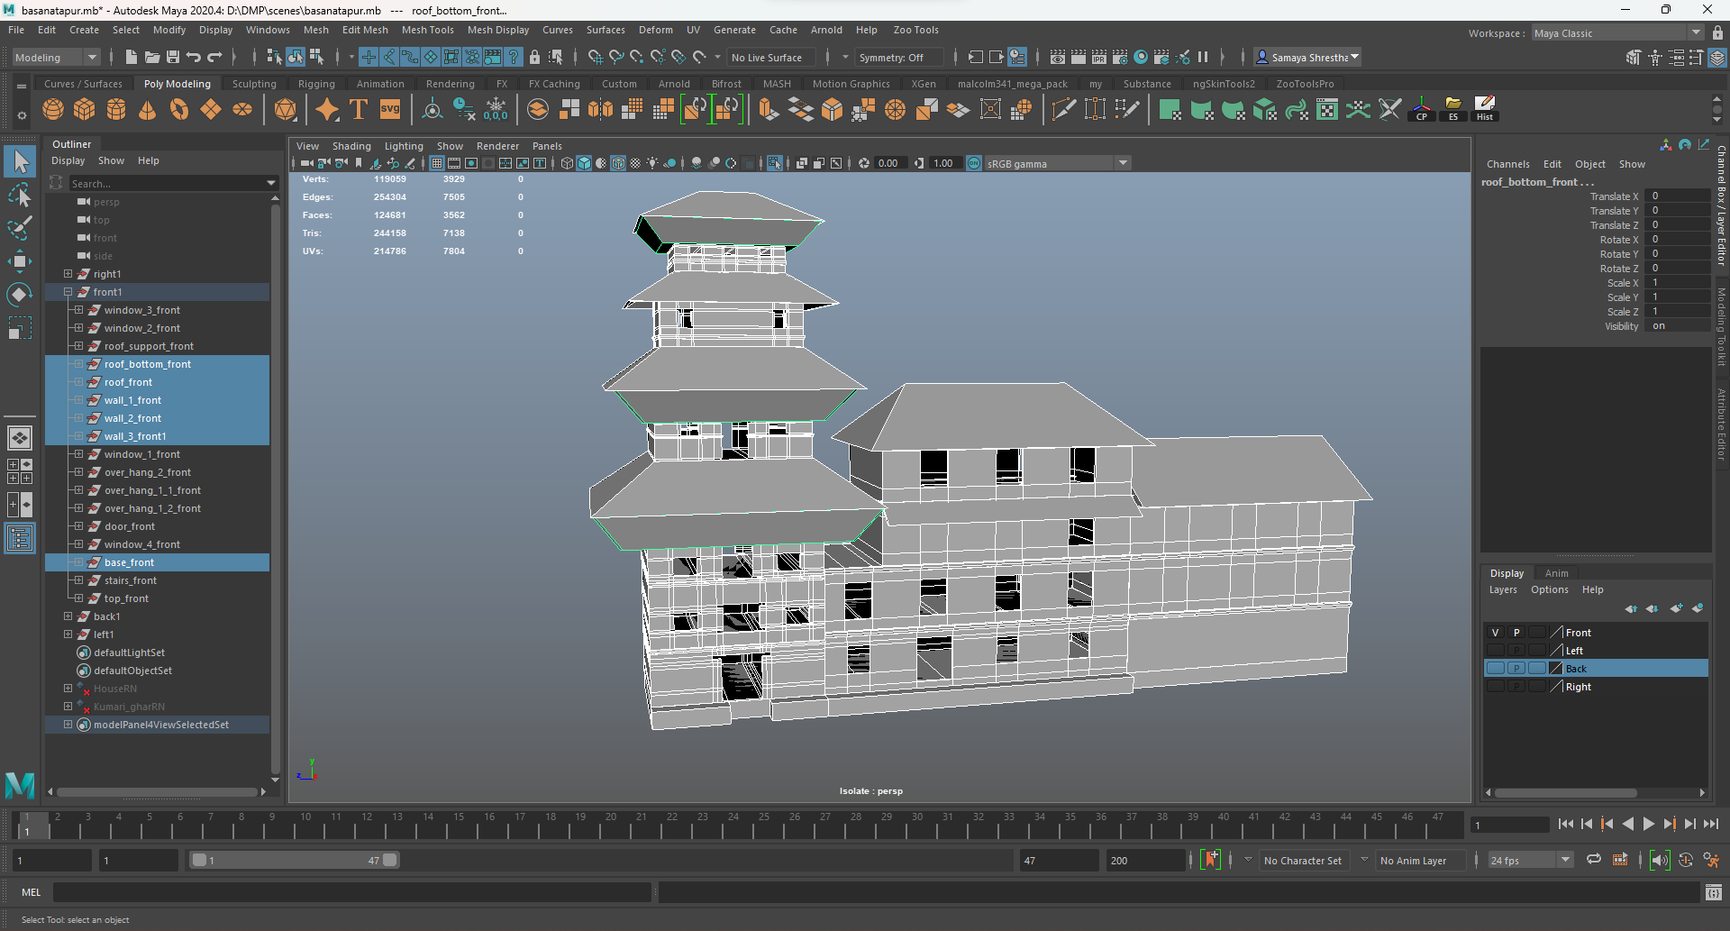

Figure : Adding roofs.

After the roof was made the overhang of the building was made.

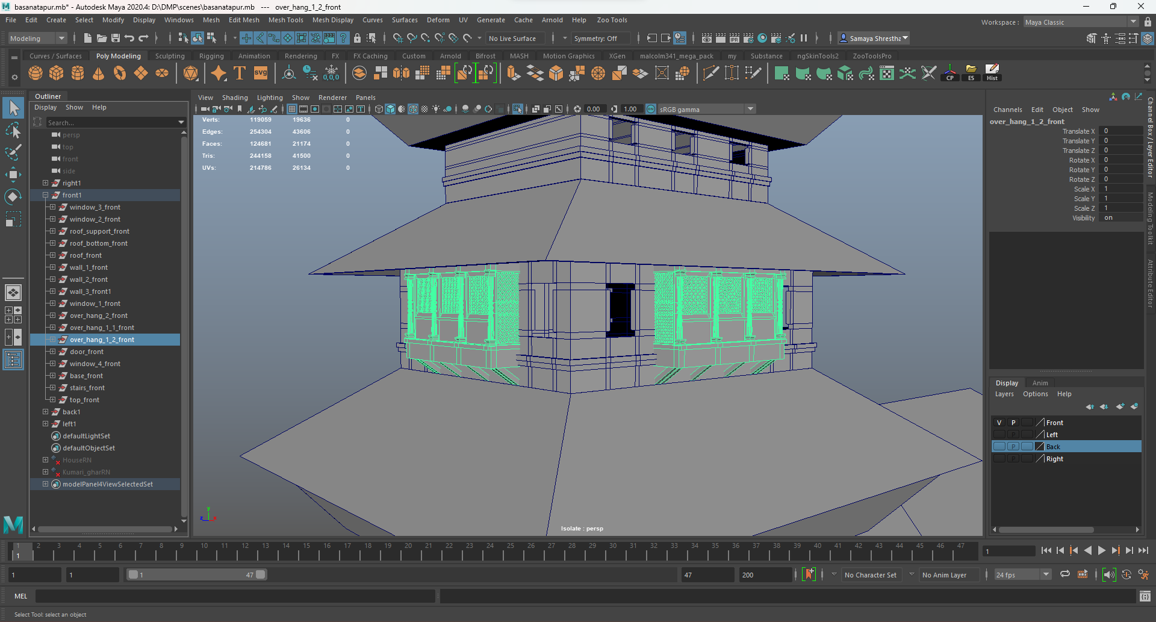

Figure : Creating and adding overhang 1.

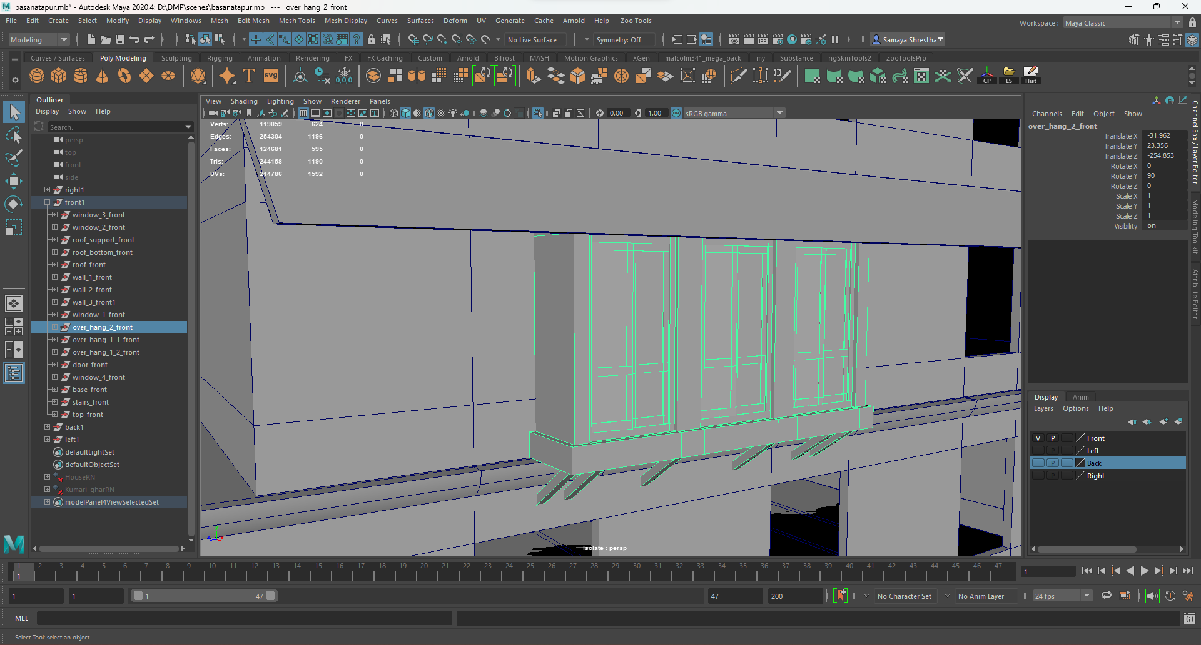

Figure : Creating and adding overhang 2.

Then the windows were made along with the door were made. Then the roof supports were made.

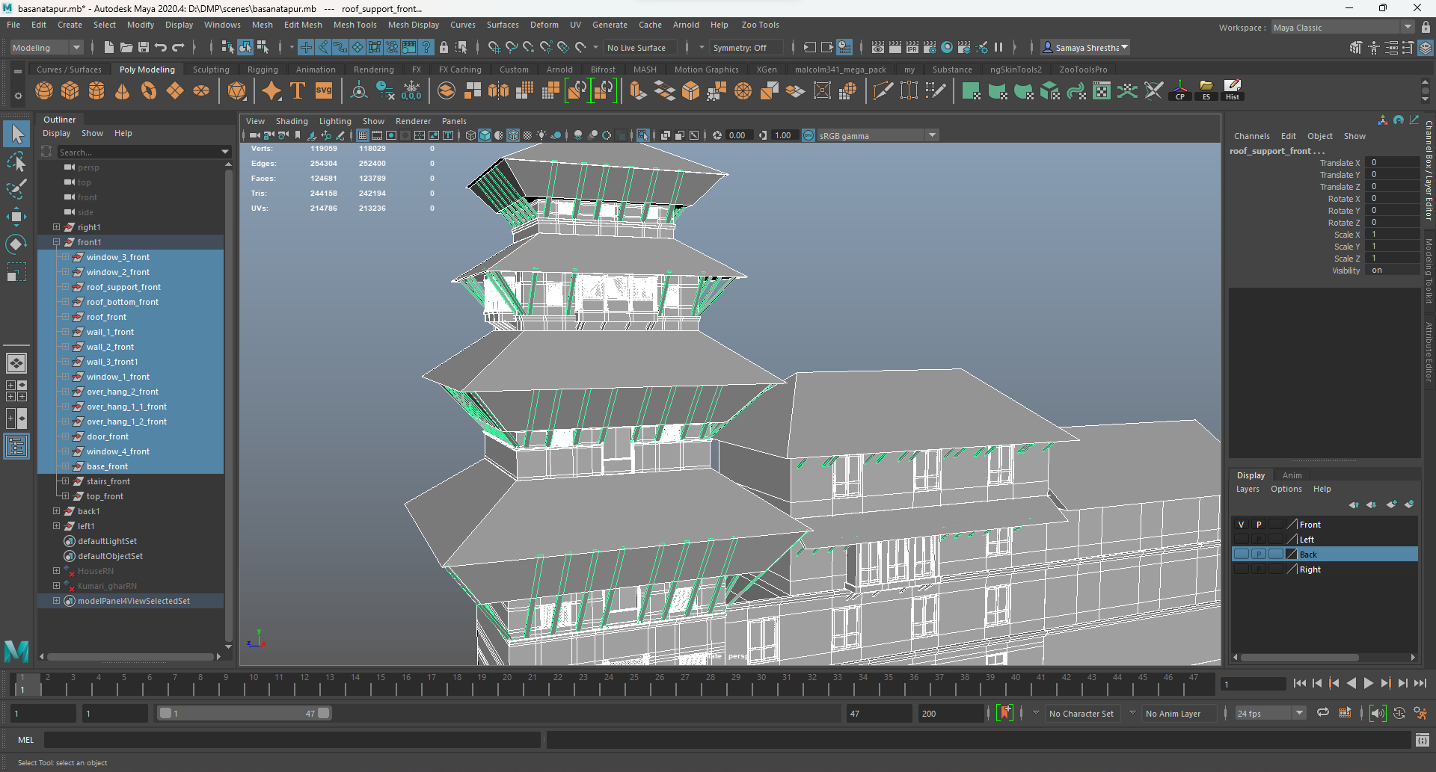

Figure : Adding roof supports.

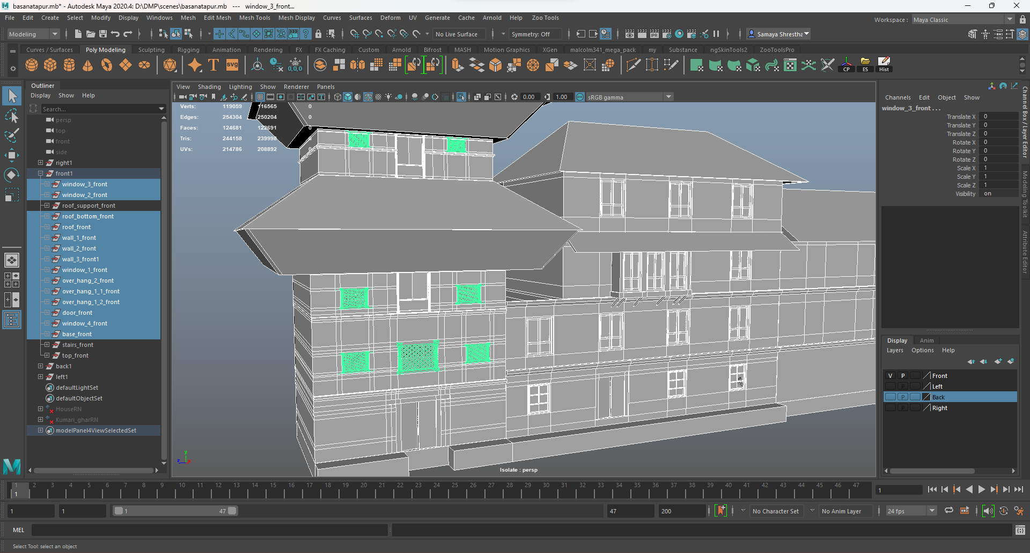

Figure : Adding windows.

At last, the top of the architecture was made along with the stairs.

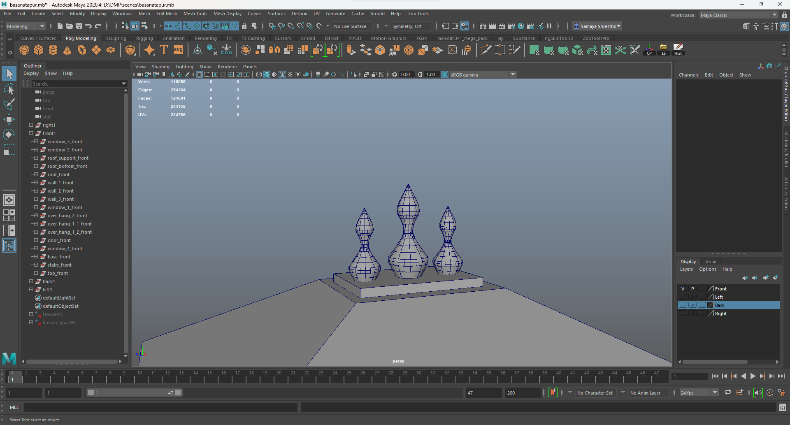

Figure : Creating the top.

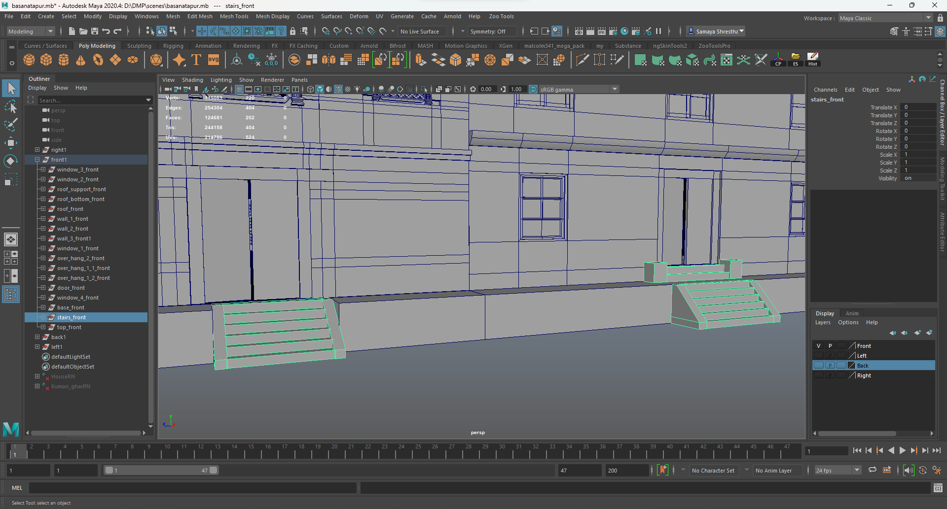

Figure : Creating the stairs.

Thus, the structure was completed.

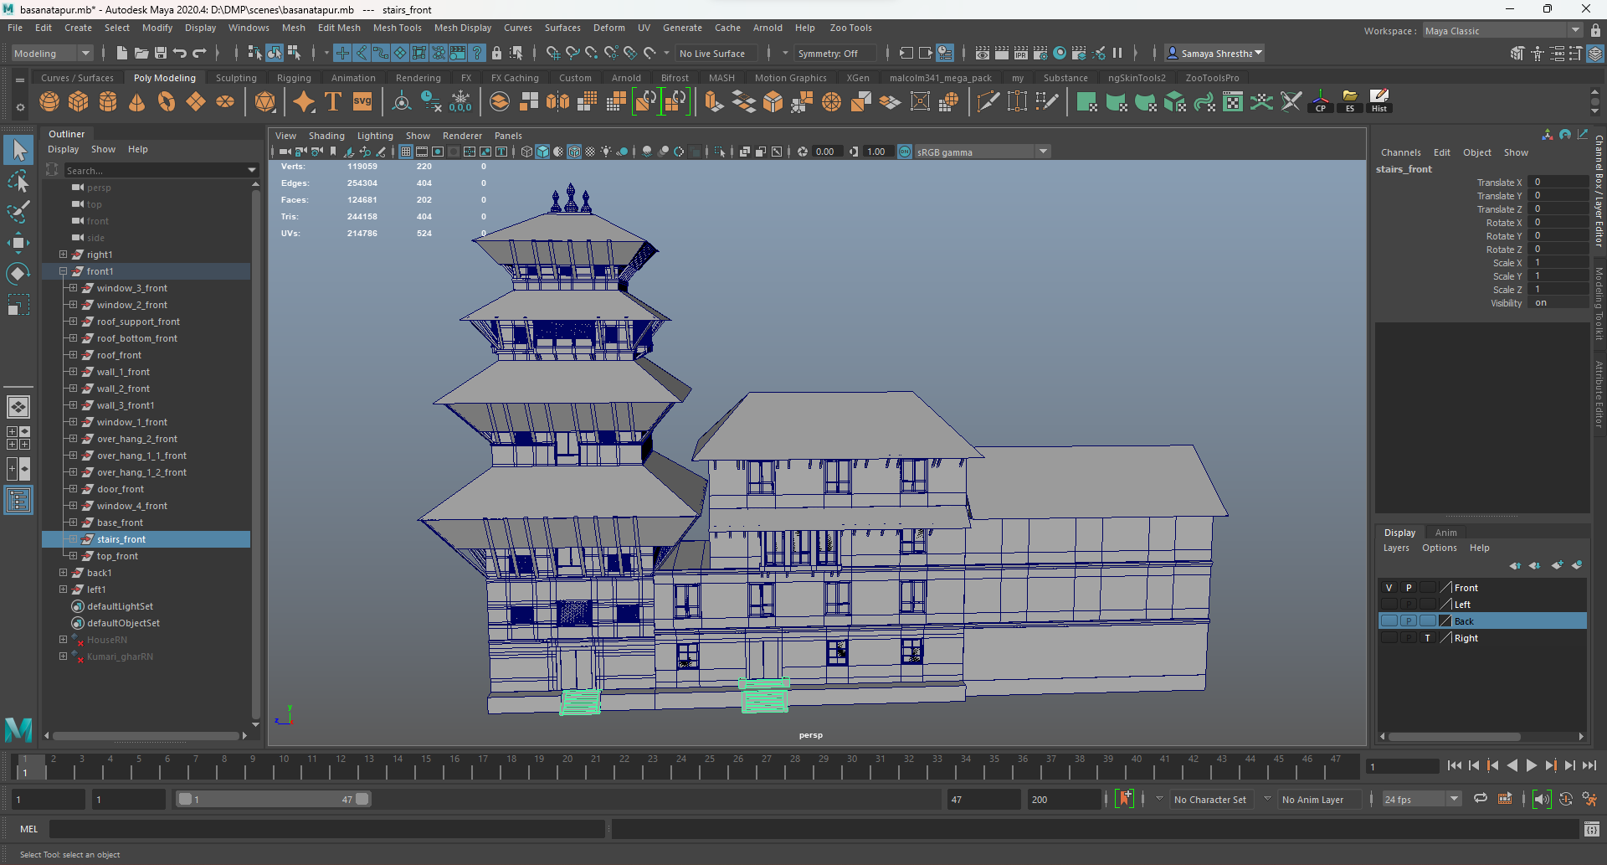

Figure :Completed structure.

#### Houses

For the houses firstly a cube was taken, and a rectangular shape of the house was given. It was duplicated and placed on top of the previous one.

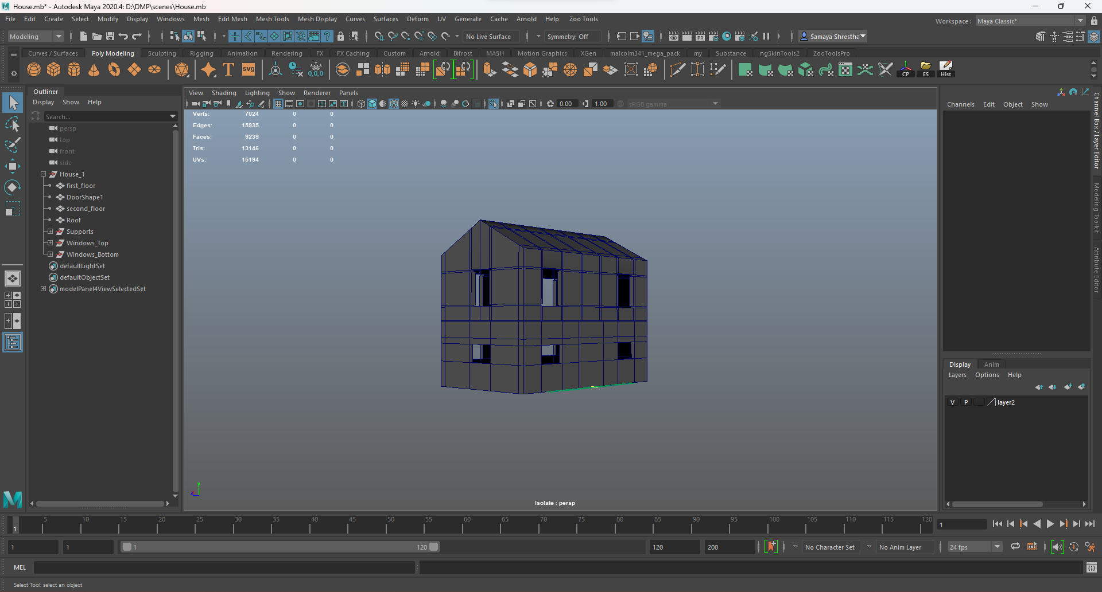

Figure : Creating the body of the house

Then the roof was created using a new cube which was subdivided into two from the middle making it easy to give the center and pull it up to give it the shape of the roof.

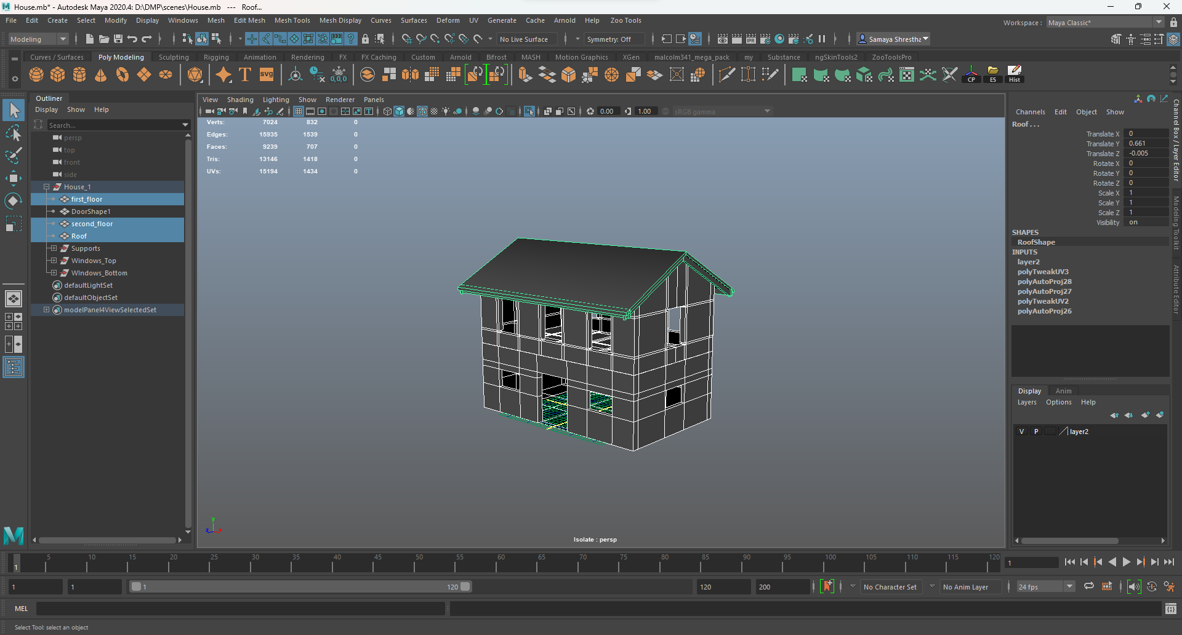

Figure : Creating and placing roof.

Windows were designed using the same methods as before using cubes. There were three to four types of windows in the house. As there are different designs some of the steps in the process were different. Then they were placed in the structure along with door.

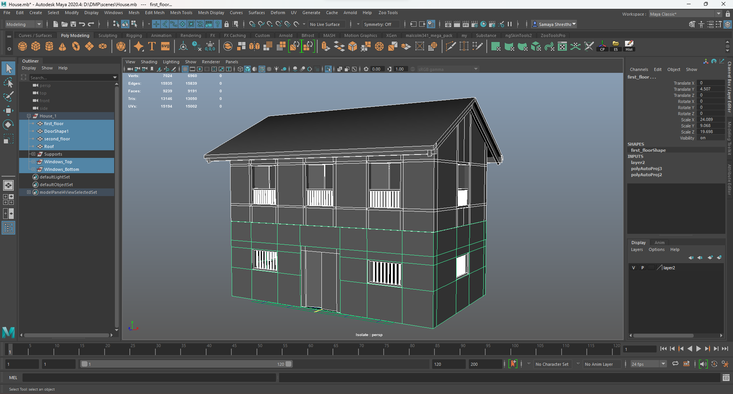

Figure : Creating and placing windows and door

Lastly the supports were made and placed on the structure. Thus, the house was completed.

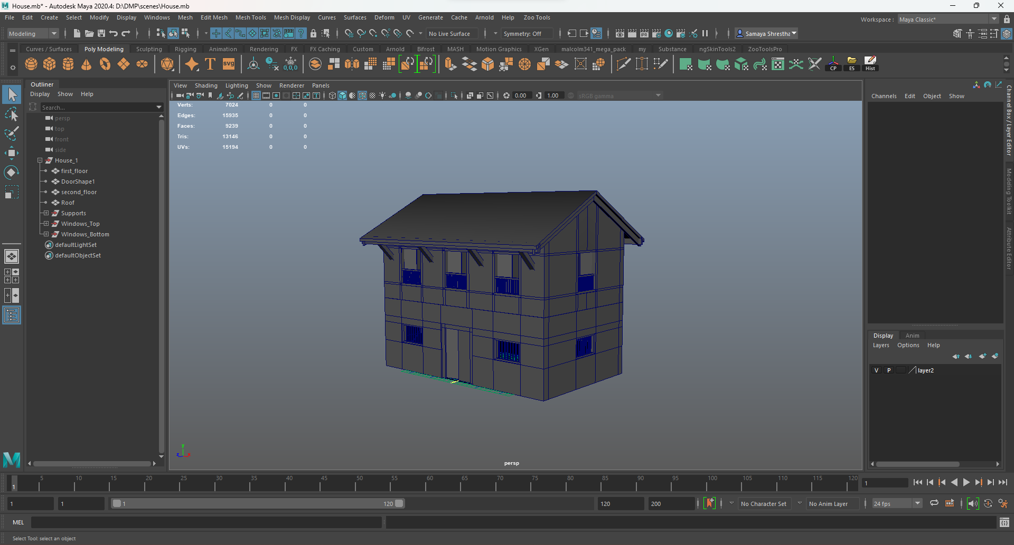

Figure :Completed house.

Other houses were also made using the same process.

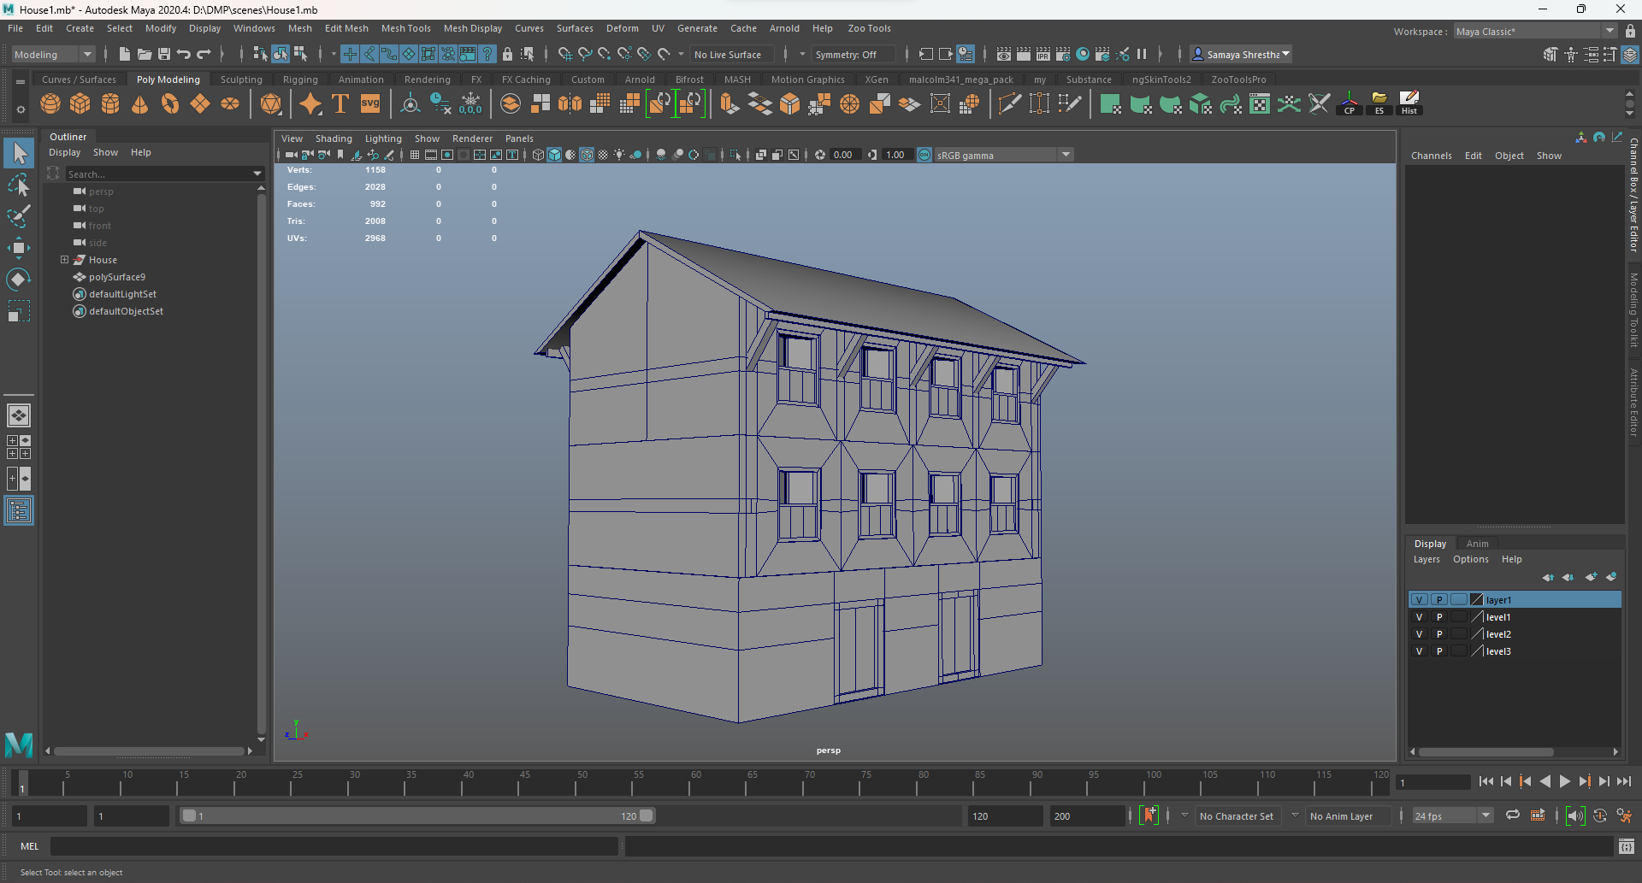

Figure :Completed house 1.

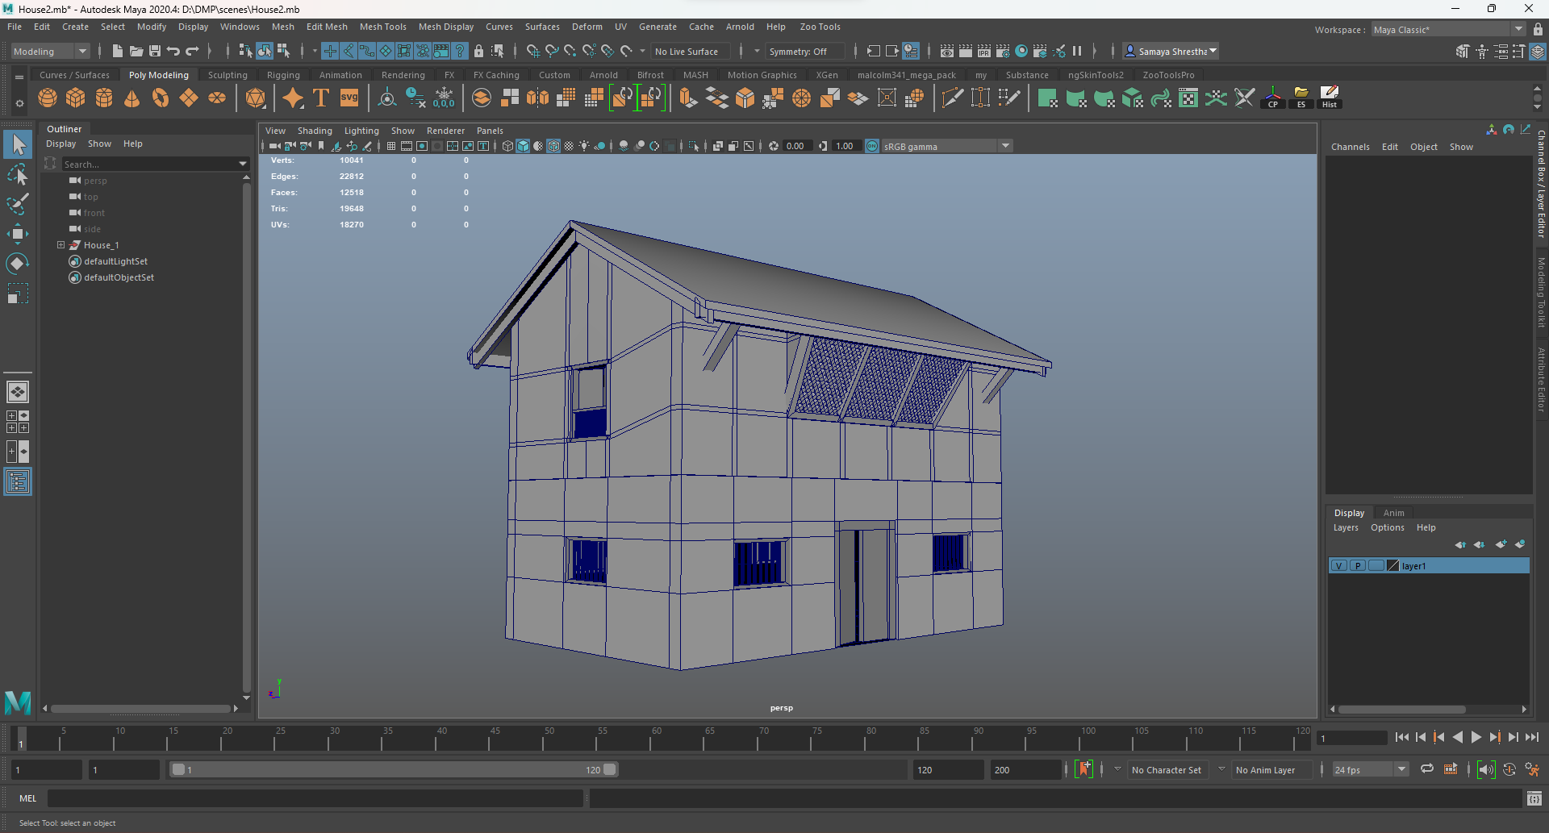

Figure :Completed house 2.

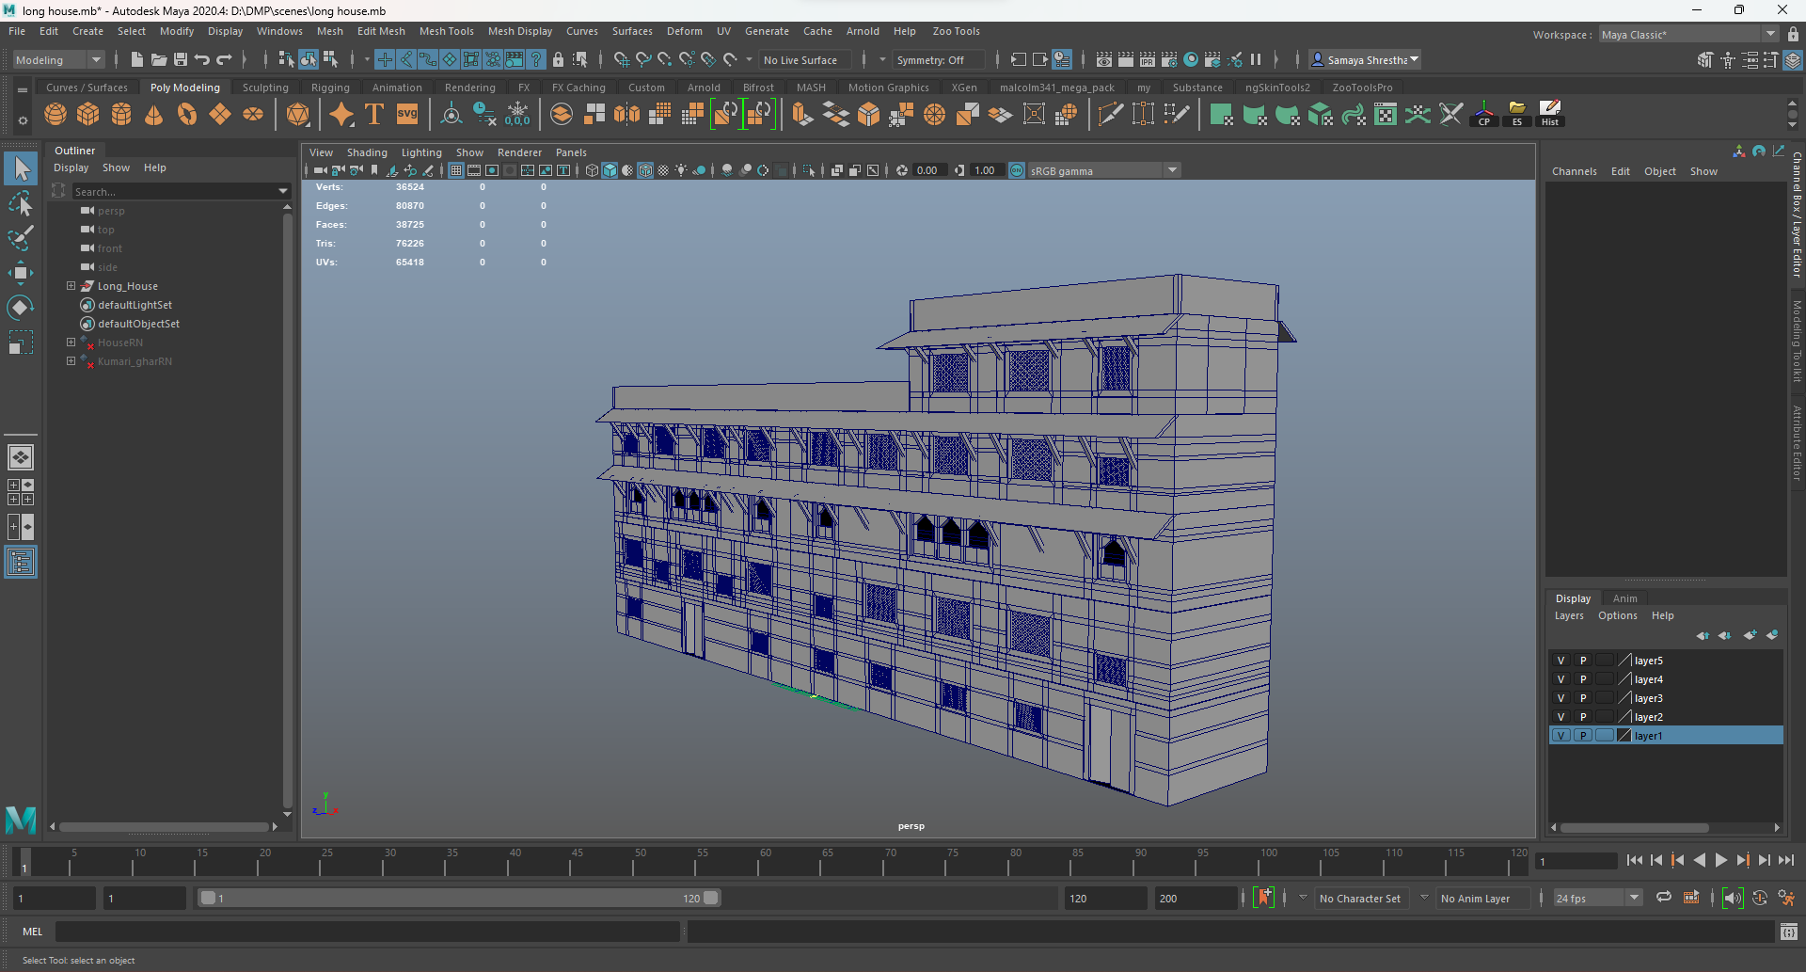

Figure :Completed house 3.

### UV Editing

For properly texturing the models, UV map needs to properly unwrapped. The UV unwrapping is completely done in Maya. Malcolm unWrapper script is used for ease of cutting seams and unwrapping efficiently along with the automatic unwrap in Maya. Most of the uv maps are given below:

#### Gaddi Baithak

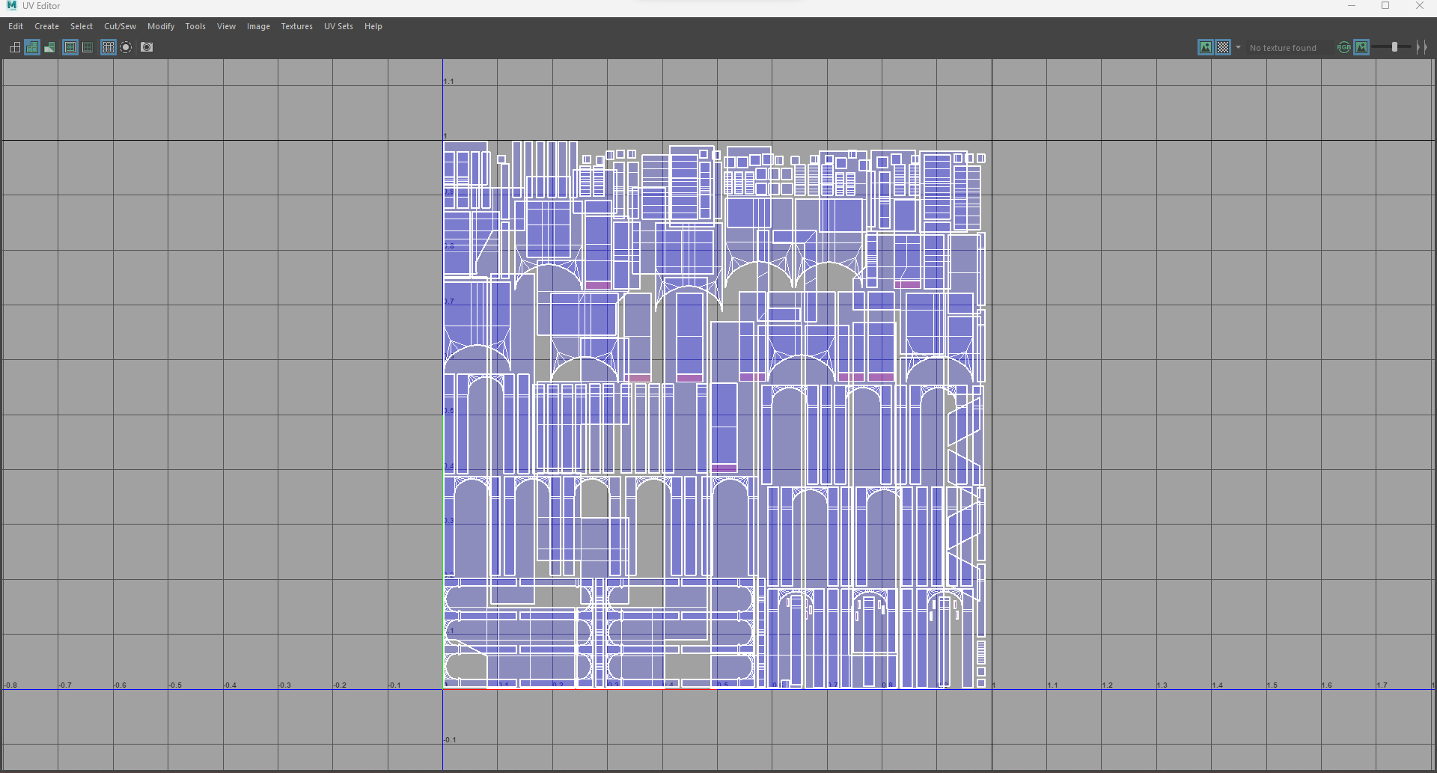

Figure : Uv Map Pillar

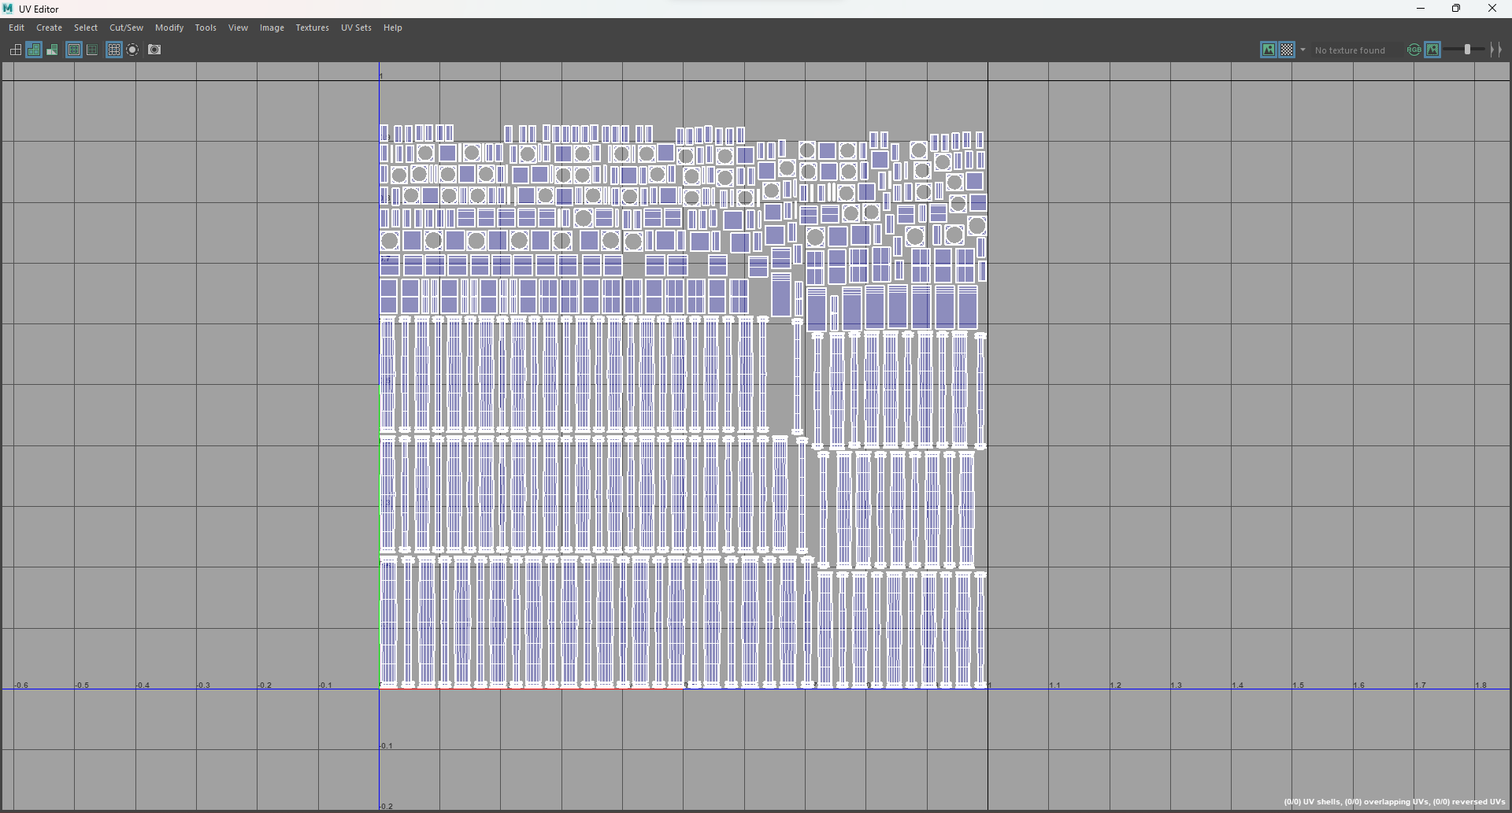

Figure : Uv Map Pole

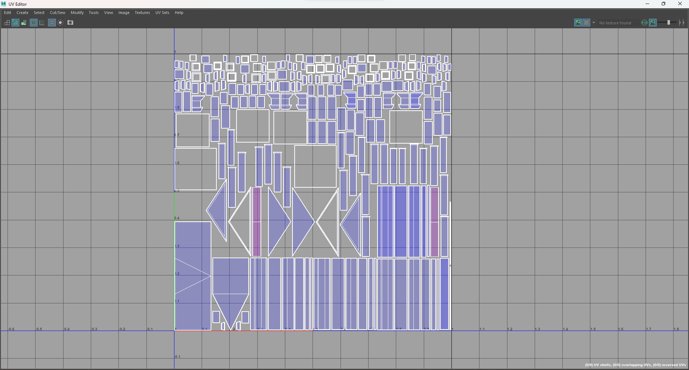

Figure : Uv Map Arch

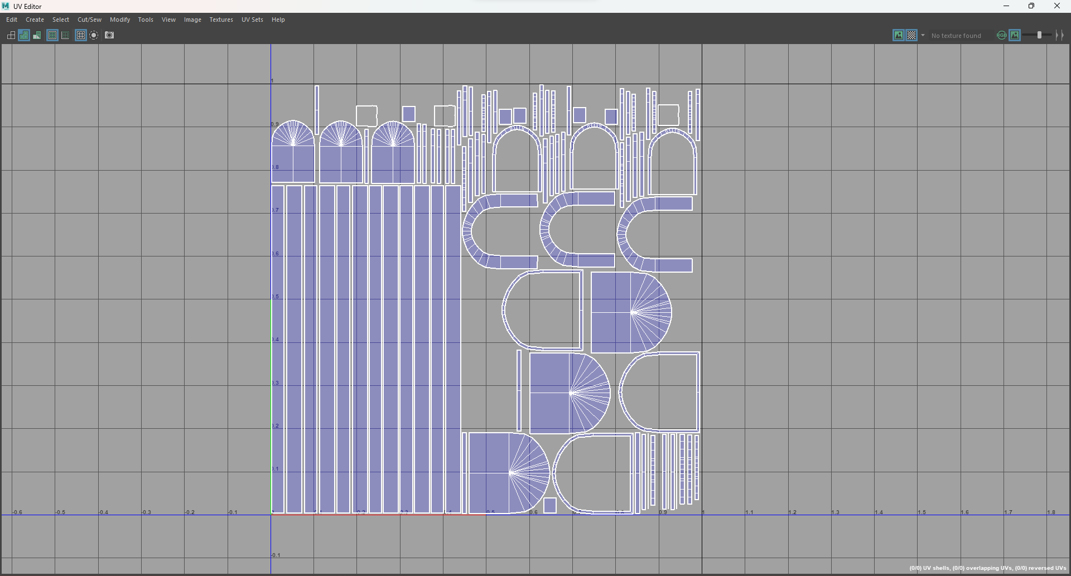

Figure : Uv Map Window

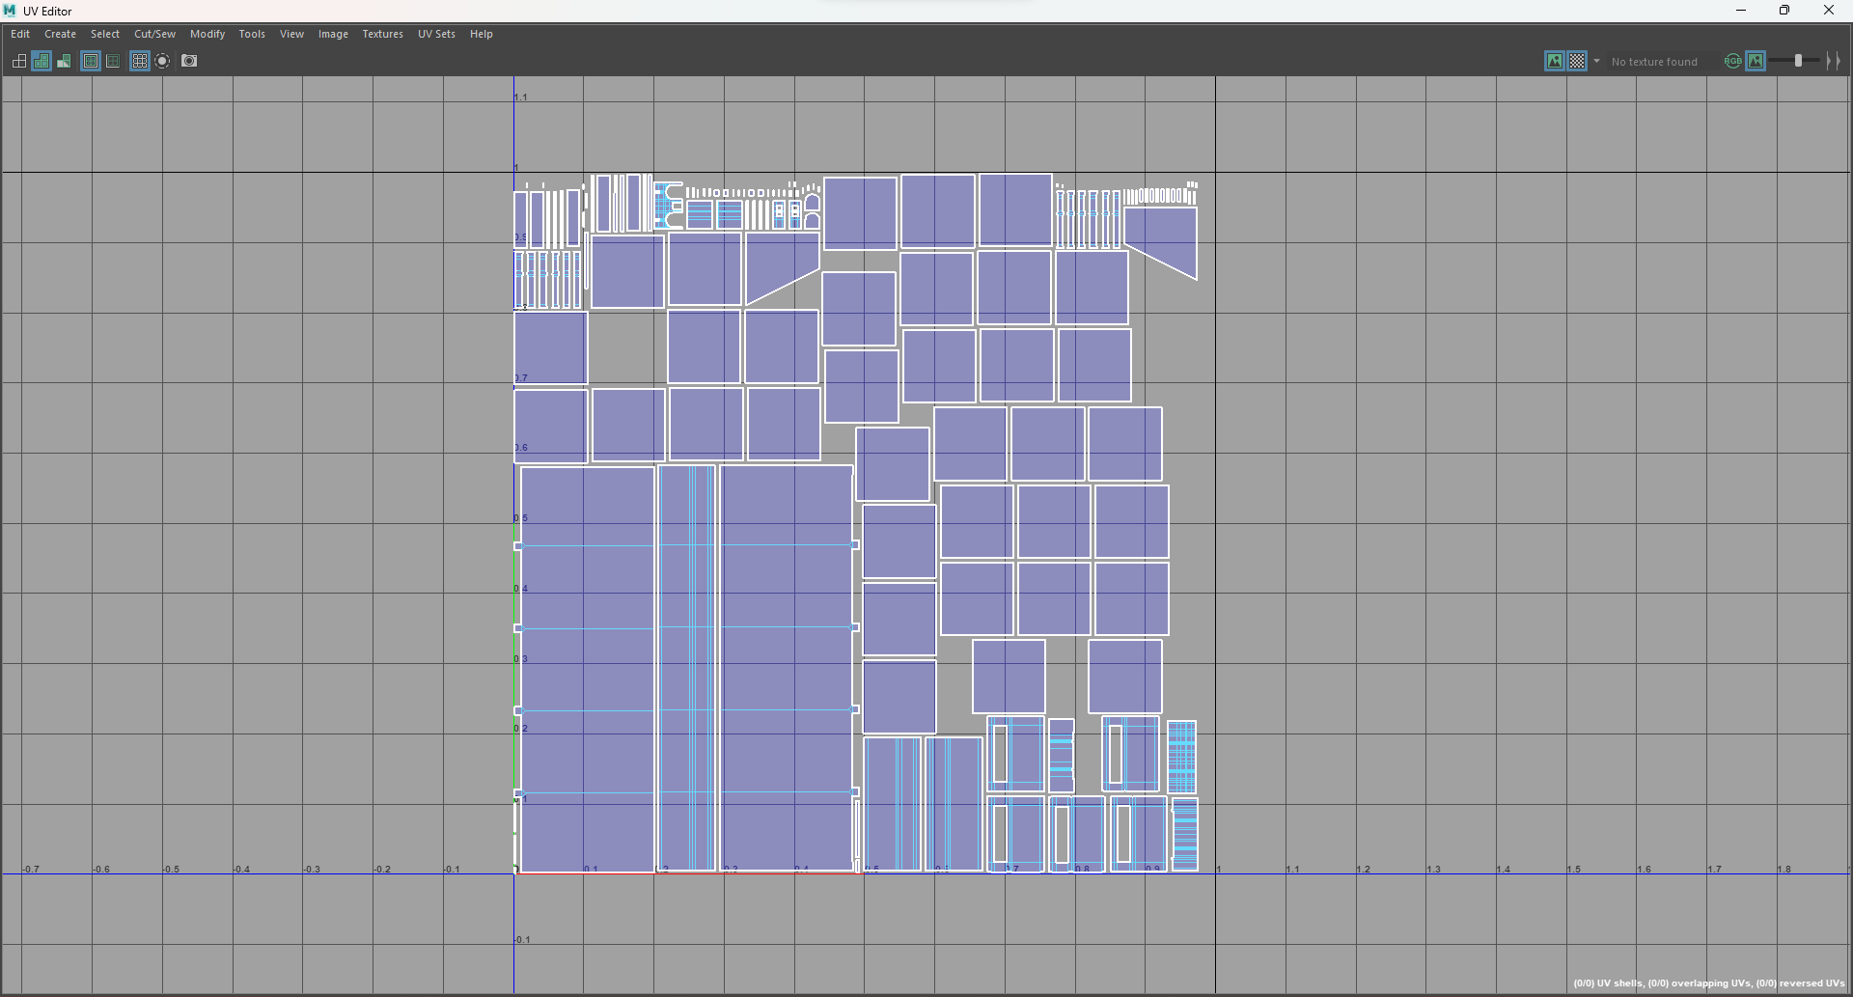

Figure : Uv Map Side Building

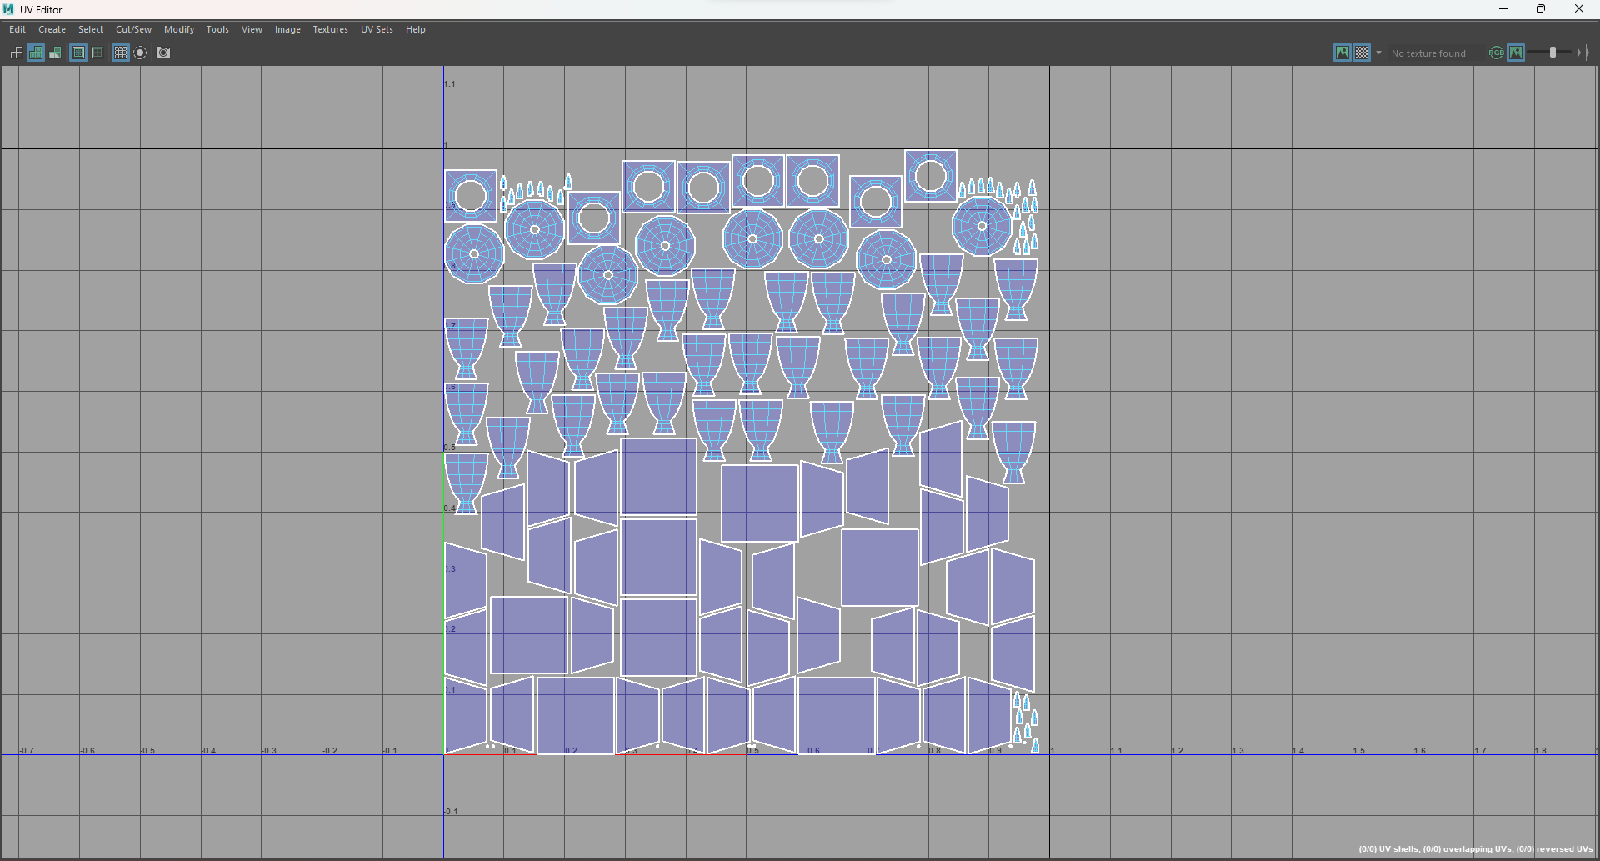

Figure : Uv Map Roof Artifacts

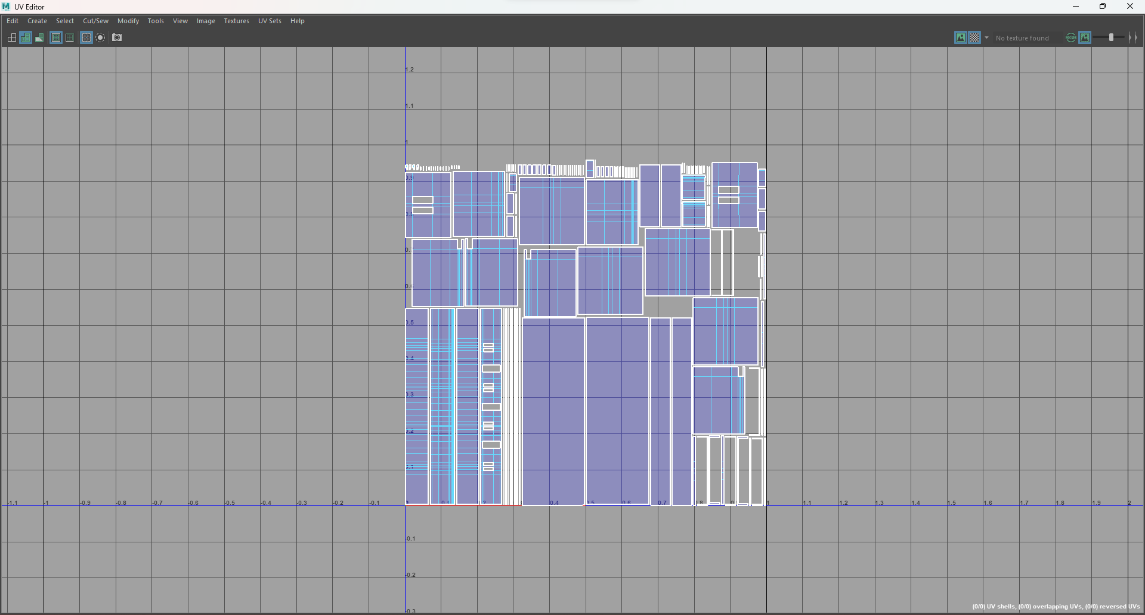

Figure : Uv Map Base

#### Kumari Ghar

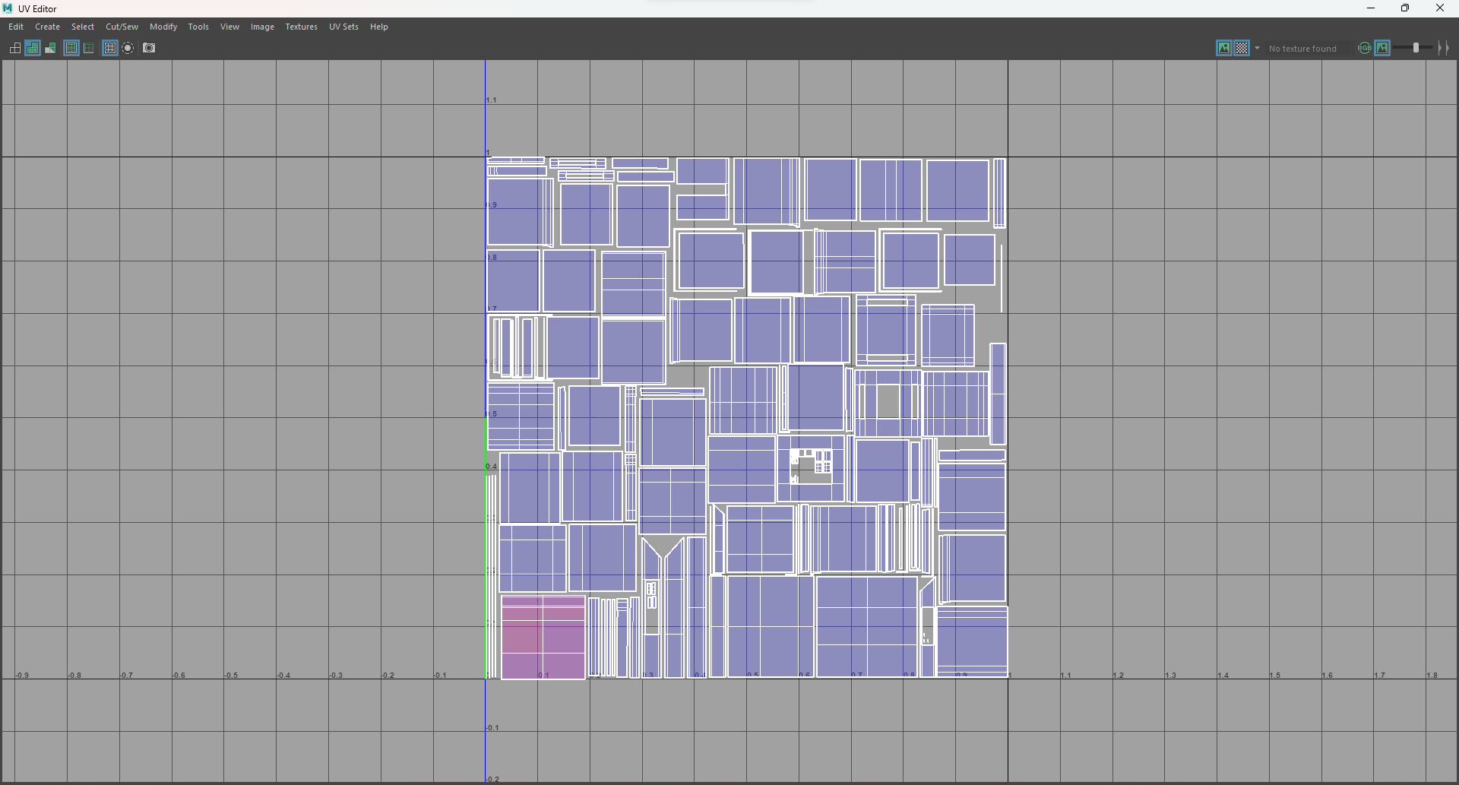

Figure : UV map Wall

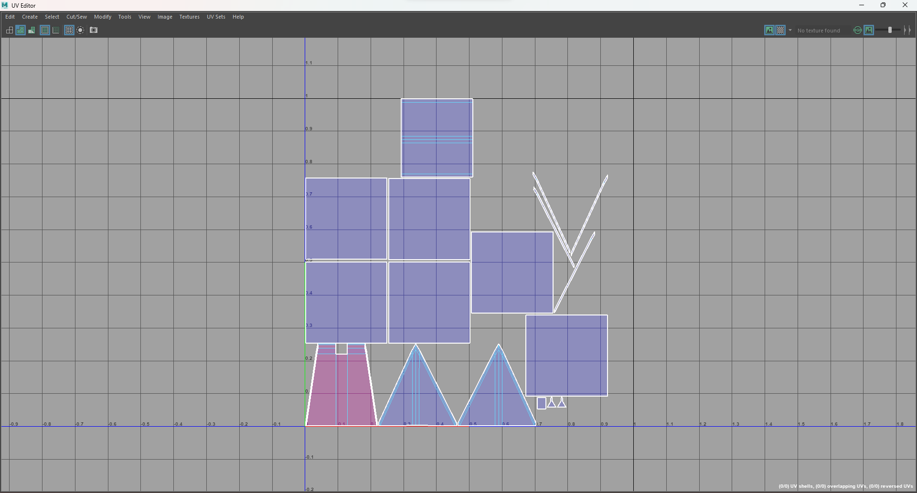

Figure : UV map Roof

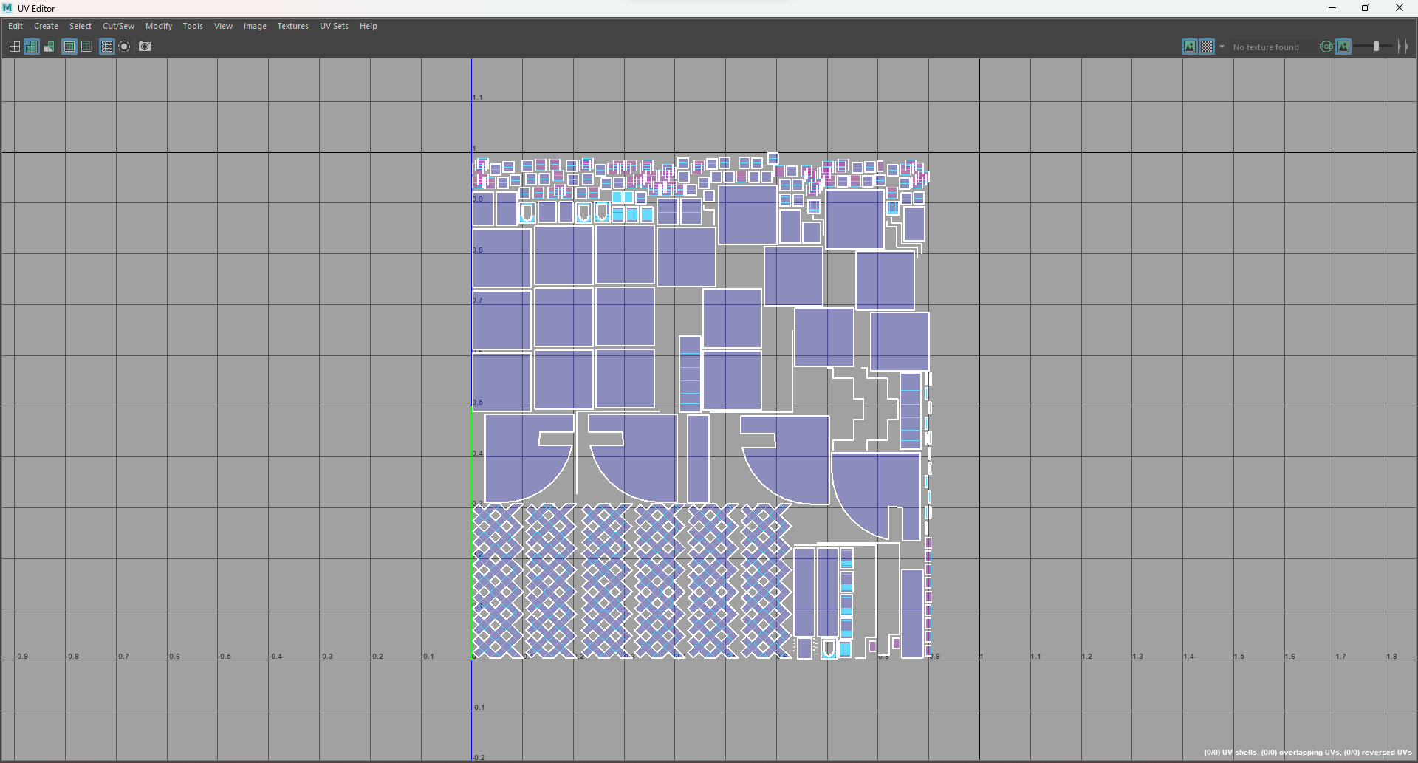

Figure : UV map Window 1

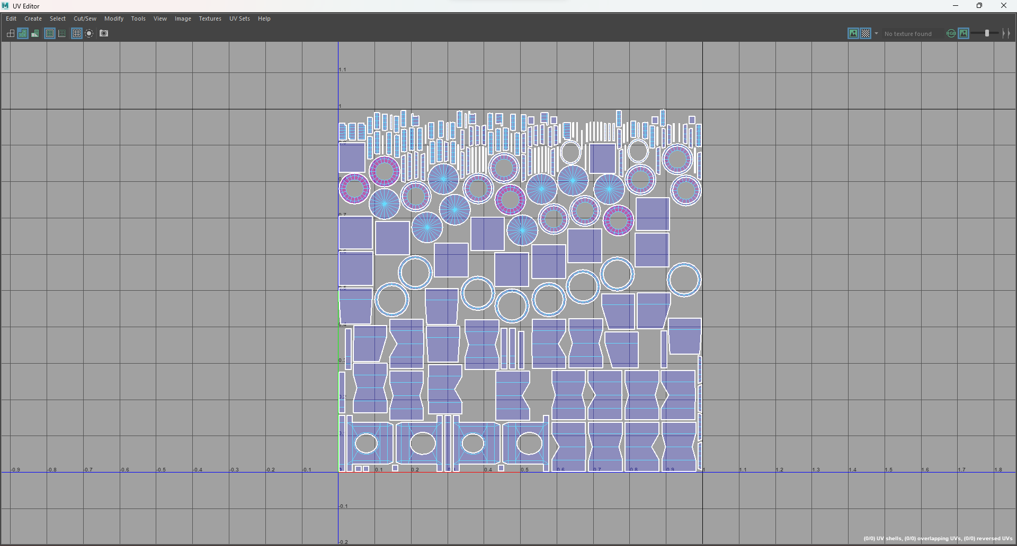

Figure : UV map Window 2

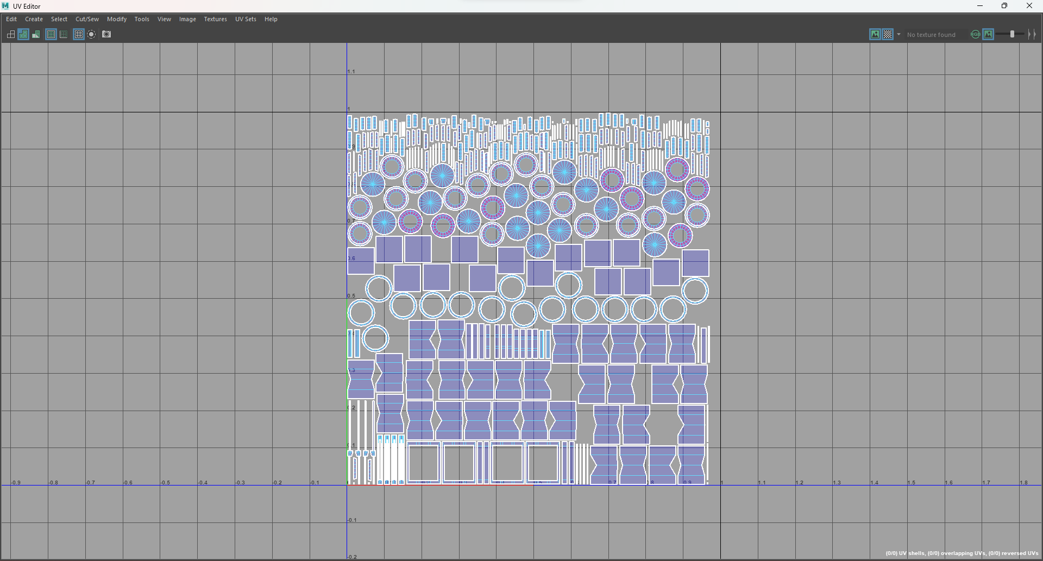

Figure : UV map Window 3

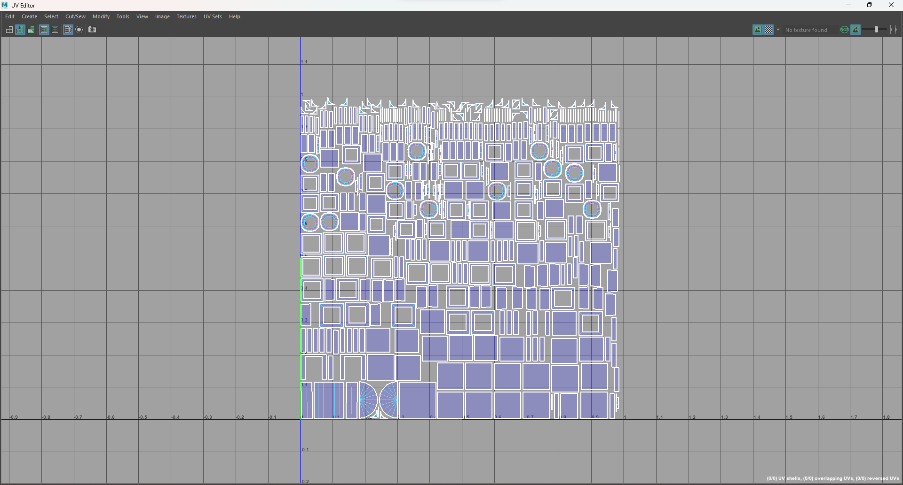

Figure : UV map Door

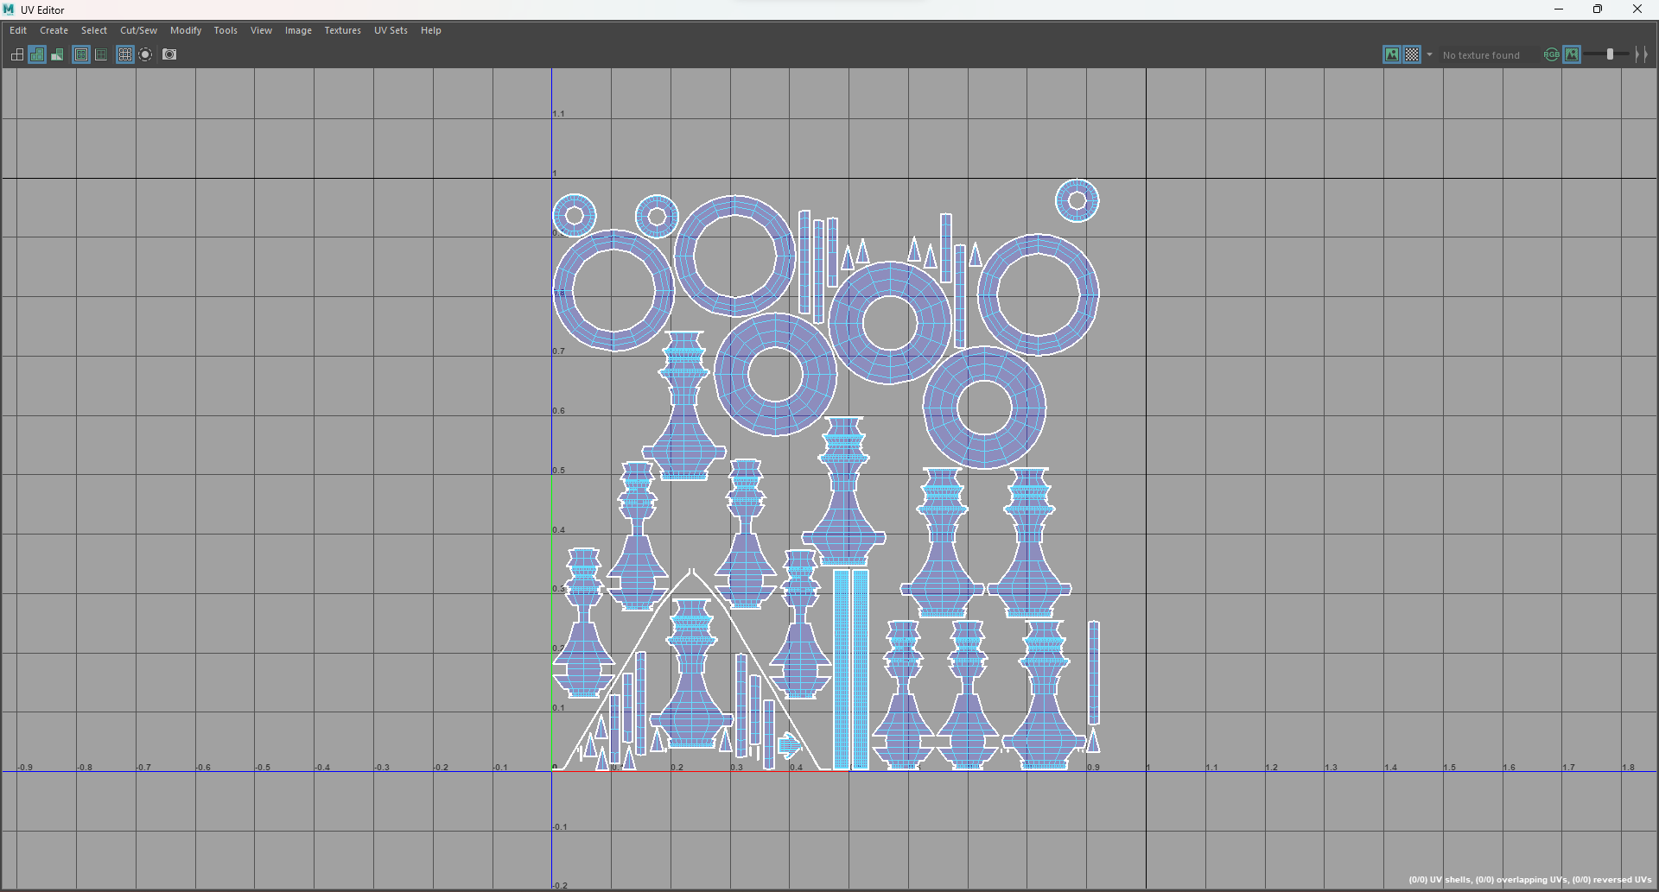

Figure : UV map Top

#### Basanatapur Durbar

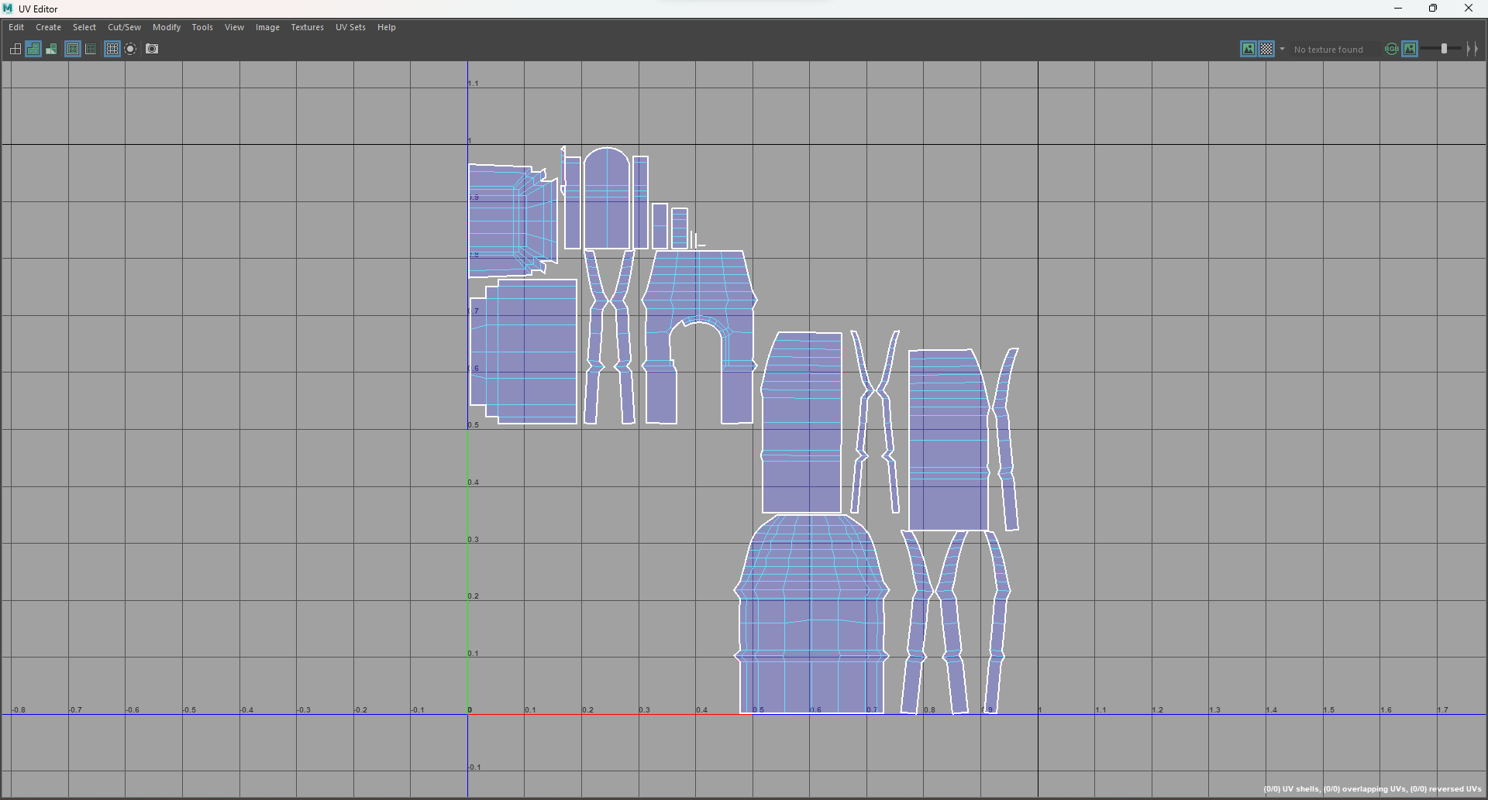

Figure :Uv map temple(right)

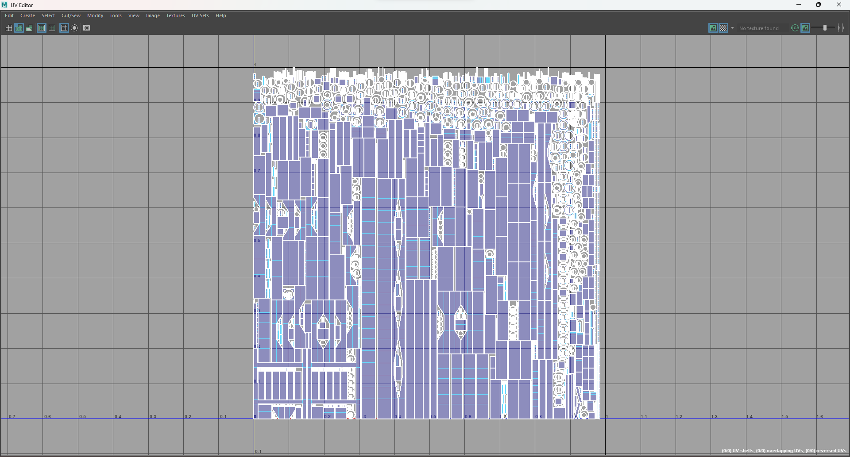

Figure :Uv map doors and poles(right)

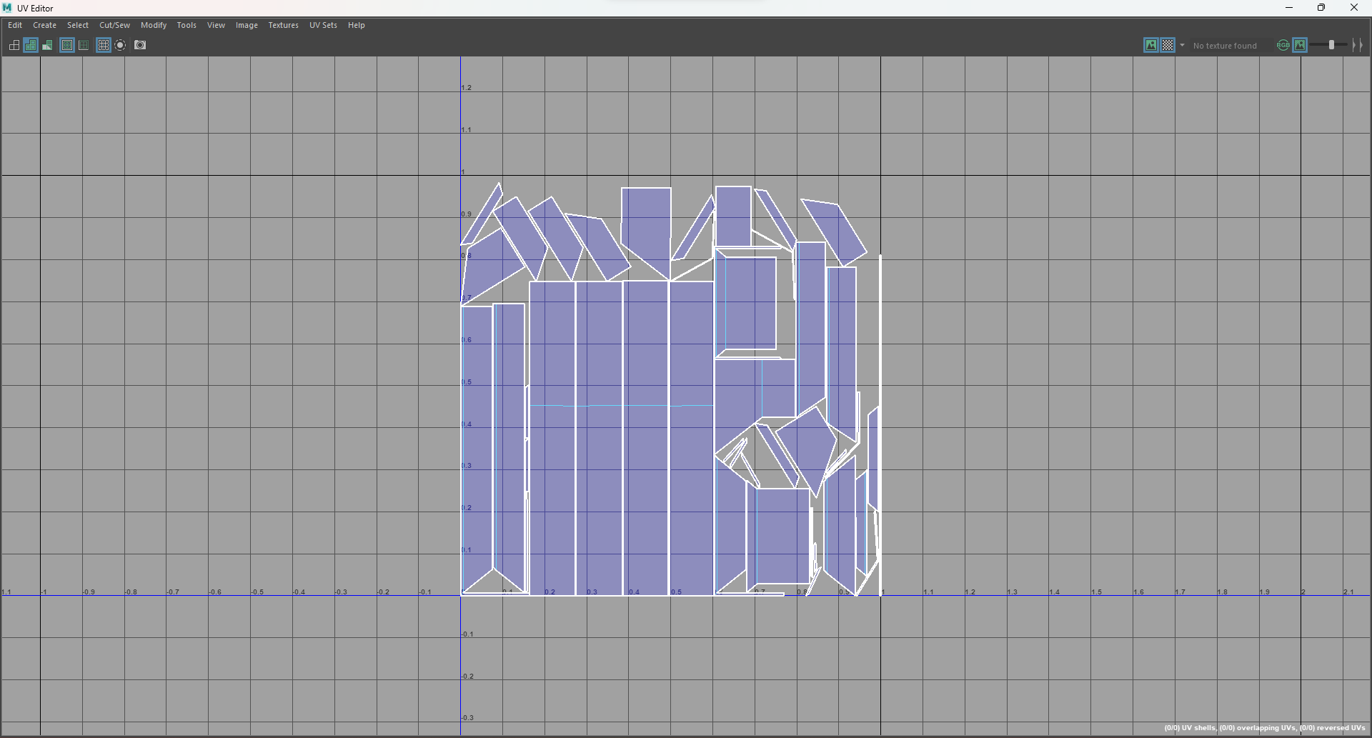

Figure :Uv map roof(right)

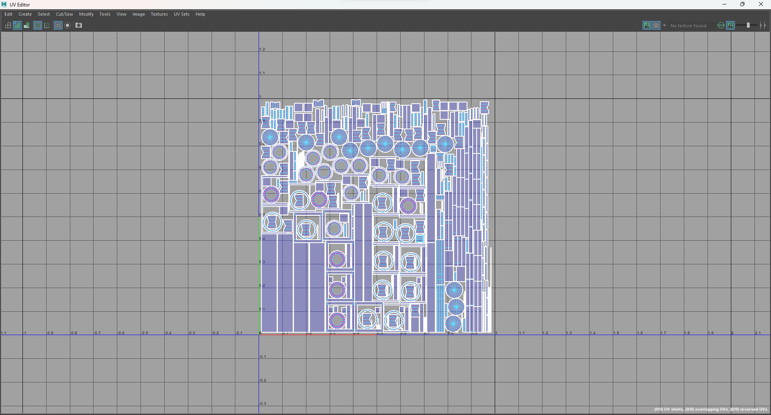

Figure :Uv map overhang(right)

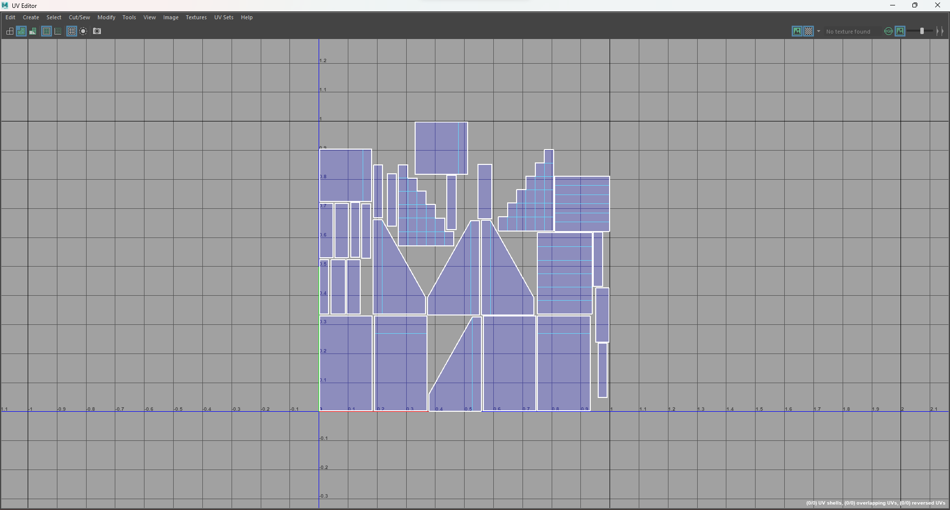

Figure :Uv map stairs(right)

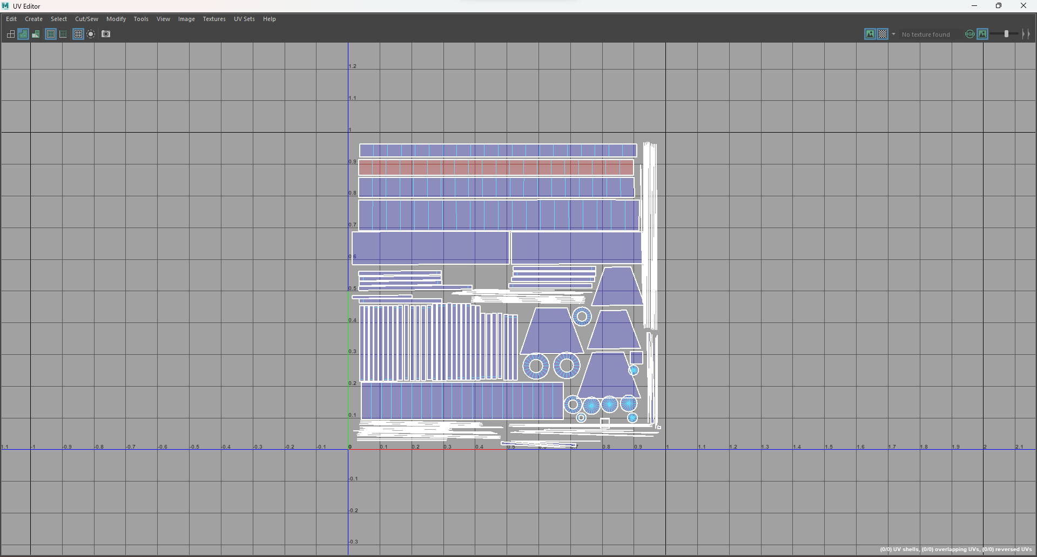

Figure : Uv map roof(back)

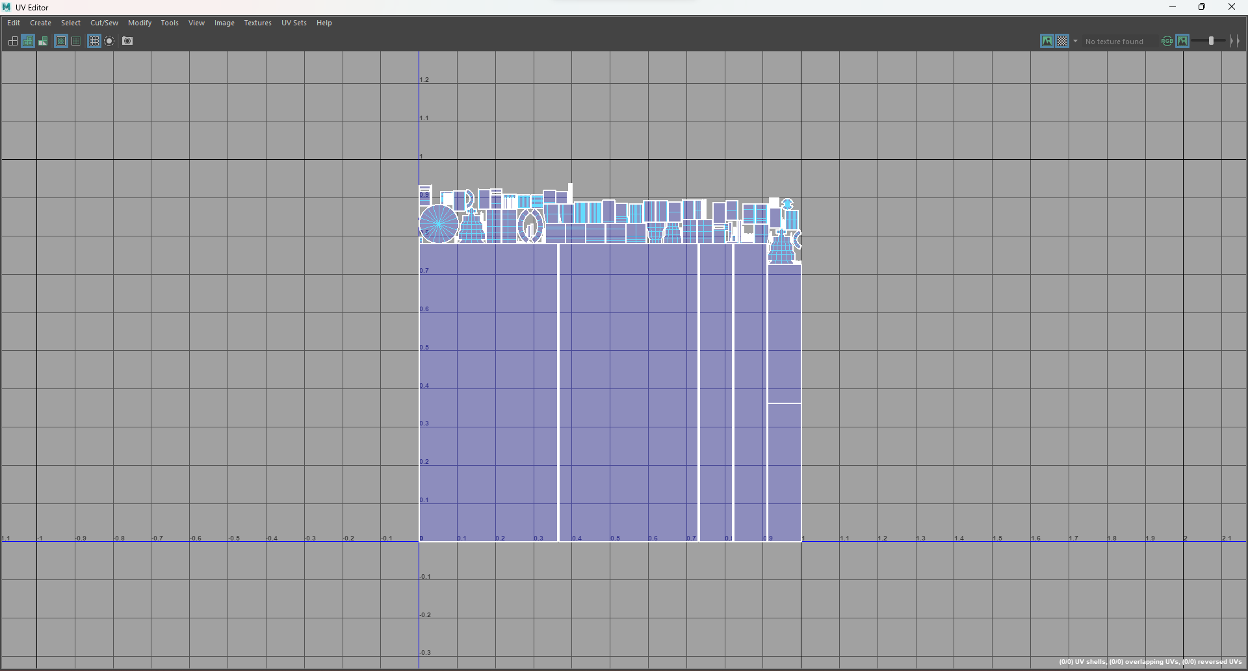

Figure : Uv map walls(back)

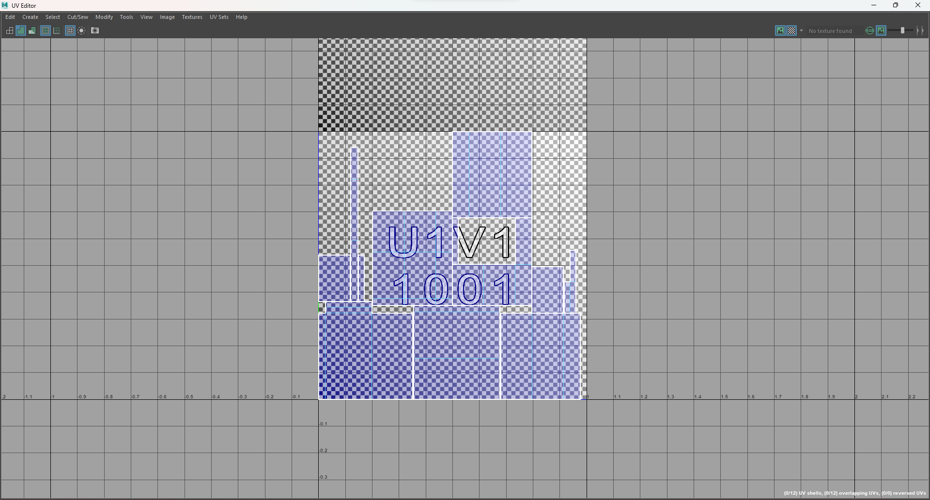

Figure : Uv map base(back)

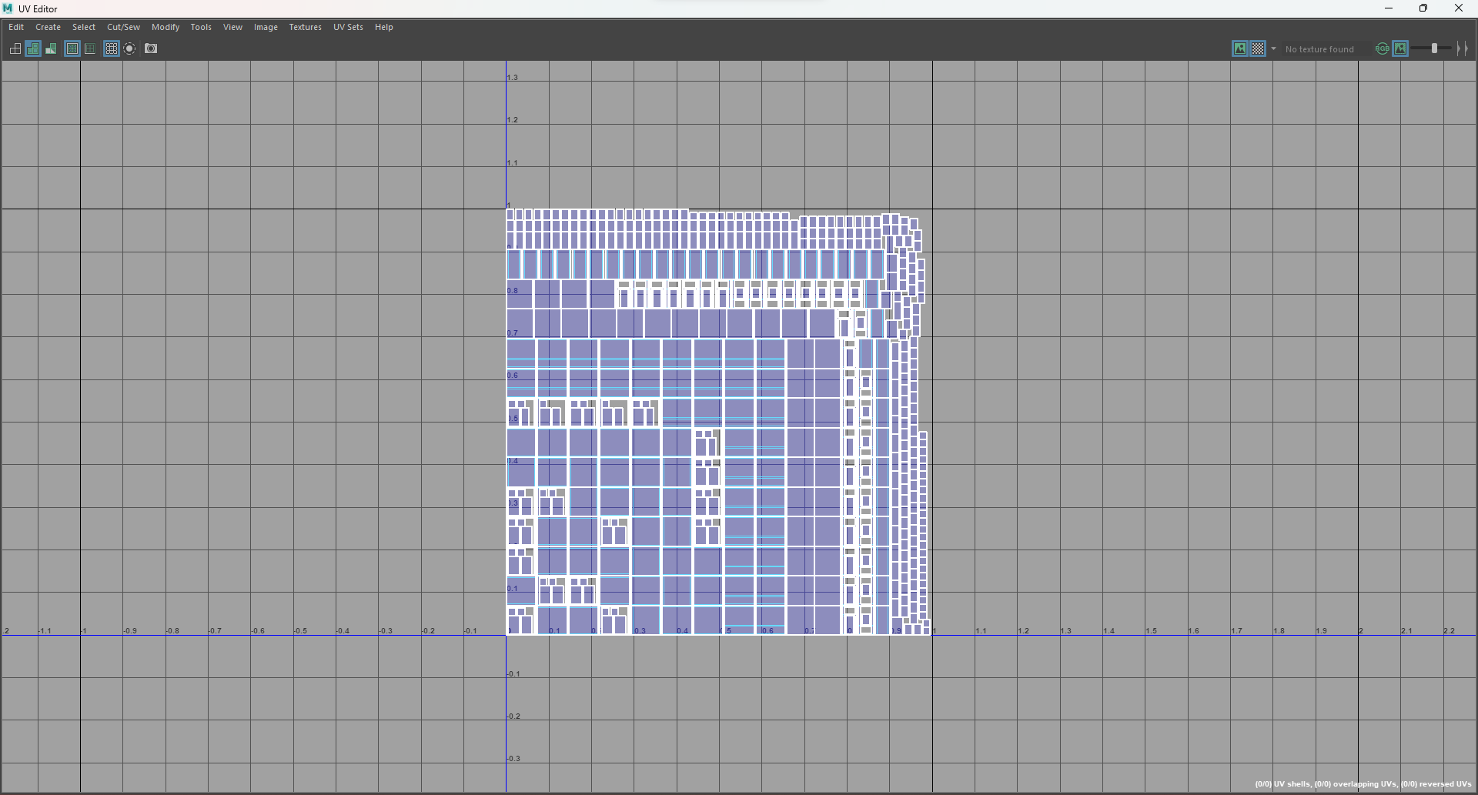

Figure : Uv map window(back)

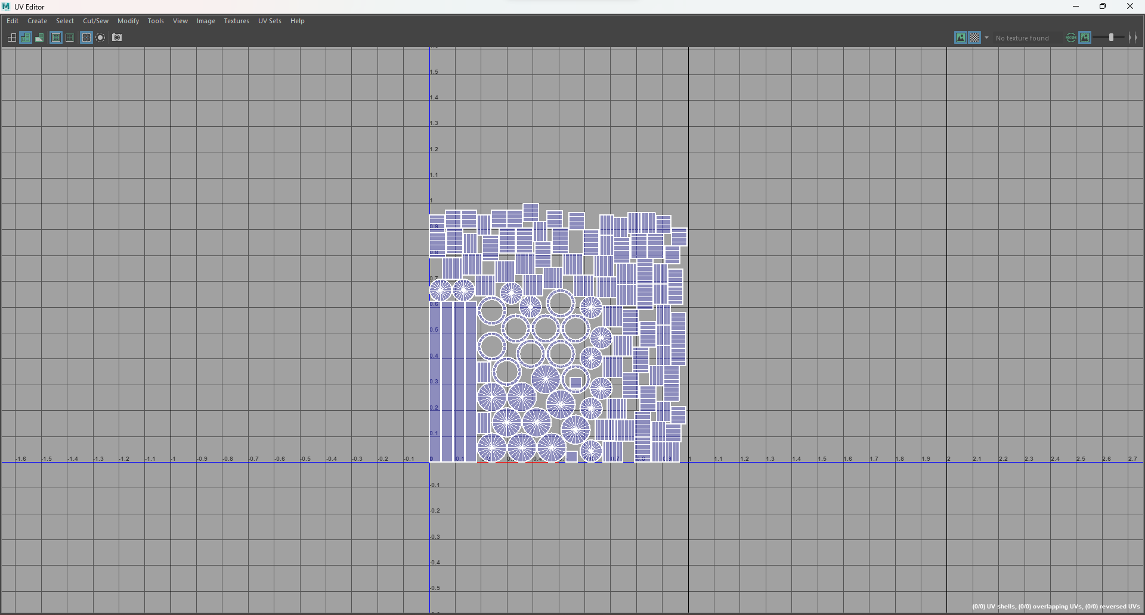

Figure : Uv map pole(back)

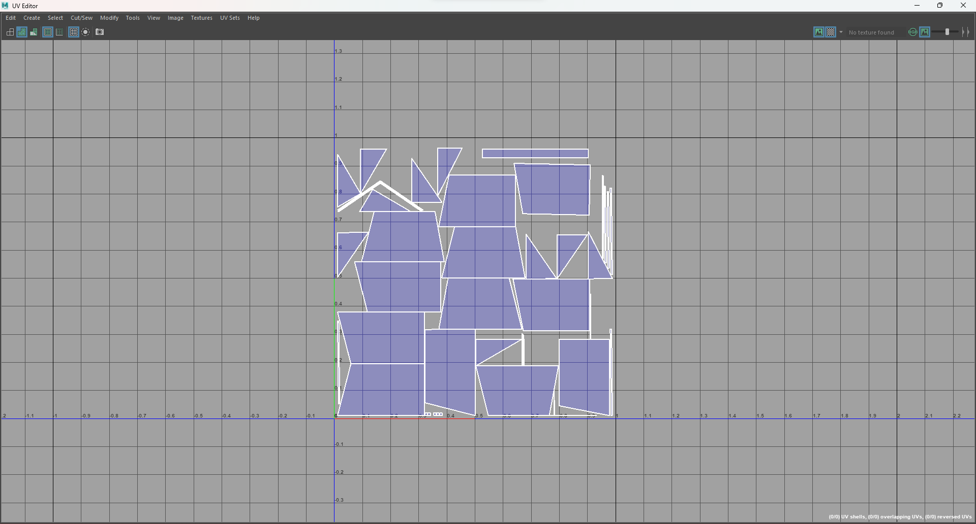

Figure : Uv map roof(left)

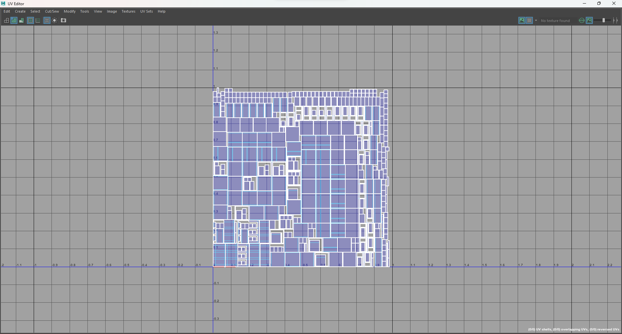

Figure : Uv map overhang (left)

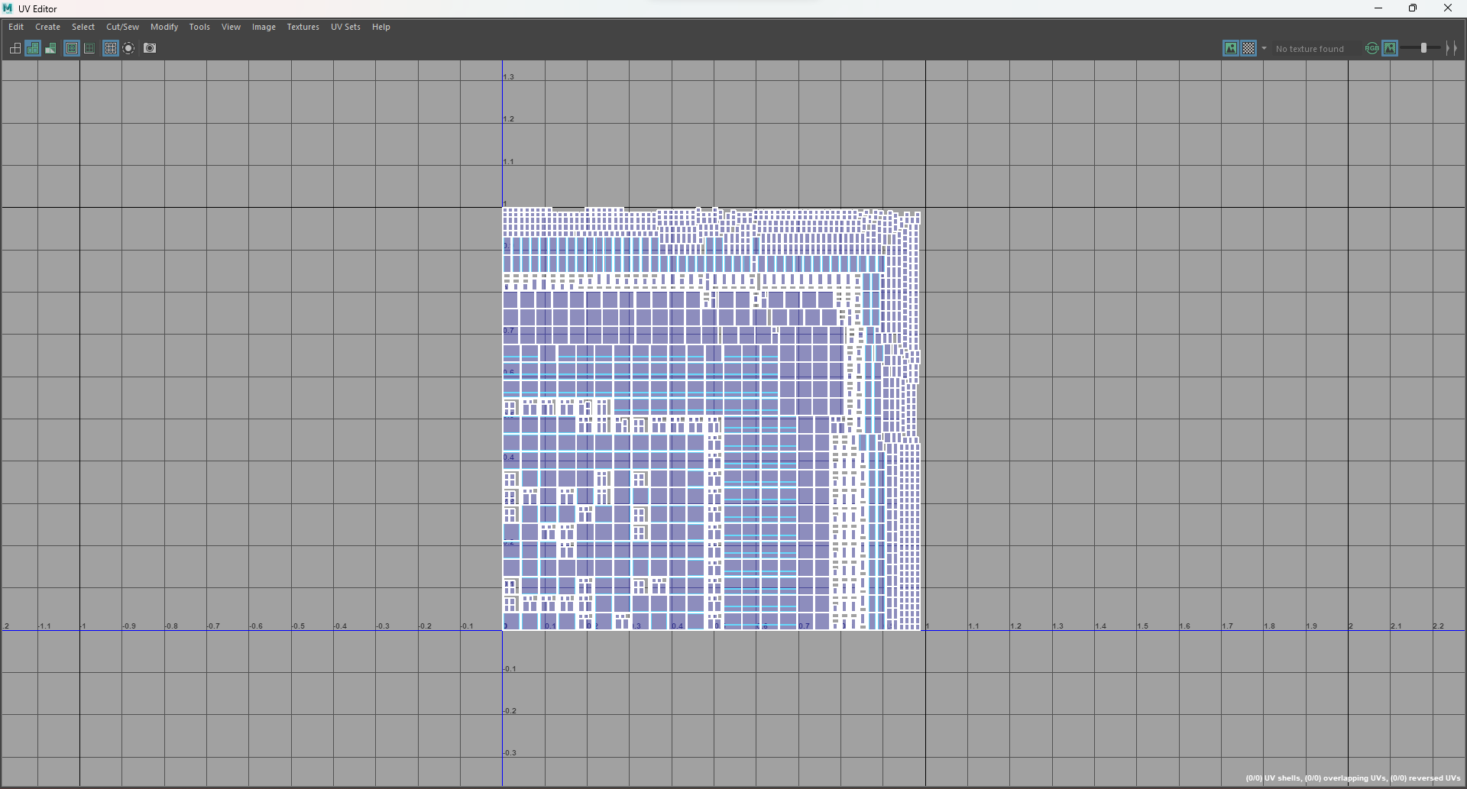

Figure : Uv map window(left)

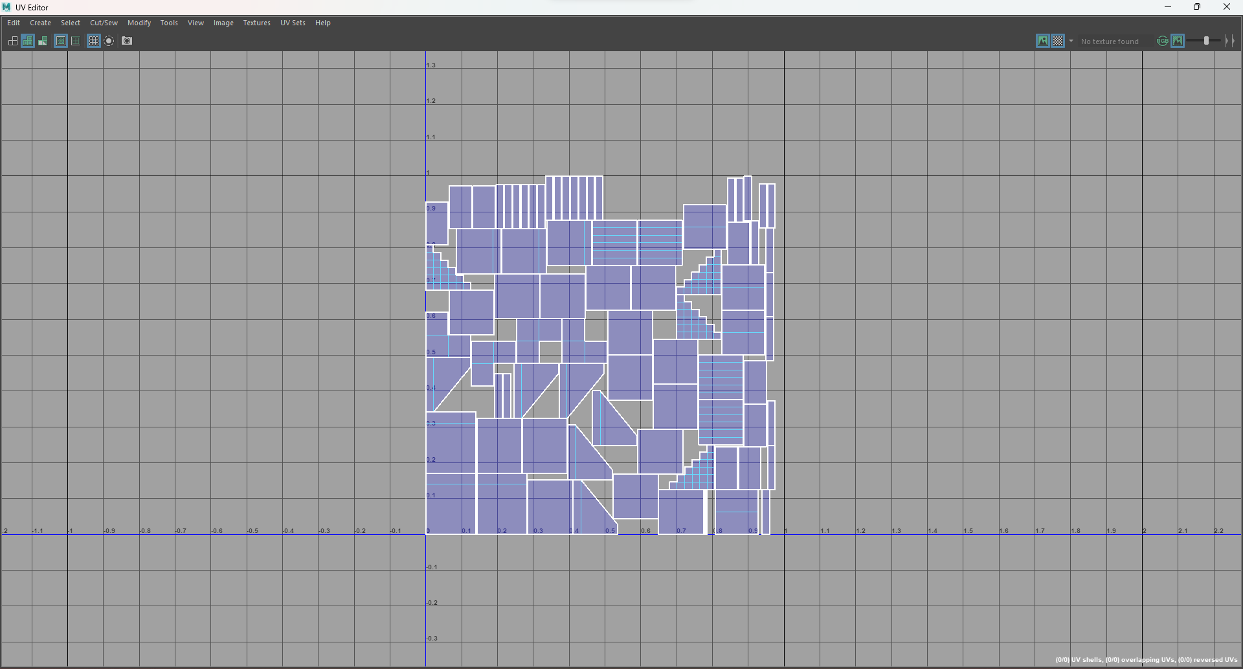

Figure : Uv map stairs(left)

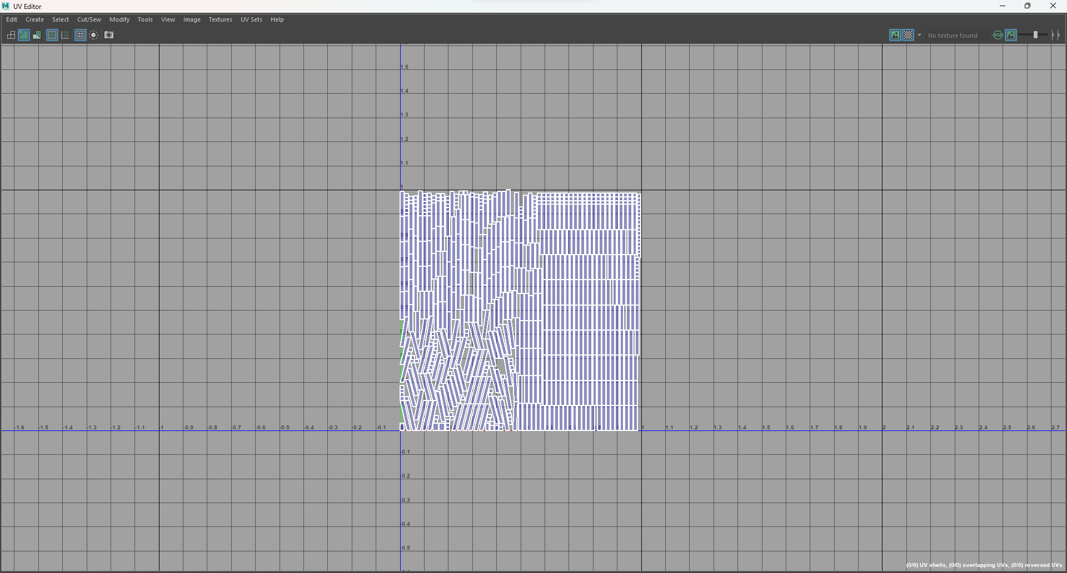

Figure : Uv map roof support(back)

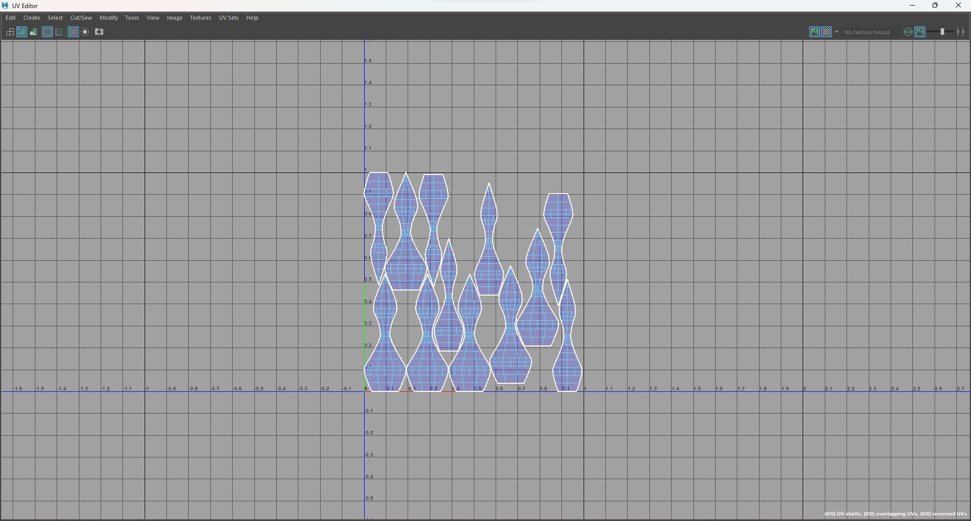

Figure : Uv map top(front)

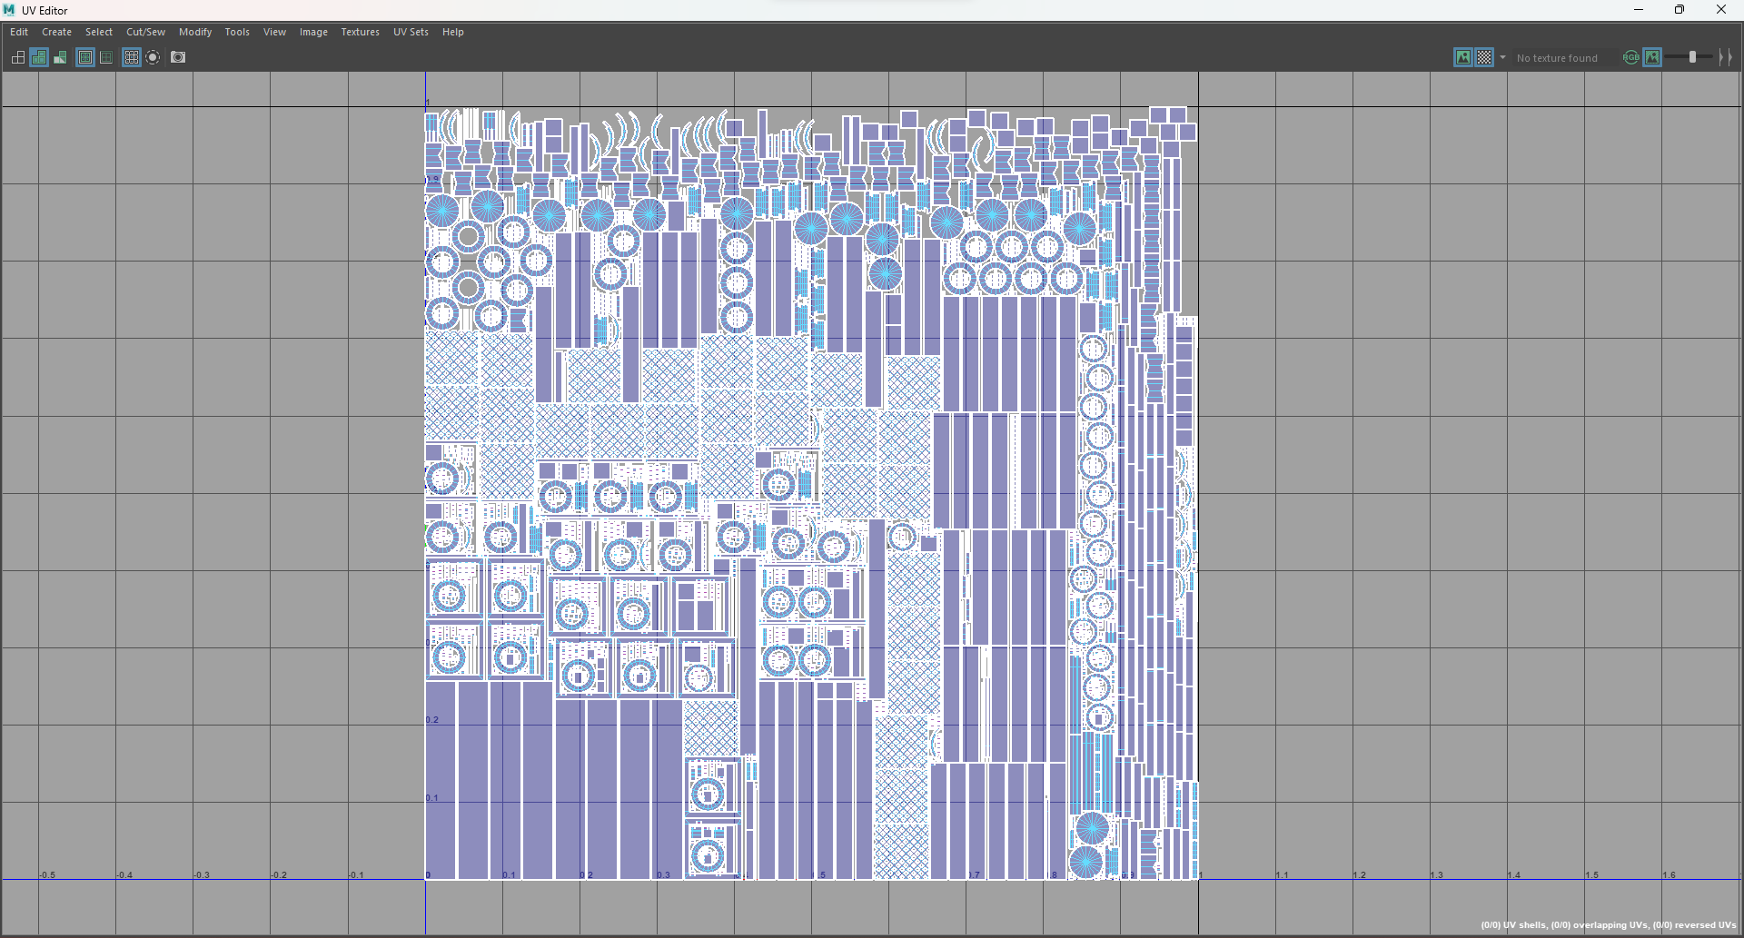

Figure : Uv map overhang 1(front)

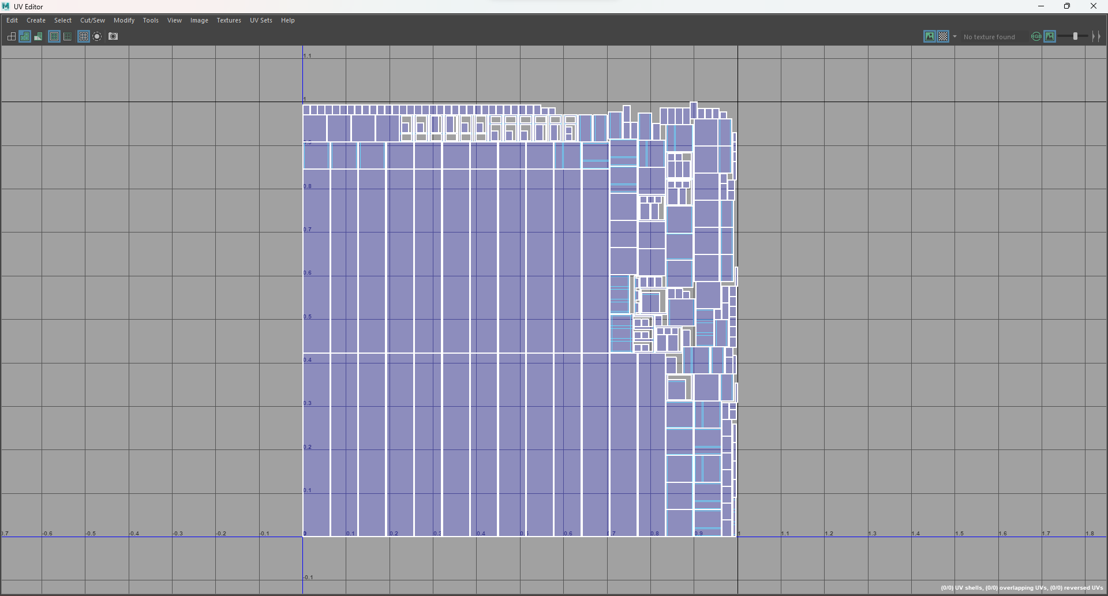

Figure : Uv map overhang 2(front)

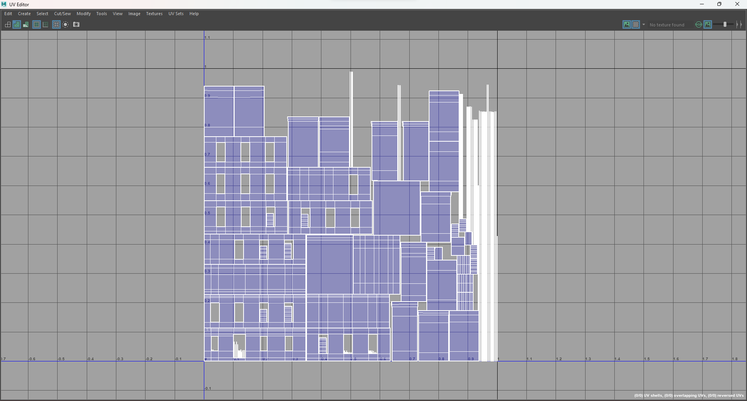

Figure : Uv map wall(front)

#### Houses

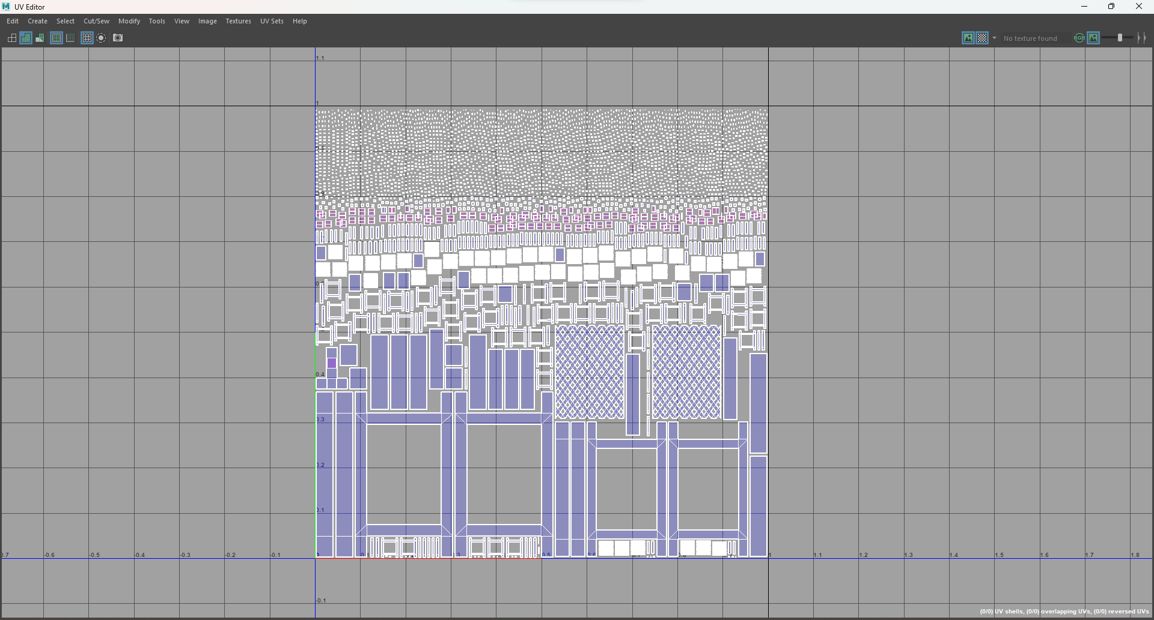

Figure :Uv map window 1(house3)

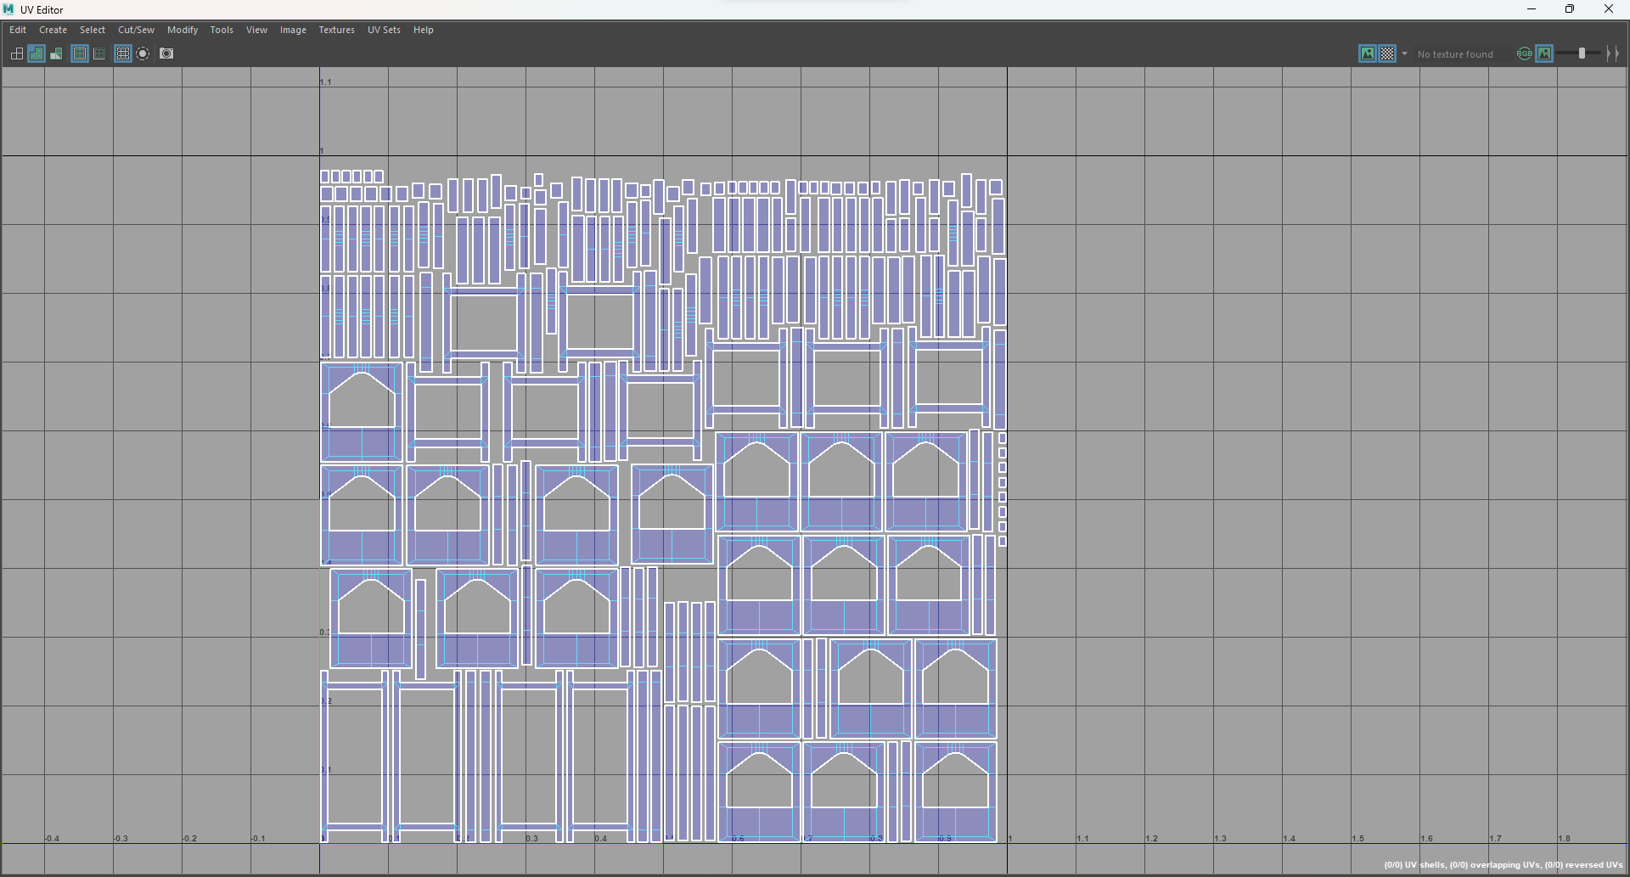

Figure : Uv map window 2(house3)

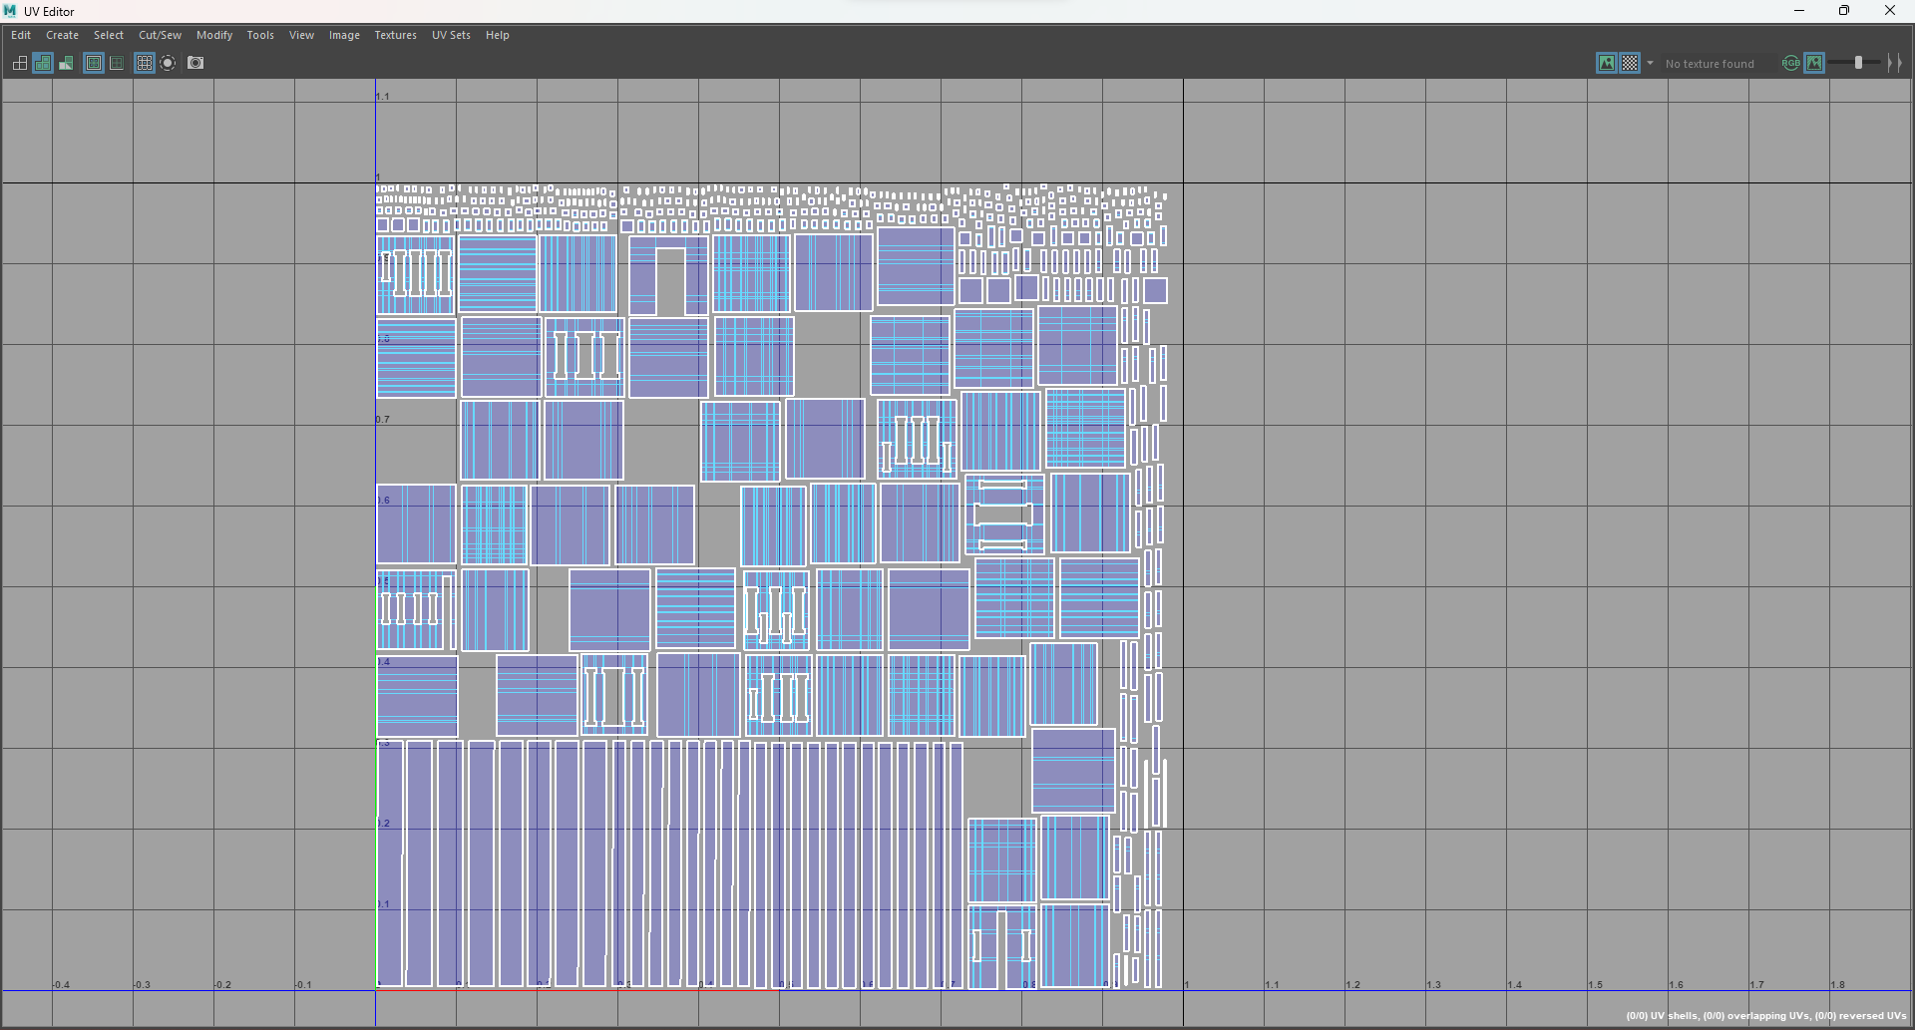

Figure : Uv map walls 1(house3)

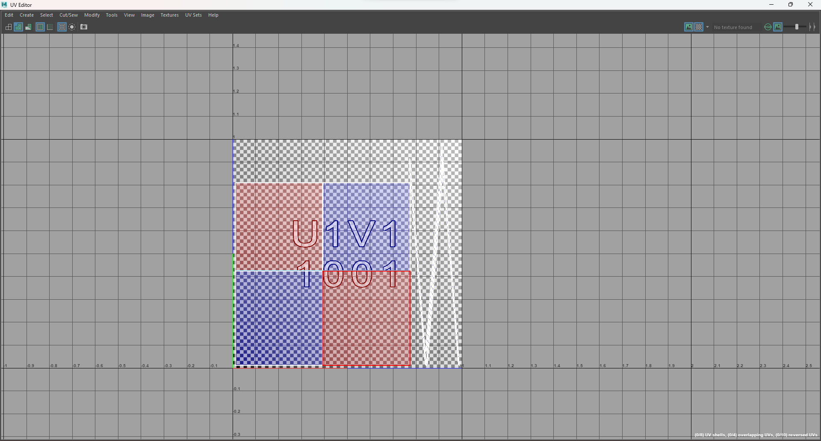

Figure : Uv map roof(house1)

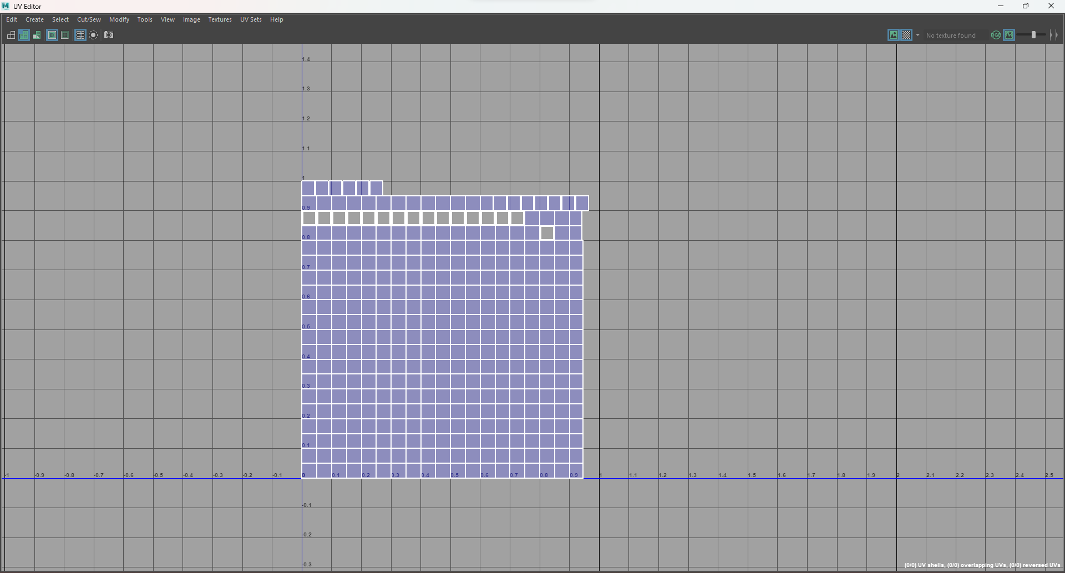

Figure : Uv map window(house1)

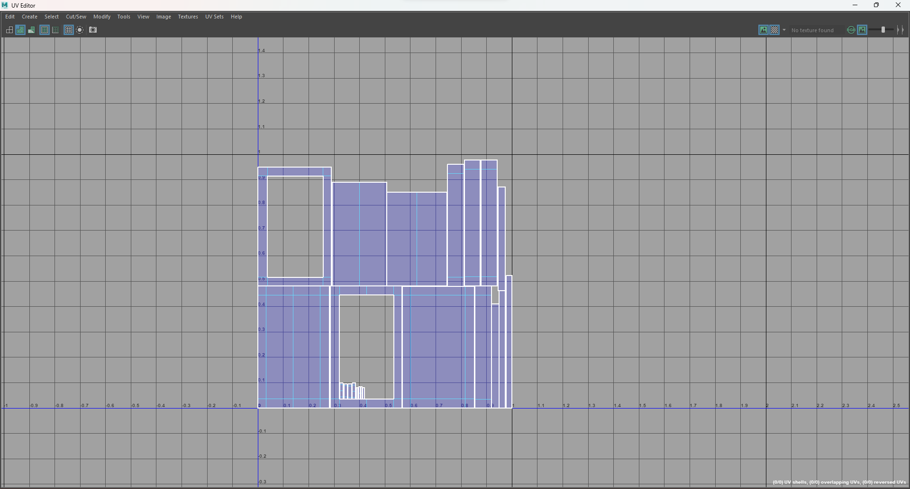

Figure : Uv map door(house1)

### Texturing

After all the UV Maps for all of the 3D assets have properly been unwrapped, the files are then exported as an OBJ format and loaded inside Substance Painter. The workflow from Maya to Substance Painter is briefly touched on below:

Firstly, new project was created.

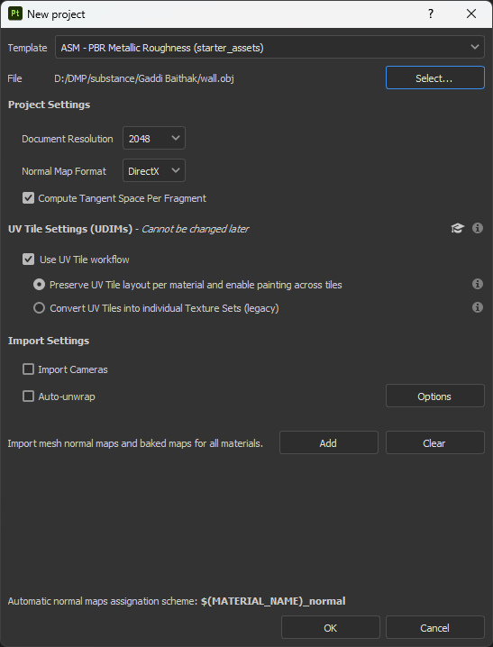

Figure : Creating new project.

Then, the uv map was imported.

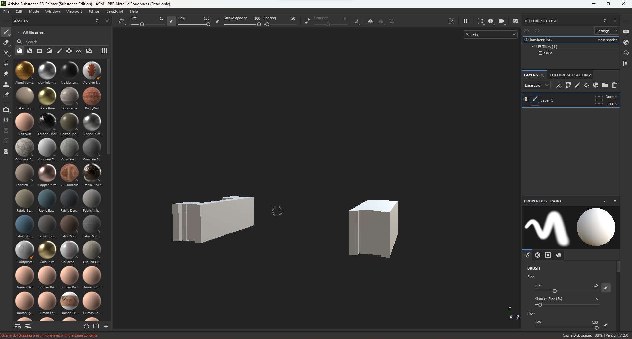

Figure : Importing UV map.

Then the texture was baked.

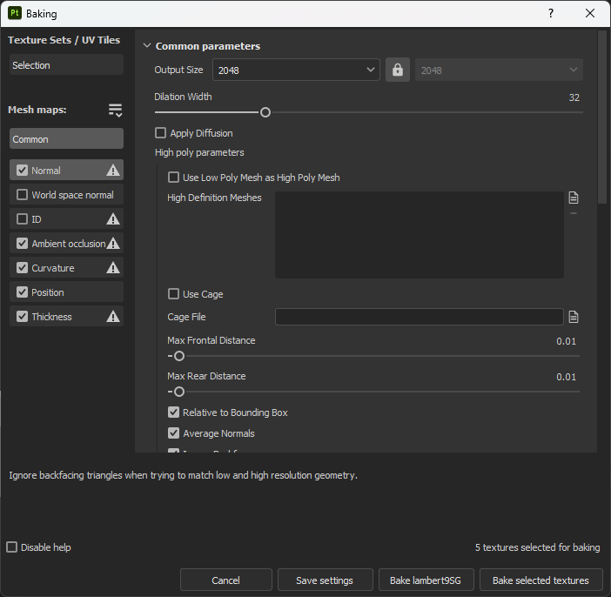

Figure : Texture bake settings

Then the substance textures were applied.

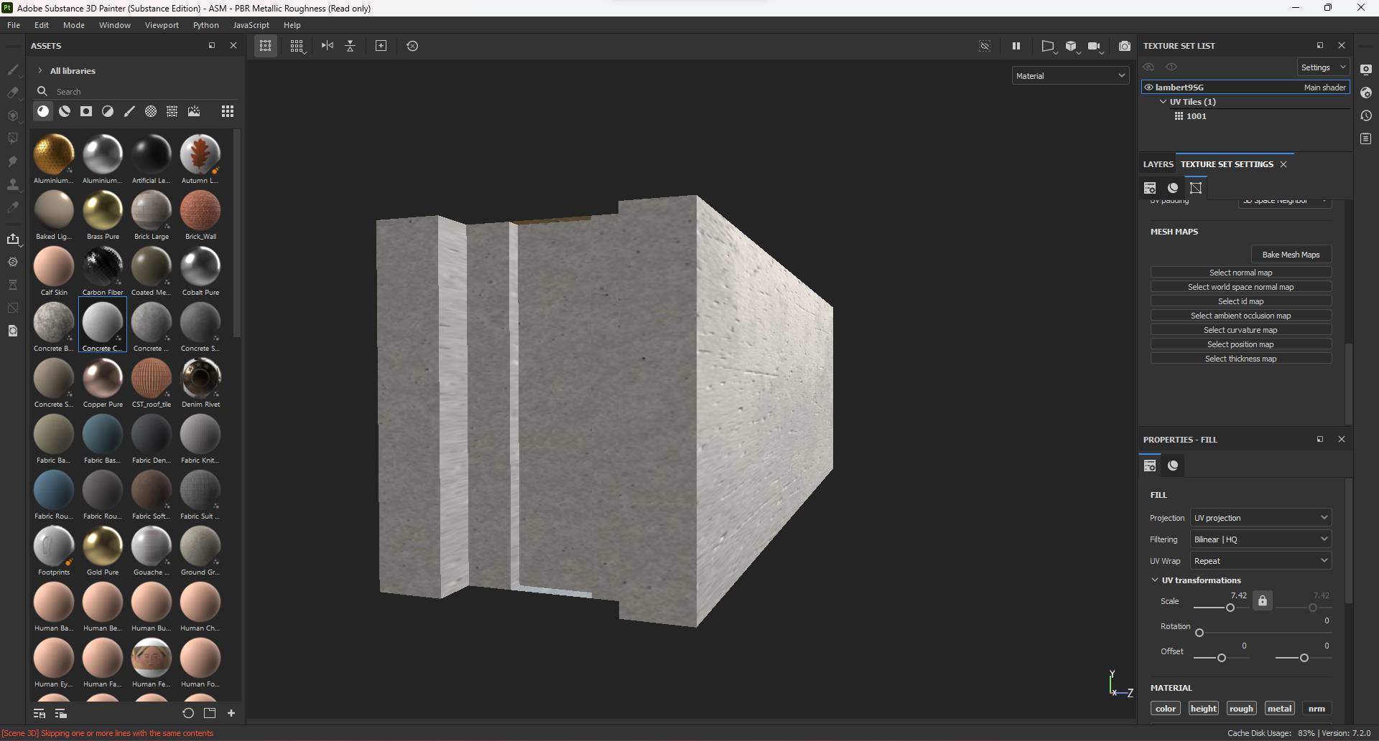

Figure : Applying texture.

Then the files were exported.

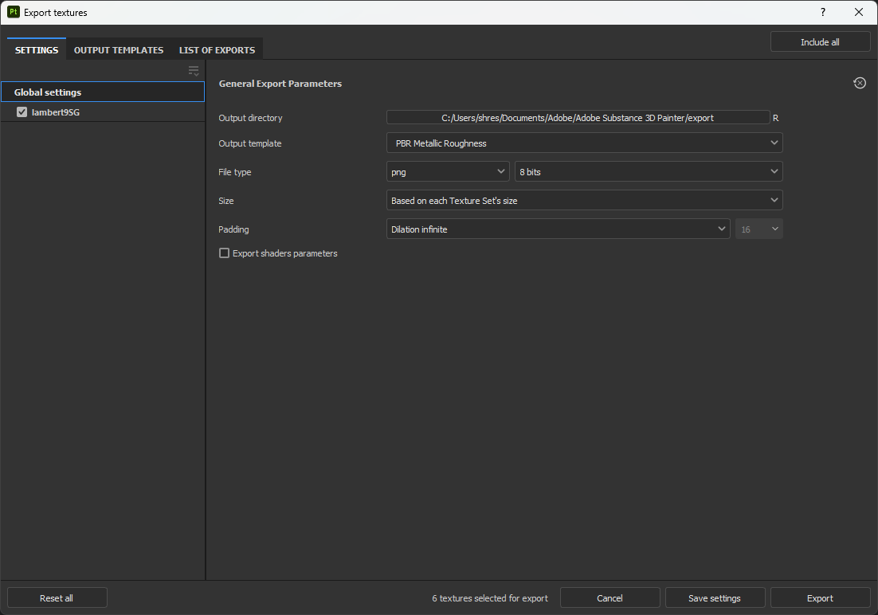

Figure : Export settings

This process was used for all the materials that were created. Some of the textures are as follows

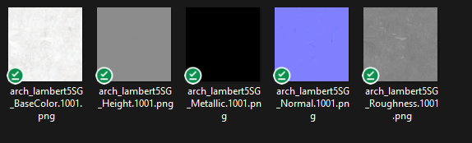

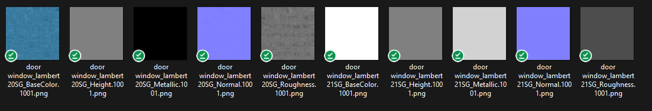

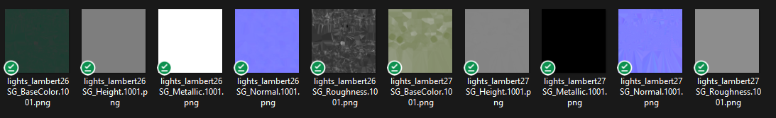

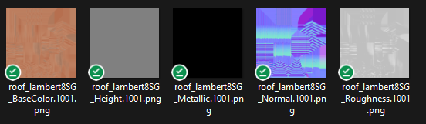

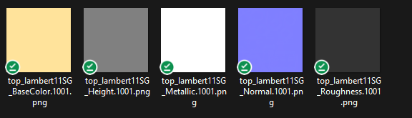

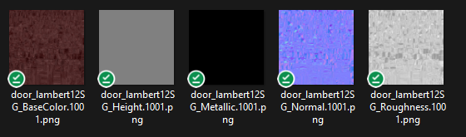

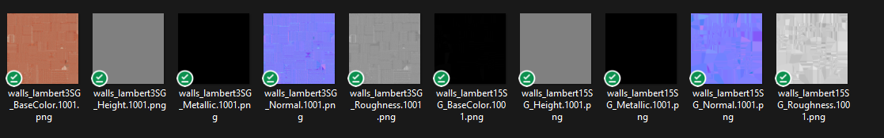

### Compilation & Rendering

After all the textures were completed, the models as well as the textures are imported into Twinmotion. The models and the textures have to be imported individually and then linked inside. First, a new project is created in Twinmotion.

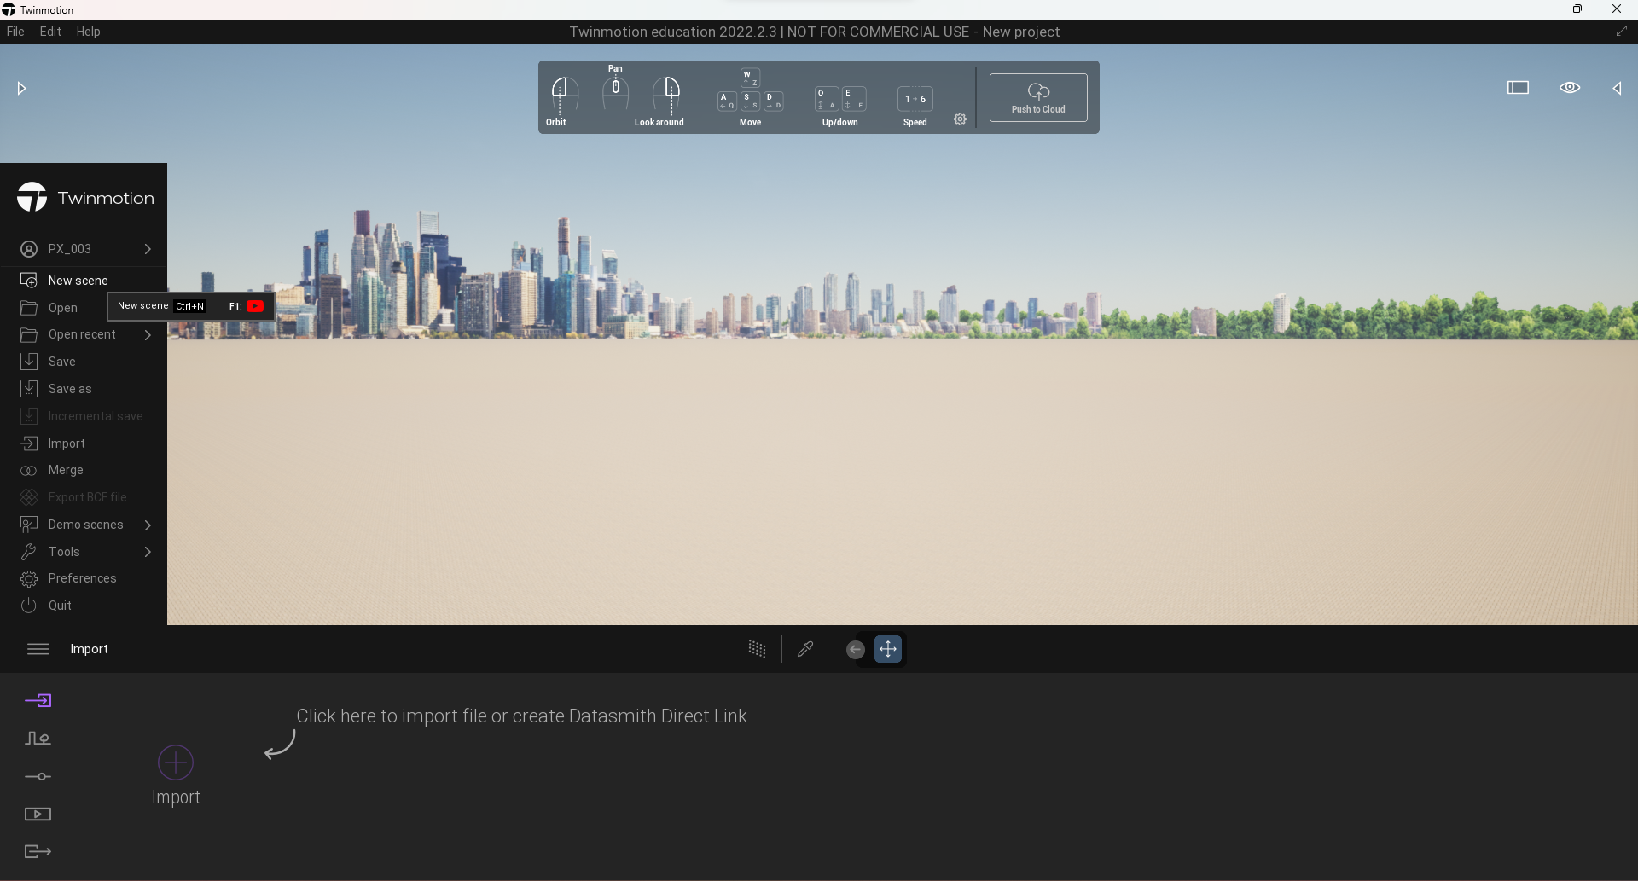

Figure : Creating project in Twinmotion

The 3D assets is imported inside the Twinmotion by the ‘Import’ options. Under the ‘Collapse’ menu, the option ‘Collapse by material’ was used.

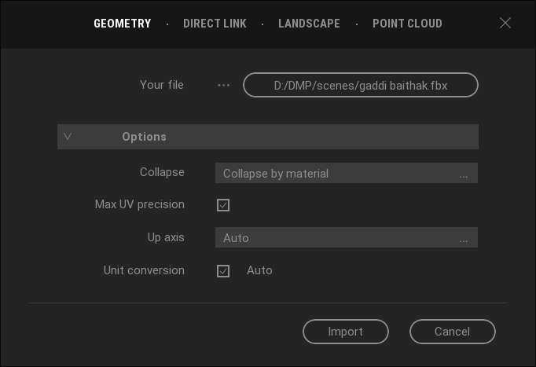

Figure : Selecting Import option.

After the files are imported, the files were present on the right dock menu. The file can be brought inside by dragging the item from the dock onto the viewer.

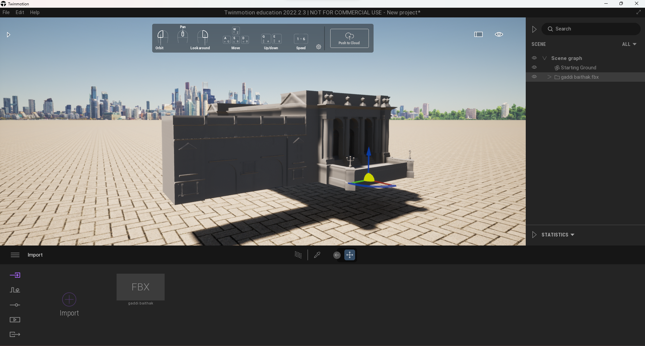

Figure : Importing assets

After importing the model were finished, the textures of the models were imported. This can be done by selecting the eyedropper menu and clicking on the model whose textures the was being imported. This opens a sub menu of materials for the highlighted 3D model.

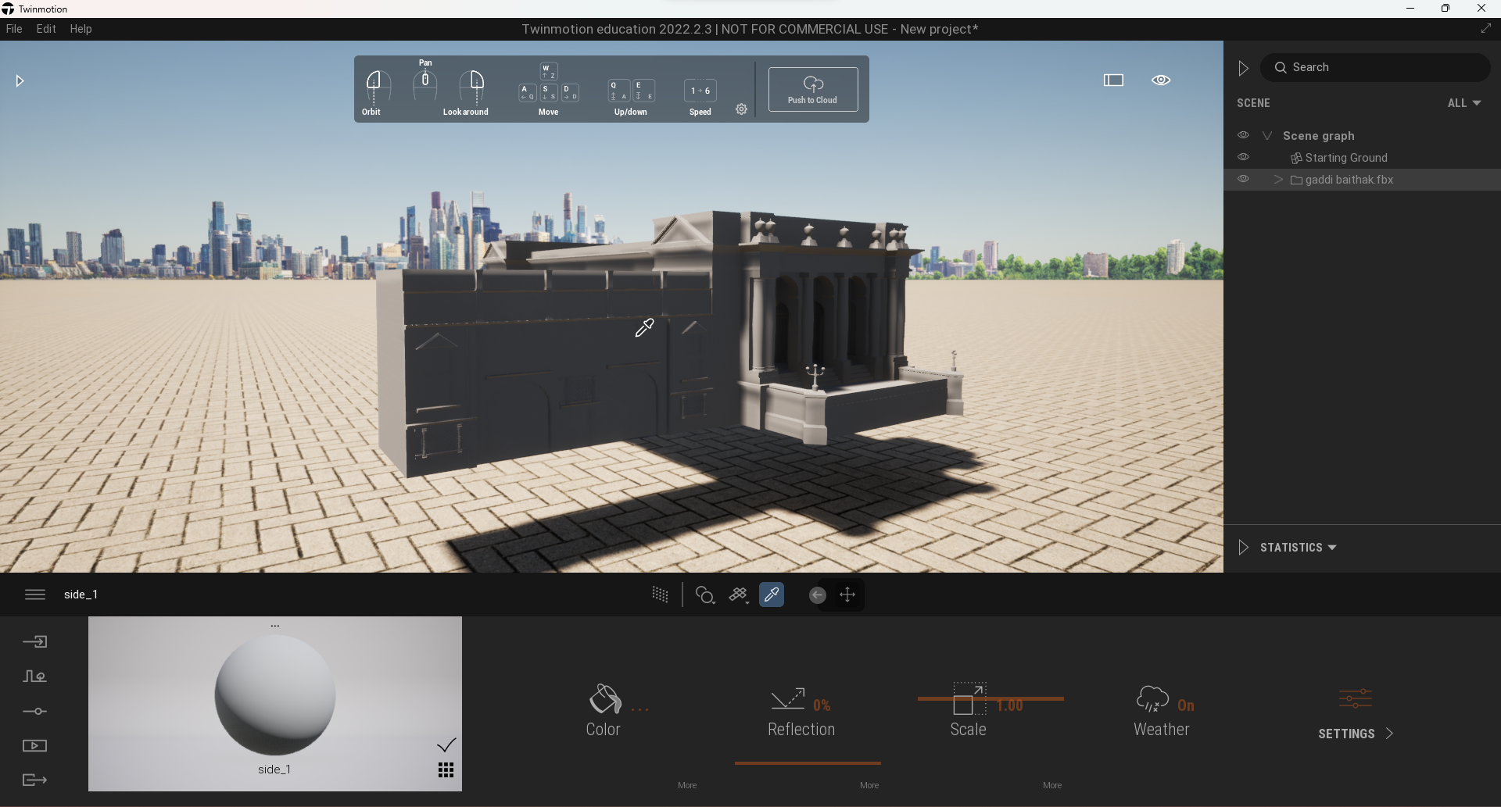

Figure : Assigning texture to assets

In this moment, the material properties panel for the model of a Gaddi Baithak is loaded. From here, base color maps was imported inside the ‘Colors’ tab, roughness map was imported inside the ‘Reflection’ tab. Normal map was imported inside the ‘Bump’ tab that was inside the ‘Settings’ tab and metallic map was imported inside the ‘Metalness’ tab which was also found inside the ‘Settings’ tab. All of the 3D assets are loaded into Twinmotion and textures were assigned. They were used to block out the environment map. 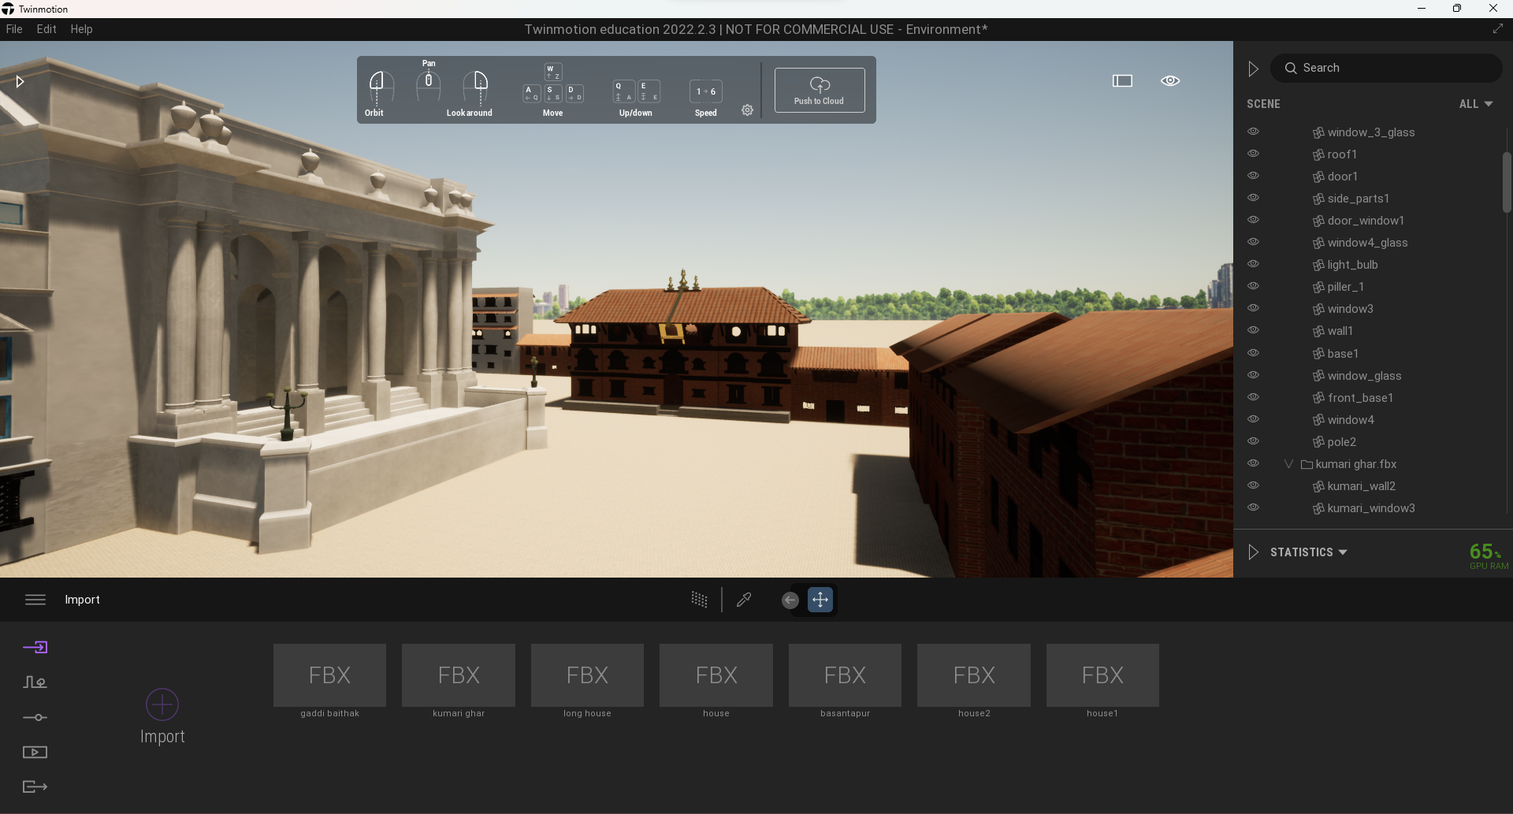

Figure : Creating Environment

To create a walkthrough video of the environment map, the ‘Video’ tab is selected.

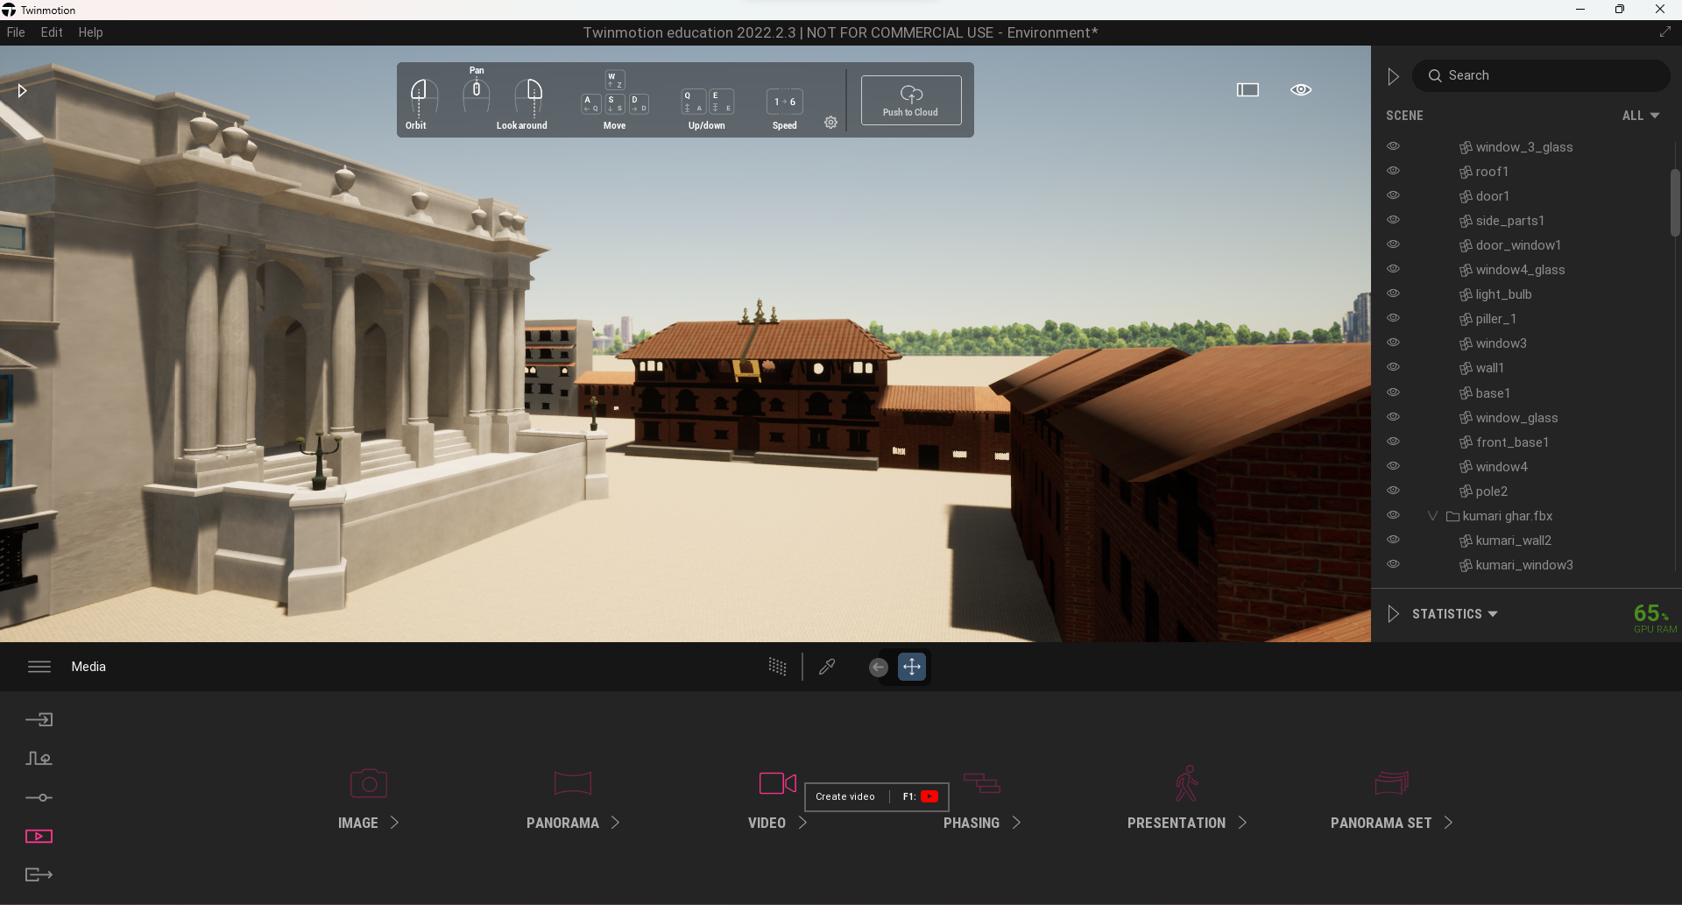

Figure : Opening video settings

To record different parts of the environment map without the camera frames being linked to the last keyframe, a new section is added when there is a need for transitioning to other parts of the map.

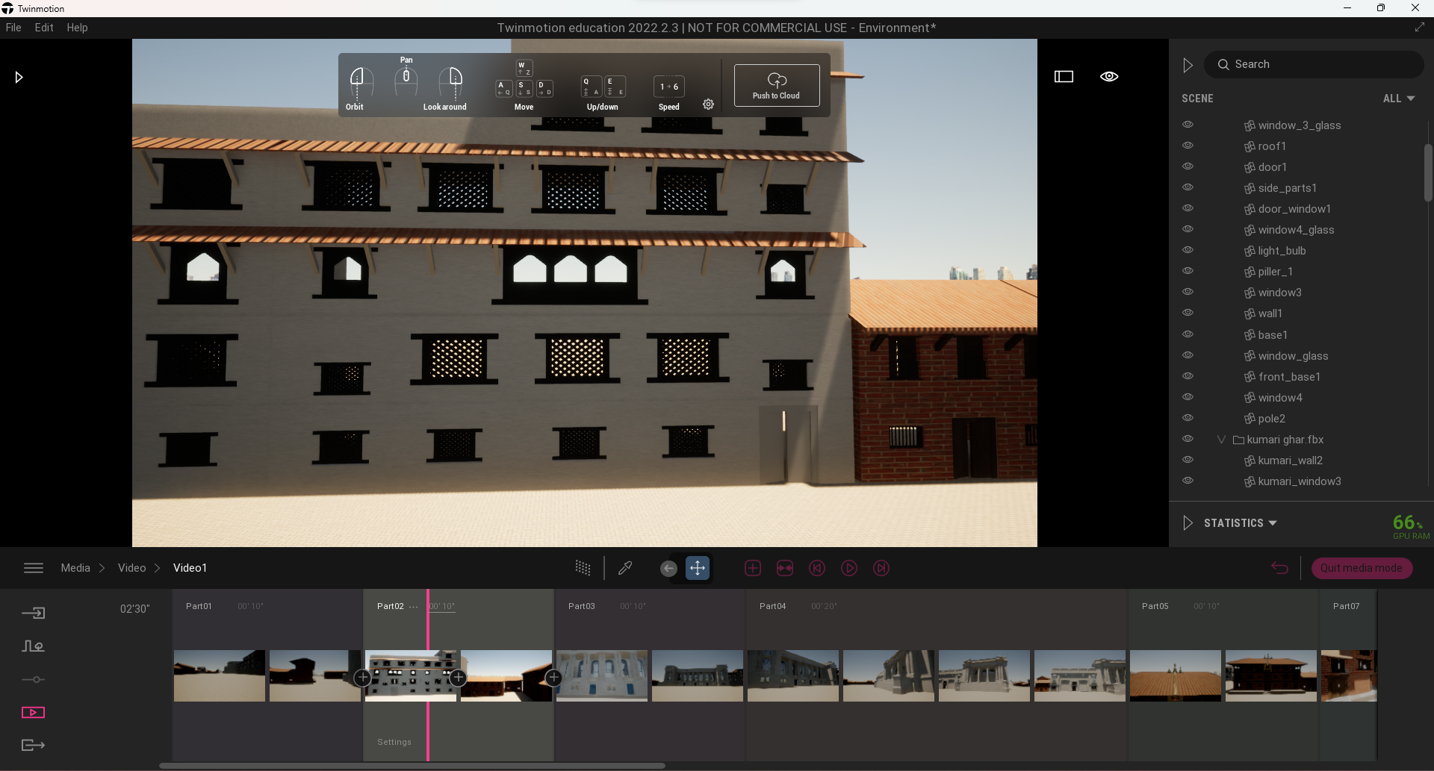

Figure : Creating a walk through video.

After finishing recording the walkthrough video of the environment map, the render is exported as a video format in 1080p resolution and 30 fps.

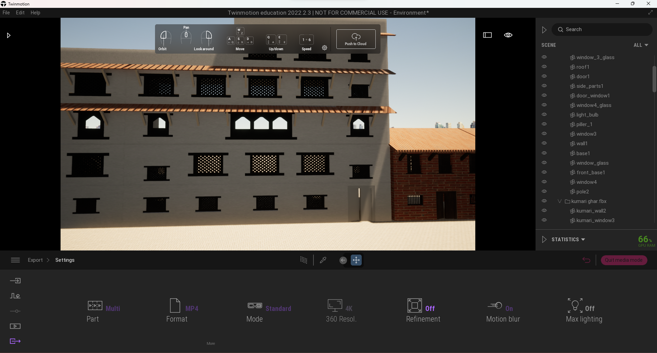

Figure : Managing Export Settings

## Post-production

Post-production is the third and last phase of the production. This phase mainly consists of video editing, color grading, etc.

In the project, the main task for the postproduction is mixing and compiling the video along with sound. For this part of the project Adobe Premier Pro was used.

### Compiling

A new project was created.

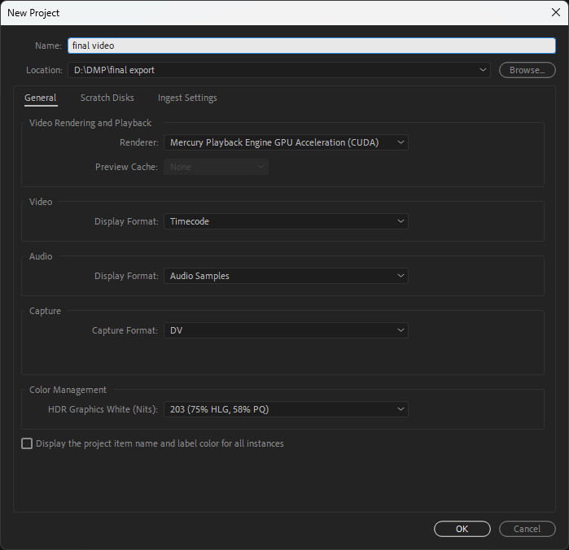

Figure : Creating new project.

The files that were required were imported to the project i.e., render video, audio file, etc.

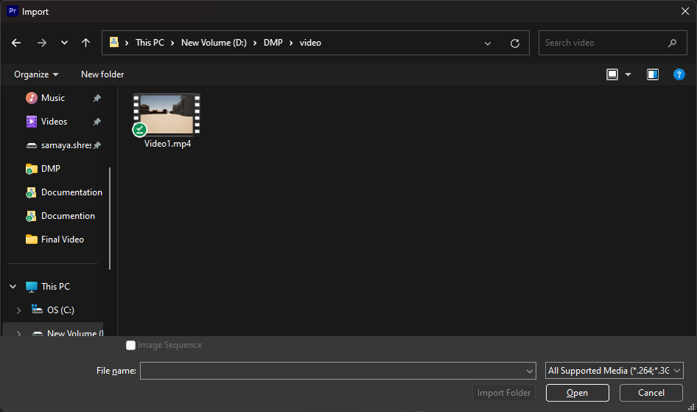

Figure :Importing video.

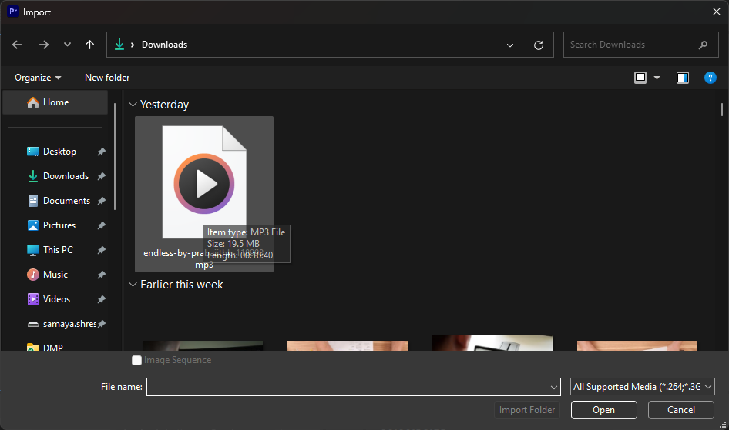

Figure : Importing audio file.

After the final video output is compiled perfectly, the file is rendered and then exported as a video format. The file is exported in H.264 format.

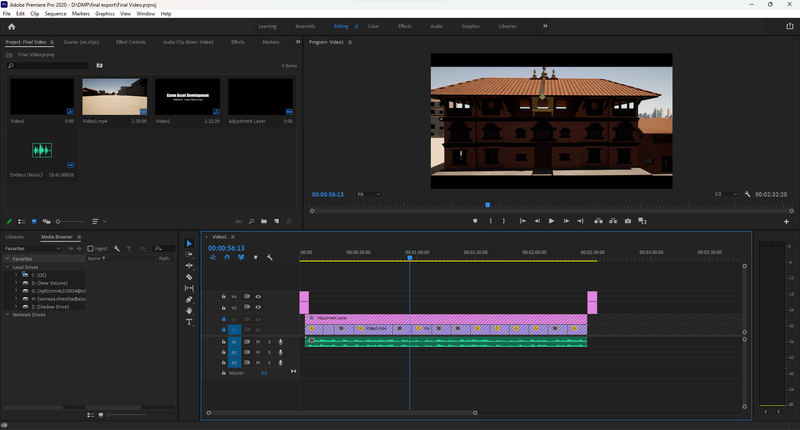

Figure : Compiling Video

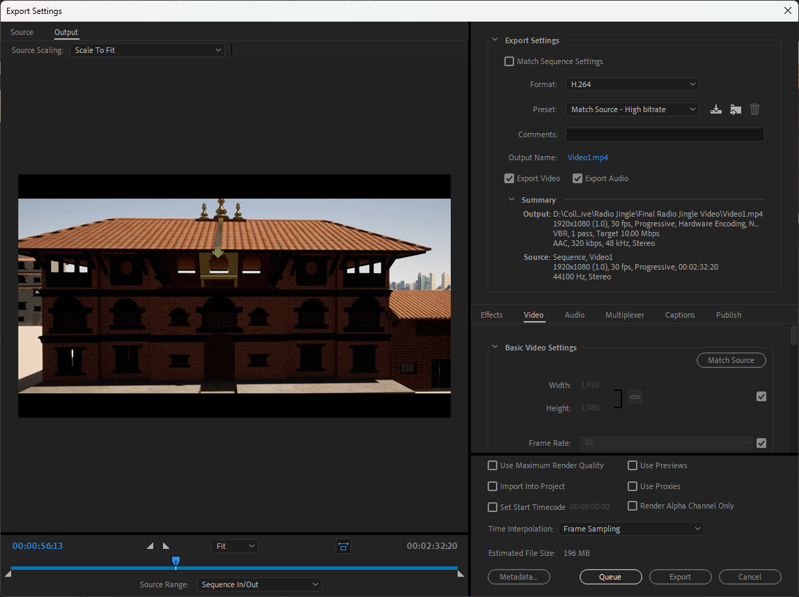

Figure :Exporting Final Video

# Testing

For the testing of the models, the showcase video was first shown to 20 individuals where after checking out the complete video were asked to fill up the survey questions provided to them via Google Forms. The questions have been given below as follows:

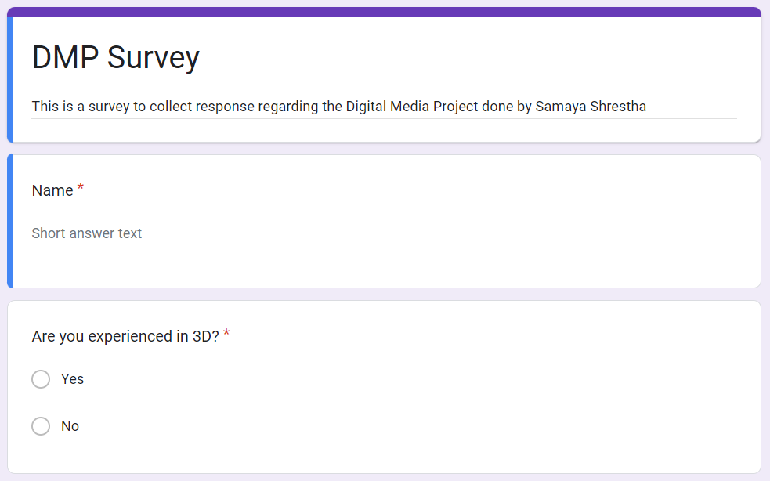

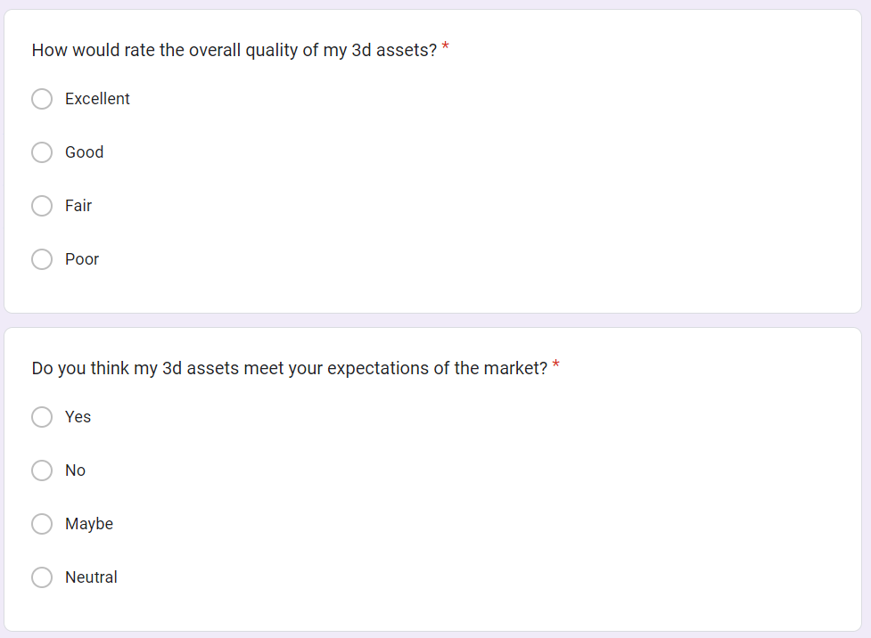

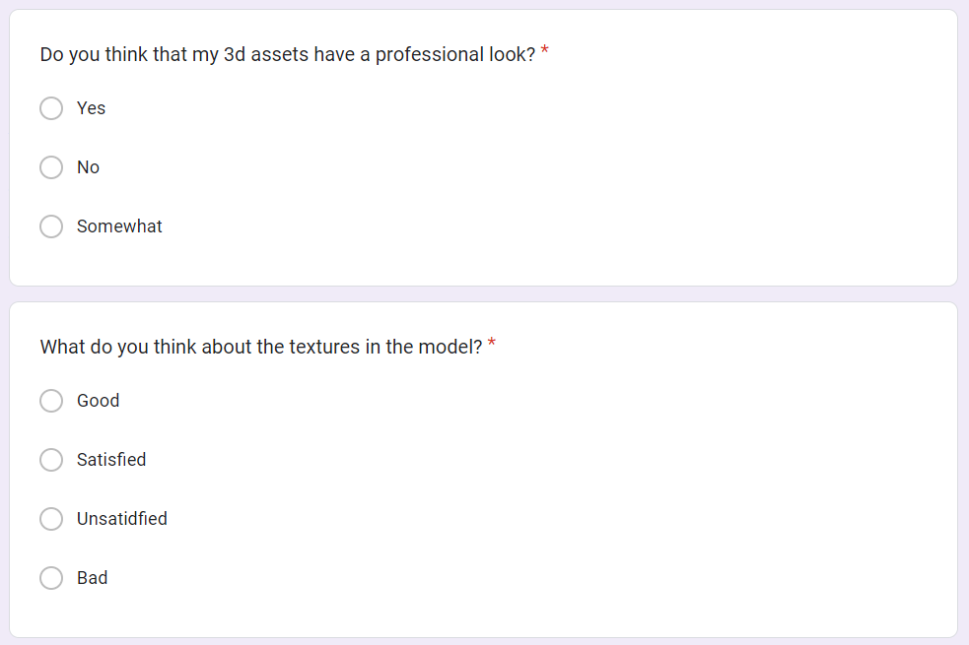

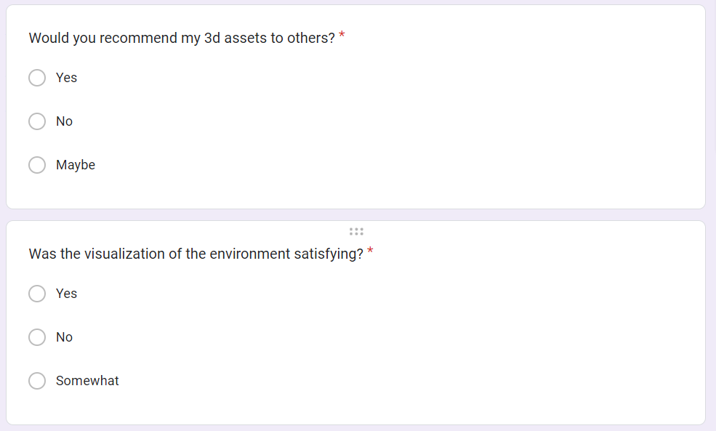

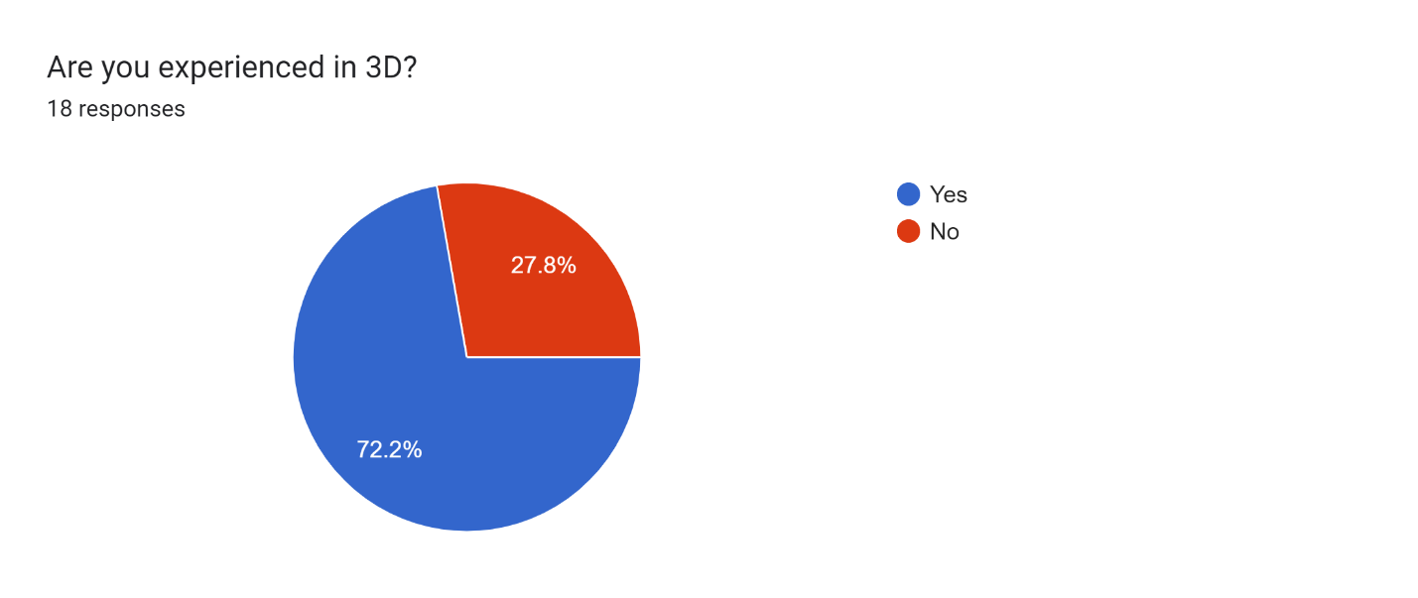

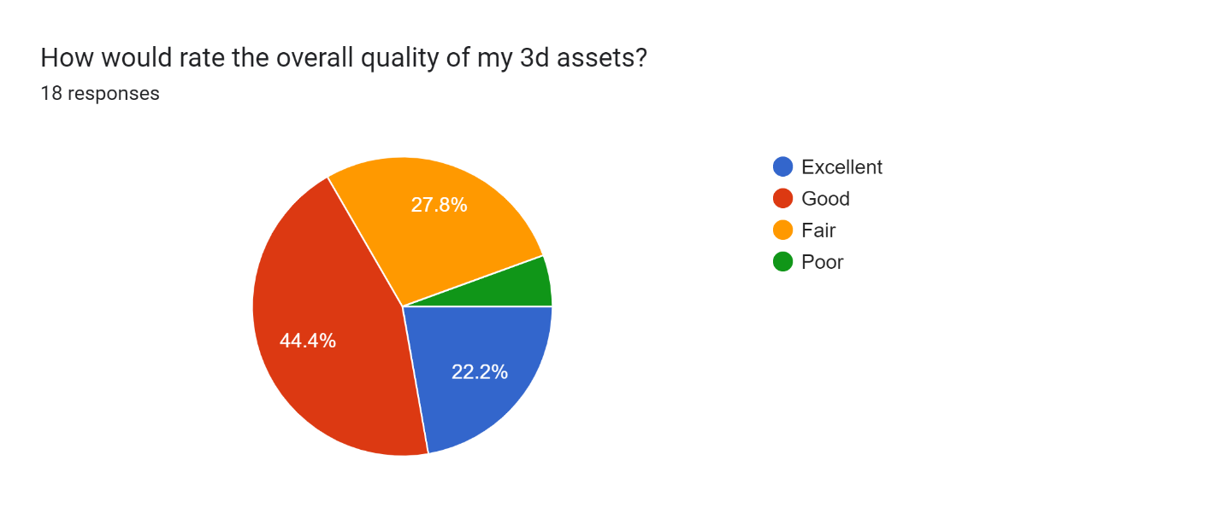

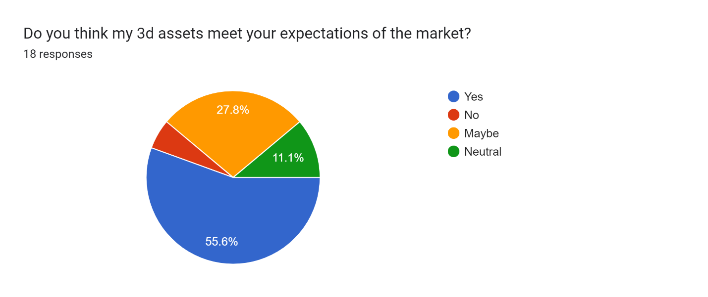

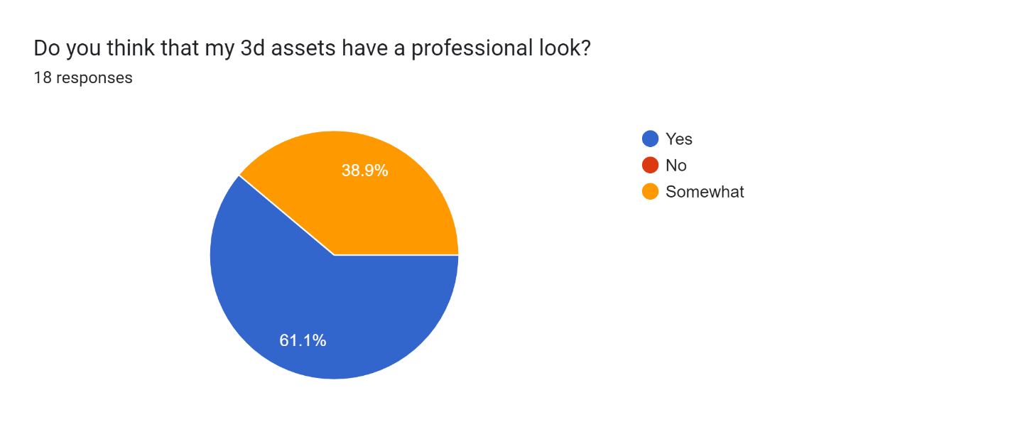

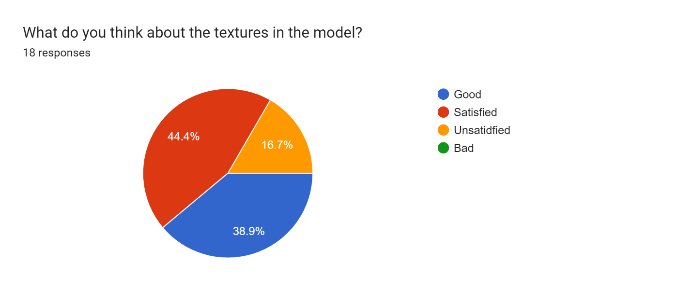

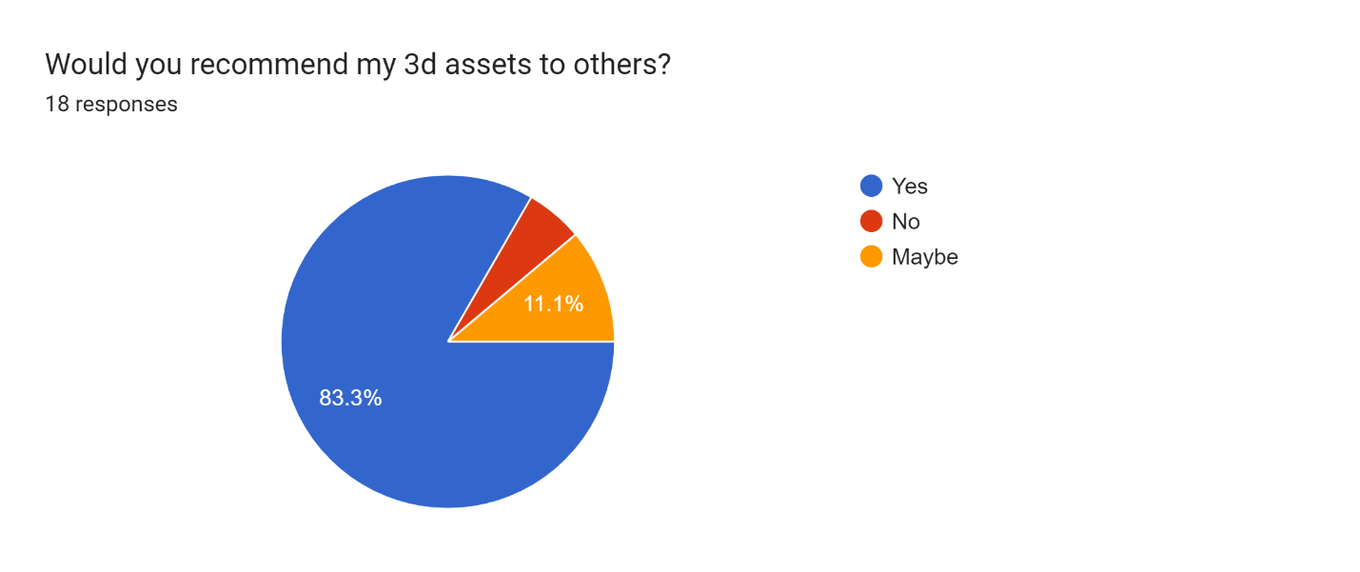

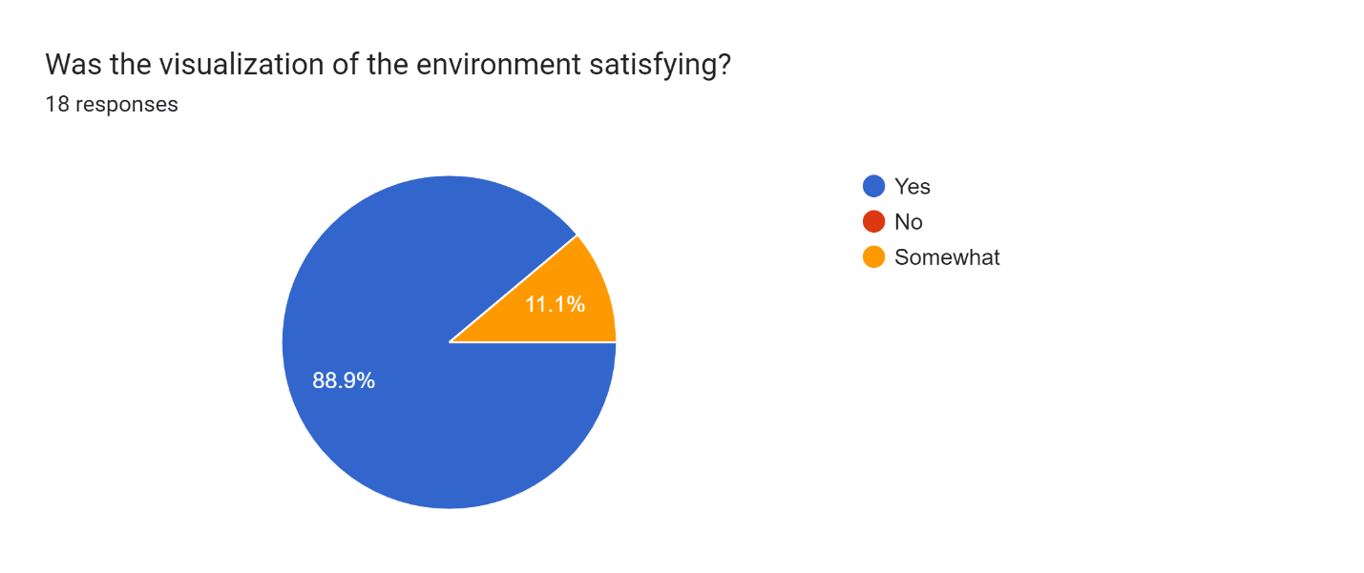

* The first question outcomes that people chosen for the survey have some experience in 3D
* The second question outcomes the overall quality of the 3D assets where majority voted for good, excellent and fair.
* The third question outcomes that the assets created have meet the expectations that is available in the online market and industry.
* The fourth question outcomes that most people has agreed on the professional look of the 3D assets.
* The fifth question outcomes that majority of the people have been satisfied or rated good for texturing of the model while few have remained neutral.
* The sixth questions outcomes that majority of the people recommend these assets to be used in the field.
* The final question outcomes that the overall visualisation of the environment is satisying.

Based on these outcomes, certain changes and improvements were made for the final product to be more eye-catching and attractive to the viewers as well as buyers in the industry that can make use of these assets for game development, movies, educational purposes and so on.

# Links

## YouTube link:

<https://youtu.be/qGGVqN-sHmo>

## Drive

<https://drive.google.com/drive/folders/1-6sO6LNkKjL4Ovb0hZrnOGH9PZjf1gbT?usp=share_link>

## GitHub

<https://github.com/SamayaStha/DMP-Coursework>

# References

* All3DP, n.d. *What Is Substance Painter? – Simply Explained.* [Online]   
  Available at: https://all3dp.com/2/what-is-substance-painter-simply-explained/  
  [Accessed 2023].
* Wikipedia, n.d. *Adobe Premier Pro.* [Online]   
  Available at: https://en.wikipedia.org/wiki/Adobe_Premiere_Pro  
  [Accessed 2023].
* Wikipedia, n.d. *Autodesk Maya.* [Online]   
  Available at: https://en.wikipedia.org/wiki/Autodesk_Maya  
  [Accessed 2023].
* Wikipedia, n.d. *Twinmotion.* [Online]   
  Available at: https://fr-m-wikipedia-org.translate.goog/wiki/Twinmotion?_x_tr_sl=fr&_x_tr_tl=en&_x_tr_hl=en&_x_tr_pto=sc  
  [Accessed 2023].

# Appendix

## Logbook

